**CREW EVALUATION**

Table of Contents

**Purpose 2**

**Controls & Actions Required 2**

**Using the module 3**

**To EVALUATE the Crew 6**

**To ADD Appraisee Comments 10**

**Appendix – A : Seafarer Appraisal Business Process 12**

# Purpose

To evaluate/appraise ship-staff, as per the planned schedule for that rank.

# Controls & Actions Required

Master can assess all Deck Officers and ratings.

The Chief Engineer can assess all Engine/Electrical Officers and ratings.

Master & Chief Engineer’s appraisal will be carried out from the office end.

# Using the module

1. Start the JotERP Onboard Module from the Desktop.
2. After login, the **STARTUP** screen is displayed.
3. 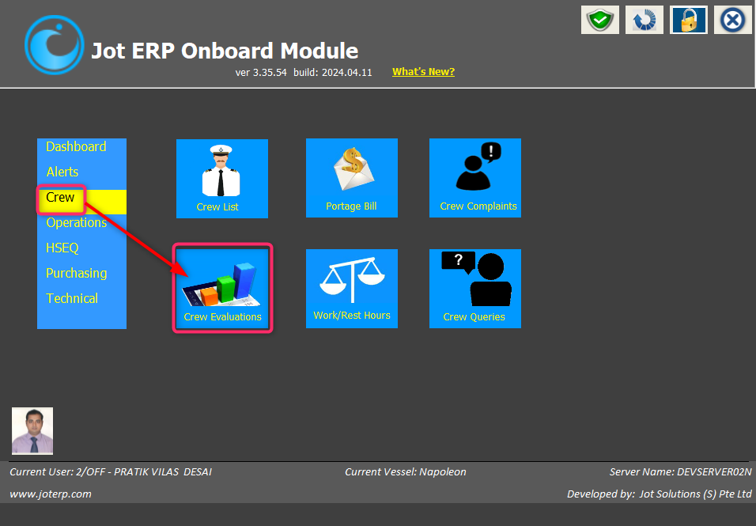In this screen, click the button **CREW EVALUATIONS** under **CREW** menu.
4. The main screen of the **Crew Evaluation** module will open, and it will display the list of crews whose evaluation is **IN PROGRESS**.
5. The evaluations that are currently **OVERDUE** will have their **DUE DATES** in **RED** colour, as shown below.

1. In the main screen –
2. **Top part** of the window contains various **filters** to filter relevant Crew Evaluations:

* Staff Code / Name
* Staff Onboard / Signed-Off
* Department
* Rank
* Evaluation Status – Planned / In Progress / Completed
* Due From/ To Date
* A screenshot of a computer

  Description automatically generatedClear Filter

1. **Lower part** of the window by default displays –

* Entire **crew list whose evaluation is pending**, with their due dates.
* A screenshot of a computer

  Description automatically generatedAlso displays the following information: **Staff Code, Staff Name, Rank, Joining Date, COC, Sign-Off Date, Evaluation** (Type, Due Date, Status, Done Date and % Score) **AND Appraisee Acknowledgement.**

# To EVALUATE the Crew

1. To evaluate any crew in Crew Evaluations, click on the row of the desired crew.
2. A screenshot of a survey

   Description automatically generatedAnother window will open, showing details as given below.
3. In the **upper section**, you will see the crew details - *Staff Code, Rank, Sign-On Date, Staff Name, Sign-Off Date, Evaluation Due Date, Evaluation Date and Evaluation*.

1. A screenshot of a survey

   Description automatically generatedIn the **lower section**, it will have the *Question that will show the different criteria to evaluate/rate the crew under ‘Select Rating here’ options*.

**Note:** If ratings under **‘Select Rating here’** option goes **‘Below Average’** an additional remark will automatically alert for remarks. **Min 20 characters required to move on next criteria.**

Also, if you try to move on next criteria without rating it will prompt you an alert message **“*Select a rating for these criteria first!*”** and not allow user to move on next or previous criteria.

1. If the criteria or question is not applicable, you can select option **NOT APPLICABLE** button.

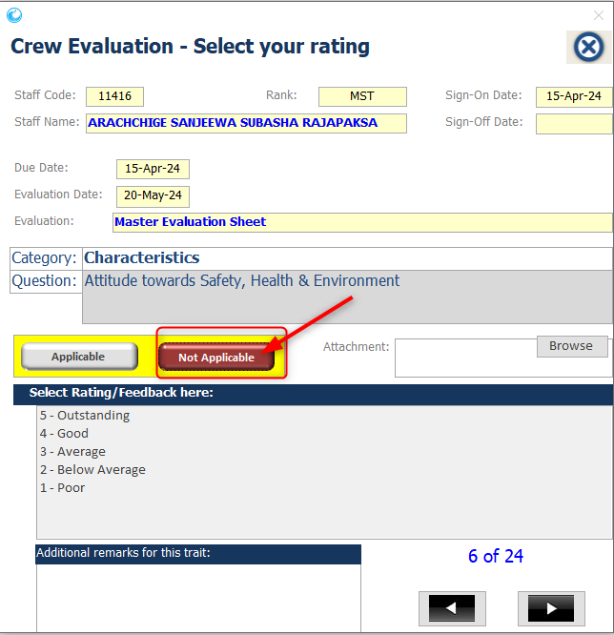

1. When you finish rating as per various criteria’s, the next button will automatically change into **‘Finalize and Send to Office’** button.
2. 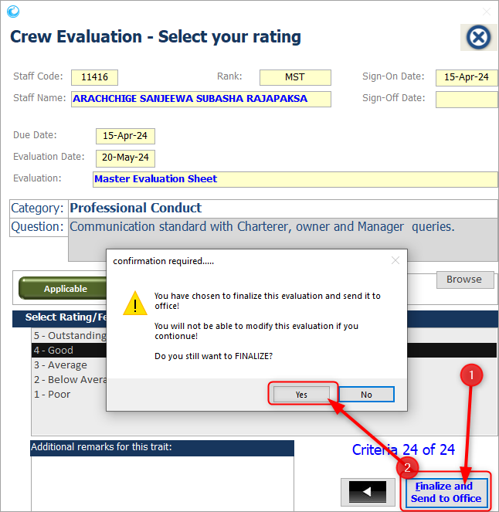To **finalize** it will ask for confirmation, click **YES** to complete the evaluation exercise for the selected staff.
3. A screenshot of a computer

   Description automatically generatedOnce you finalize the Crew Evaluation that crew name will automatically go to the **Completed evaluation list** and can be viewed only using **‘Evaluation Status’** filter.

# To ADD Appraisee Comments

**Note:** Each seafarer, whose Appraisal / Evaluation has been marked **completed** by the department head, will be able to login to the Jot ERP Onboard module, and be able to **view** his own appraisal.

He will also be able to give his **feedback** about each of the grading that is given in his appraisal under column **APPRAISEE COMMENTS**.

1. To add the Appraisee Comments, login into Jot ERP Onboard Module.
2. Click on **Crew Evaluation**, under **Crew** menu.
3. The Appraisee, will be able to view the Evaluations marked as **Completed**.
4. A screenshot of a computer

   Description automatically generatedClick on the **latest** Evaluation.
5. A new window will open, with the **Ratings & Remarks**.
6. The Appraisee can input their Remarks under **SEAFARER REMARKS** column.
7. Once all the Remarks are added, click on **APPRAISEE ACKNOWLEDGEMENT** button.
8. Click on **YES**, when asked for confirmation.

**Note:** Once the Appraisee Acknowledgement is recorded, it cannot be edited.

# Appendix – A : Seafarer Appraisal Business Process

**Planned Evaluations / Appraisals are automatically created.**

in the Jot ERP Office side, based on the schedule provided by the Crewing Department

Planned Evaluations are then **visible onboard ships**

Upon the DUE DATE, the Master & Chief Engineer onboard can **update the evaluations** for Deck and Engine respectively departments

Evaluations can be updated and saved.

**REMARKS are mandatory by the Appraiser if poor rating is given to a question**.

Once an evaluation is completed, the Master/Chief Engineer can **FINALIZED** that evaluation.

The **Appraisee** can then login to the Jot ERP onboard, and he can view only his own appraisal.

He **can view it and place his response for each grade**. Once completed, he has to **Acknowledge** that he has sighted and responded to the appraisal.

The Evaluation is then automatically synchronized with the office side, where the Crew Team and the **Superintendent** can view it and mark it as **VERIFIED**.