**CREW LIST**

**Table of Contents**

**Purpose** 2

**Controls & Actions Required** 2

**Using the module** 3

**To EDIT the Crew Details** 5

**To RESET the Password** 9

# **Purpose**

* Provides the list of **current & signed-off crew** for the respective vessel.
* Along with other details such as – **Personal details, Voyages history, Bank Account details, Dependent/ NOK details & COVID records**.

# **Controls & Actions Required**

* All the Crew details are added from the **office end**, and **MASTER** can edit the details.
* **ONLY** Master has access to the Crew List module.

# **Using the module**

1. A screenshot of a computer

   Description automatically generatedTo open the module, click on **CREW LIST**, under **CREW** menu on the **DASBOARD** page.
2. A new window will open displaying the **CREW LIST** with some details like – **Staff Code, Staff Name, Rank, DOB, Passport details, Contract Starting Date, Sign-On Date/ Port, COC & Sign-Off Date/ Port**.
3. By default, the system will display the **CURRENT** Crew List.
4. To **VIEW** the complete Crew List, click on **“Crew List Type as ALL”**, in the **SEARCH FILTER** section.
5. To **SEARCH** any Crew, use the filters – **Staff Code/ Name OR Rank drop-down**.
6. To **PRINT** the Crew List, click on **PRINT IMO CREW LIST FOR CURRENT CREW button**.
7. To clear the filters or refresh the page, click on **CLEAR ALL FILTERS** button.

## **To EDIT the Crew Details**

1. On the **Crew List Index** page, click on any **Crew** for which you want to edit the details.
2. 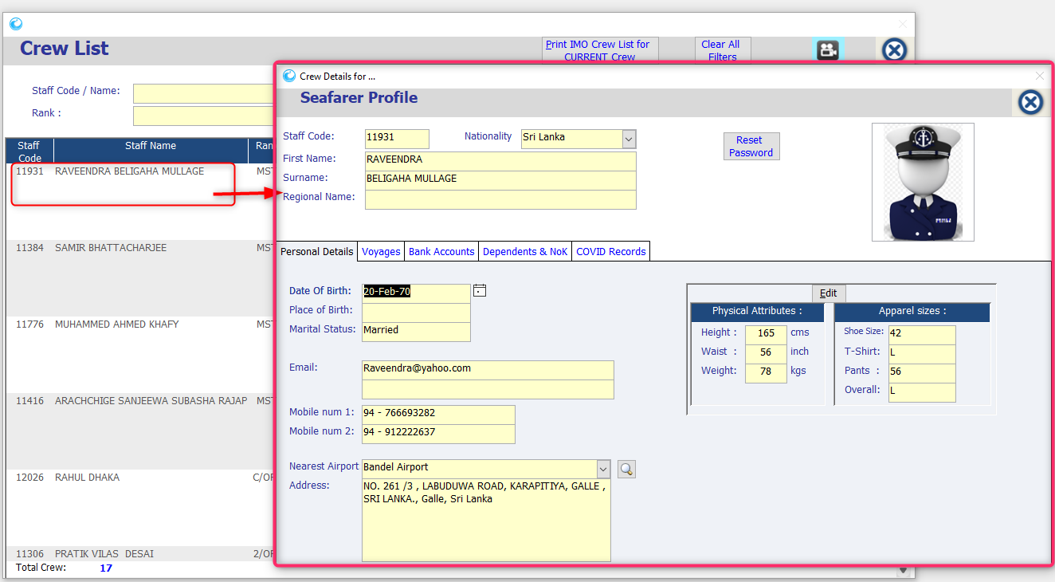The Seafarer Profile page will open, displaying the Personal Details of the Crew.
3. A screenshot of a computer

   Description automatically generated**Personal Details:** Under this tab, Master can edit the selective details of the crew - **DOB, POB, Marital Status, Email ID, Nearest Airport, Physical Attributes & Apparel Sizes**.
4. **Voyages:** Under this tab, Master can edit the latest voyages details.

* Click on **Voyage** and a new window will open.
* Enter the **Sign-Off Date, Port & Reason**.
* A screenshot of a computer

  Description automatically generatedAnd **CLOSE** the window.

1. **Bank Details:** In this tab, Master can **only** **add new** bank account details of Crew.

1. A screenshot of a computer

   Description automatically generated**Dependents & NOK:** In this tab, Master can **only** **add new** dependent or NOK details of Crew.
2. A screenshot of a computer

   Description automatically generated**COVID Records:** In this tab, Master can **only add** the COVID details of Crew.

## **To RESET the Password**

1. On the **Crew List Index** page, click on any Crew for which you want to **RESET** the password.
2. On the **Seafarer’s Profile** page, click on the **REST PASSWORD** button.
3. The system will ask for confirmation, click on **YES**.
4. The Password Reset prompt will pop-up, displaying the default password – **12345**.
5. 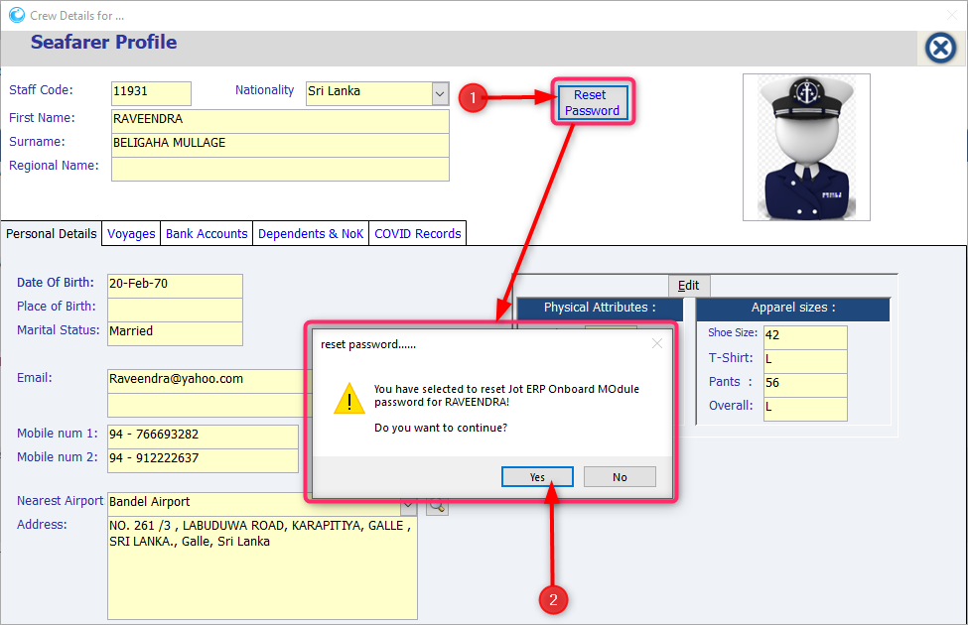Click on **OK**.