**DECKLOG BOOK**

Table of Contents

**Purpose 2**

**Controls 2**

**Using the module 3**

**Appendix – A: Workflow of information re Deck Log Book 7**

# Purpose

To allow Deck officers to update the Deck Log Book information in the JotERP Onboard Module.

# Controls

* Any Deck Officer can use the DECK LOG BOOK.
* Every watch, the log book must be updated fully and FINALIZED.
* Once FINALIZED, the deck officer cannot modify the log.
* However, only the Master & Chief Officer can modify log which is 1-day old.

After 24-hours are past of the finalization, no one can modify this log.

* You can see the workflow for this process here.

# Using the module

1. Start the JotERP Onboard Module from the Desktop.
2. After login, the STARTUP screen is displayed. 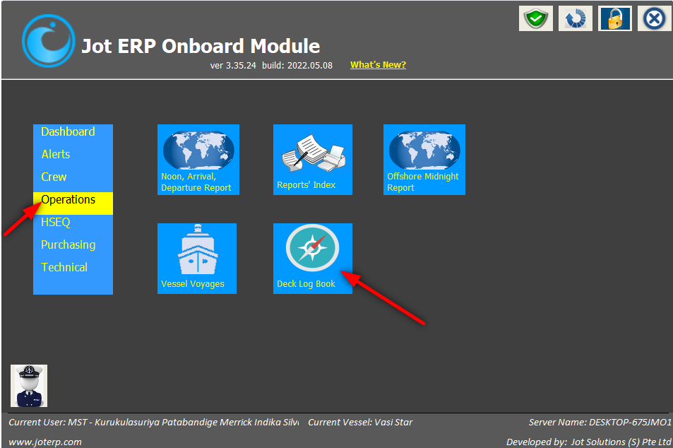
3. A screenshot of a social media post

   Description automatically generatedThe main screen of the DECK LOG BOOK will open, showing a single report dated today/yesterday.
4. A screenshot of a cell phone

   Description automatically generatedClick on the date, and the day’s Log-page will open as shown below.
5. Use the vertical scroll bar on the right side, to view the full screen shown below.
6. In this screen, update the following data:

* FROM PORT and TO PORT
* Course, Error, Wind etc every hour
* 0000hrs to 0400hrs as you do in the paper log book.
* A screenshot of a cell phone

  Description automatically generatedWheel & Look Out data

1. 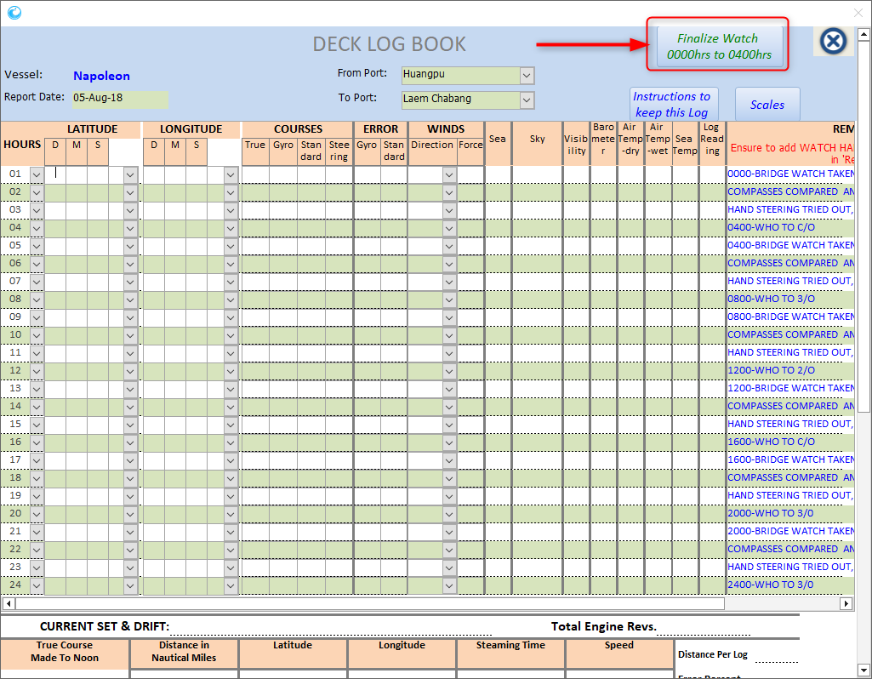Once the watch is finished, the duty Officer must FINALIZE data for his watch, by pressing the button FINALIZE WATCH 0000hrs TO 0400hrs (top-right side of this screen).

1. Only then the next Duty Officer, should start entering data for his watch.
2. 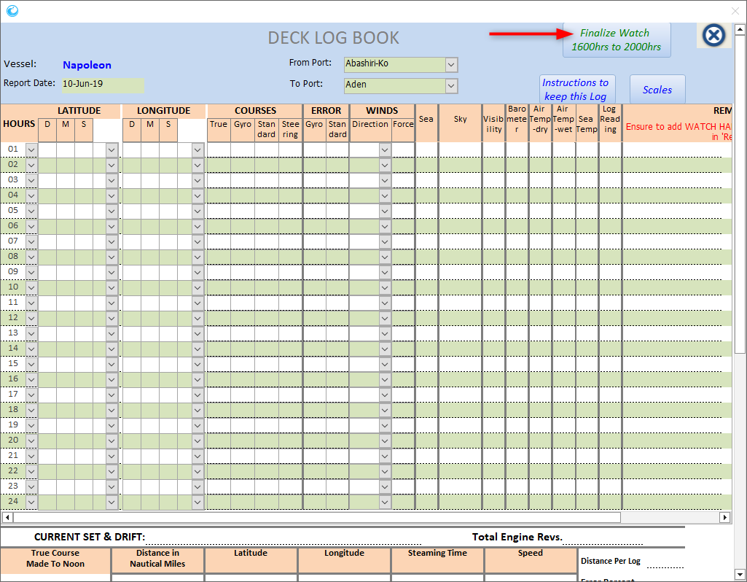The FINALIZE button will automatically change to the current watch, which has NOT yet been finalized.
3. If the Master or the Chief Office believe that there has been a typo error/mistake, he can modify the old record, if it is not more than 1 day old.
4. The JotERP Onboard Module records every change that is being done and is displayed at the office side.
5. At the **1200hrs to 1600hrs watch**, rest of the details such as CURRENT SET & DRIFT, Total Engine Revs, Distance made etc must be updated before FINALIZING this watch.

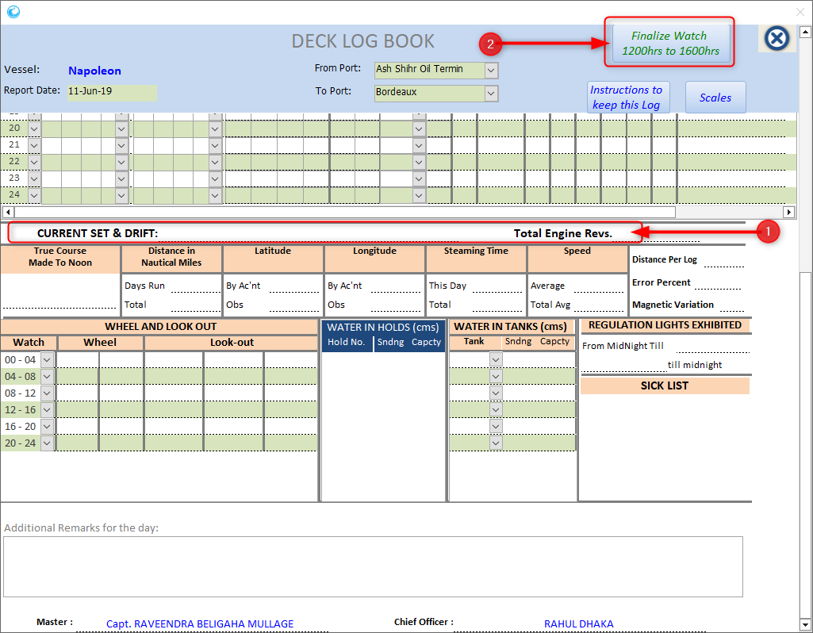

**Note:**

* Use the JotERP Onboard Synchronizer on the email computer to send this data to the office.
* If Master is taking rest or is not available, the data can be sent once he is available to make the email handshake.

# Appendix – A: Workflow of information re Deck Log Book

