**ENVIRONMENT MANAGEMENT SYSTEM (EMS)**

Table of Contents

**Purpose 2**

**Controls and Actions 2**

**Using the module 3**

**Creating a New EMS Report 5**

**a. Instructions 7**

**b. Bunkering 7**

**c. Engine Room Debilging 8**

**d. Cargo Operations 8**

**e. Sludge Operations 9**

**f. Water Management 9**

**g. SECA 10**

**Send to Office 11**

# Purpose

* To have a ship-specific list of EMS Reports onboard.
* Provide vessel with the means to record all valid and available information related to the EMS reports.
* The Superintendent in the office will be able to view the EMS Reports, on the same day.

# Controls and Actions

Vessel will update, EMS Report details like –

1. Date and time when the report send to office
2. Details of the EMS that was carried out, with specifics, such as –

* Bunkering Information.
* Cargo Operations
* Sludge & Garbage management.
* Water Management.

# Using the module

1. Start the Jot ERP Module from the Desktop.
2. After login, the STARTUP screen is displayed.
3. A screenshot of a computer

   Description automatically generatedIn this screen, click the “Environment management system”, under HSEQ menu.
4. The main screen of the Environment Mgmt System Reports module will open, as shown below.
5. In the main screen of the EMS Report, each EMS report is represented by a row.
6. To view details of an EMS Report and see its full details, click on the EMS row.

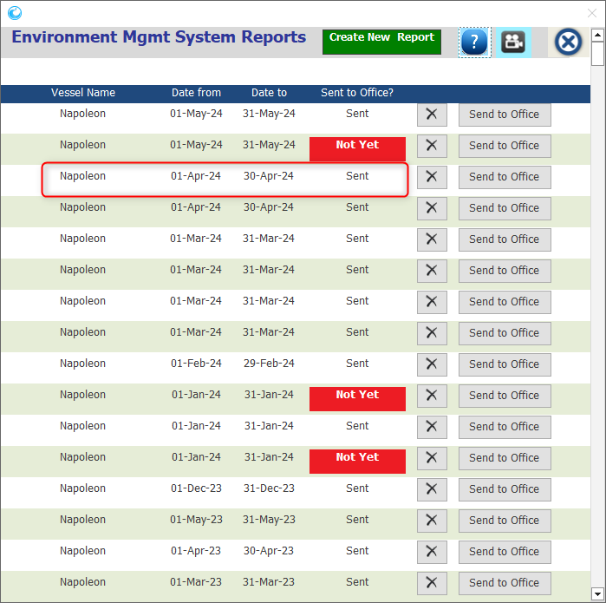

# Creating a New EMS Report

When an EMS report is created out physically by the vessel staff, you need to update details of the EMS reports in the Jot ERP using the following steps:

1. A screenshot of a computer

   Description automatically generatedIn the EMS Reports window, click on the “Create New Report” button on extreme-Top the Window.
2. A new window will open.
3. In this EMS REPORT window, select the MONTH & YEAR.

**Note: Typically, this report is to be sent only once a month to the office. Hence, the ship staff has to select the MONTH.**

1. If you have any special remarks, place same under the REMARKS field on the top-right of this report window.
2. The window will represent 8 Tabs given below -

* Instructions
* Bunkering
* Engine Room Debilging.
* Cargo Operations
* Sludge & Garbage Management
* Water Management
* SECA
* A screenshot of a computer

  Description automatically generatedAttachments

## Instructions

Instructions are predefined in the Jot ERP system to explain the ship staff to fill the EMS report.

## Bunkering

This gives the details of the total fuel onboard & the quantity spilled.

## Engine Room Debilging

It gives the details of the debilging operations carried onboard due to the OWS defect & Port regulations.

## Cargo Operations

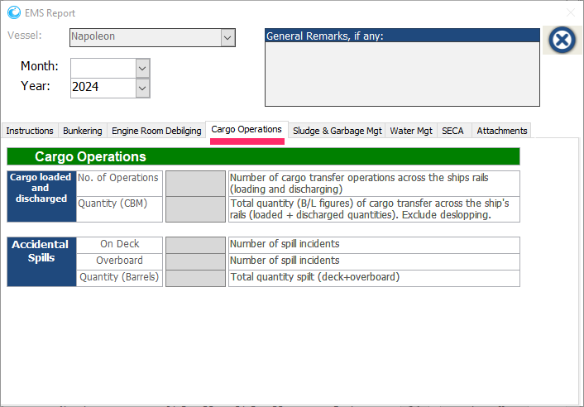It gives the details of the cargo loading & discharged quantity.

## Sludge Operations

This gives the values of the total sludge & garbage disposed at sea & at shore.

## Water Management

This tab gives the values of the washed water in the Slop tank etc. and the water quantity details that is discharged after the ballast treatment & tank cleaning.

## SECA

SECA or Sulphur Emission Control Areas are designated areas with strict Sulphur emission limits, approved by IMO.

If the vessel has visited the SECA area, only then this tab is mandatory to be filled with the relevant details.

1. Once all the tabs & fields are filled with the relevant details, close the window from the icon in the top-right corner of the window.
2. The EMS reports will be SAVED & visible in the index screen.

# Send to Office

**Note: EMS report can be sent to office ONLY by the Master of the ship.**

1. When the Master or Captain opens this window again, they can see a button “Send To Office” in this screen.
2. 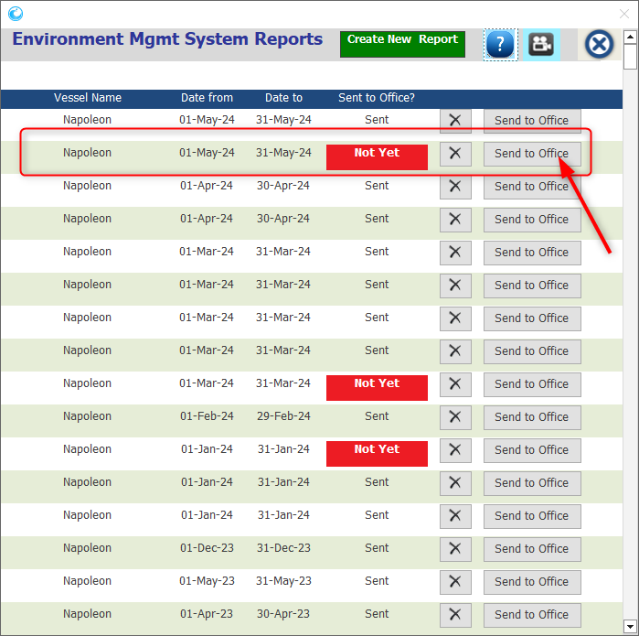They need to click this button to send this report to the office.
3. If under a case, these details are incorrect, any ship staff can choose to delete this report by using the button DELETE.

**Note: But if a report is sent to the office, it can’t be deleted or modified.**

