**INJURY REPORT**

**Table of Contents**

**Introduction** 2

**Purpose** 2

**Controls & Actions** 2

**How to ADD new Injury/Illness Report** 3

**To Add Details in Part 1: To be filled in immediately when injury occurs and Save** 4

**To Add details in ‘Part 2: Injury Investigation details to be filled in afterwards’** 8

**Part 3: Office -**To be filled by office 9

**How to SEND the Injury Report to Office** 10

**Part 4: To Add Follow-up** 11

**How to SEARCH for a specific Injury/Illness Record** 13

# 

# **Purpose**

Injury Report helps the crew to **record and inform** office aboutany Injury/Illnessonboard, to ensure the safety & health of the ship crew onboard.

# **Controls & Actions**

1. This report can only be **FINALIZED & SENT TO OFFICE** by the **MASTER**.
2. Once the **Injury Report** is saved by the user, no changes can be made in the report
3. The VERIFICATION of the injury report is done by the office end.

# **How to ADD new Injury/Illness Report**

1. Login into the Onboard module using the individual credentials.
2. A screenshot of a computer

   Description automatically generatedUnder **‘HSEQ’** menu, click on **‘Injury Reports’** module.
3. A screenshot of a computer

   Description automatically generatedOn the new window, click on **‘Add New Injury/Illness’**

# **To Add Details:**

# **Part 1: To be filled in immediately when injury occurs and Save**

Update the mandatory fields highlighting in red – **Seafarer, Type of Event (Illness/Injury), Location of Incident.**

1. **Report Number** is auto generated
2. **Injury Date-** Can be modified to past date but not to future date.
3. **Reported date** -Reflects current date, the date on which report is generated and cannot be modified.
4. **Task Involved:** Select the relevant option provided in the drop-down.
5. Users can use the **“Add Attachments”** option provided on the right side.

1. **A screenshot of a computer

   Description automatically generated**Then click on **‘Save and Close’** button.
2. A screenshot of a computer

   Description automatically generatedThe Injury report will be added to the record with **‘Sent to Office’** status **NO**

## **To Add details:**

## **Part 2: Injury Investigation details to be filled in afterwards**

1. Fill in the details from the list provided in the drop- down and a free text box is provided next to each details to fill more information. These are non-mandatory fields:
2. Body Part Affected
3. Type of Incident
4. Immediate Cause:

* Substandard Acts
* Substandard Conditions

1. Root Cause of Injury:

* Personal Factors
* Job Factors

1. Could the Injury be avoided.
2. Task Involved Remarks if any.

# 

# **How to SEND the Injury Report to Office**

1. Once all the tabs are updated properly, the Master will make a final review.
2. Then click on **‘Send to Office’** button.
3. The system will prompt for the confirmation.
4. Click on **‘Yes’** button.

1. 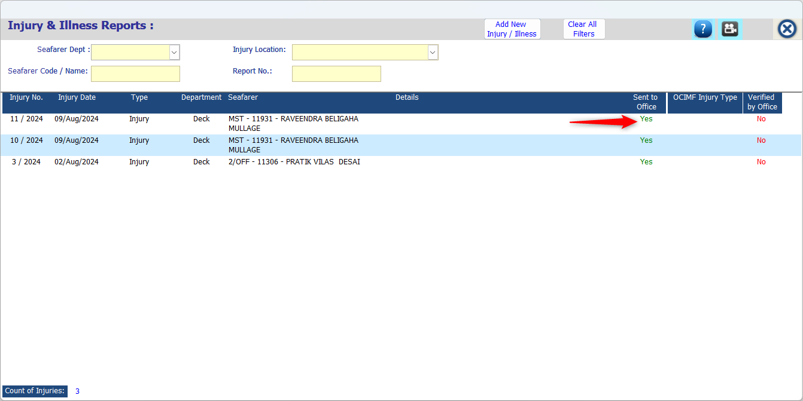The status of **‘Sent to Office?’** on the Index screen changes to ‘**YES’**.

# **Part 3: Office**

# A screenshot of a computer Description automatically generatedThis tab is only for viewing purposes and will be filled by office.

# **To Add Follow-up:**

**Part 4: Followup**

Once the Injury/Illness Report is sent to office by the Master

‘Part 4 :Follow up’gets activated.

1. A screenshot of a computer

   Description automatically generatedClick on Follow up tab to add the follow up details.
2. Once the tab opens click on **ADD FOLLOW-UP** button.
3. We can add the message along with an attachment.
4. And click on the **SAVE & CLOSE** button.
5. A screenshot of a computer

   Description automatically generatedThe said follow-up will be added.

# **How to SEARCH for a specific Injury/Illness Record**

1. On the Index screen you can search the Injury/Illness Report by **‘Seafarer Dept’, Seafarer Code/Name, Injury Location or Report No.** & press the enter key. Eg: Below screenshot shows Report No. 11
2. The respective Injury/Illness records will be displayed under the Index screen.

