LINE MANAGEMENT PLAN

Contents

Introduction 2
Purpose 2
How To ADD LMP Line 3
How To ADD ATTACHMENTS In Line Mgmt Plan 5
How To ADD LMP Details in Departure Report 6
How To ADD ATTACHMENTS In Departure Report Line Mgmt 8
How To RETIRE the LMP Line 9

Introduction

Line Management Plan (LMP) will allow the office to track usage and maintenance of Mooring Lines onboard each vessel in the fleet.

Purpose

- The current list of the Mooring Lines/Wires/Ropes present onboard, can be added onboard.
- This library of the current inventory can then be used while filling in the DEPARTURE REPORT.

How To ADD LMP Line

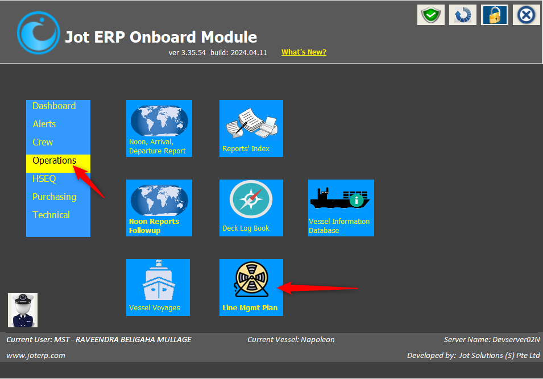
- Under ‘Operations’ menu, click on ‘Line Mgmt Plan’.

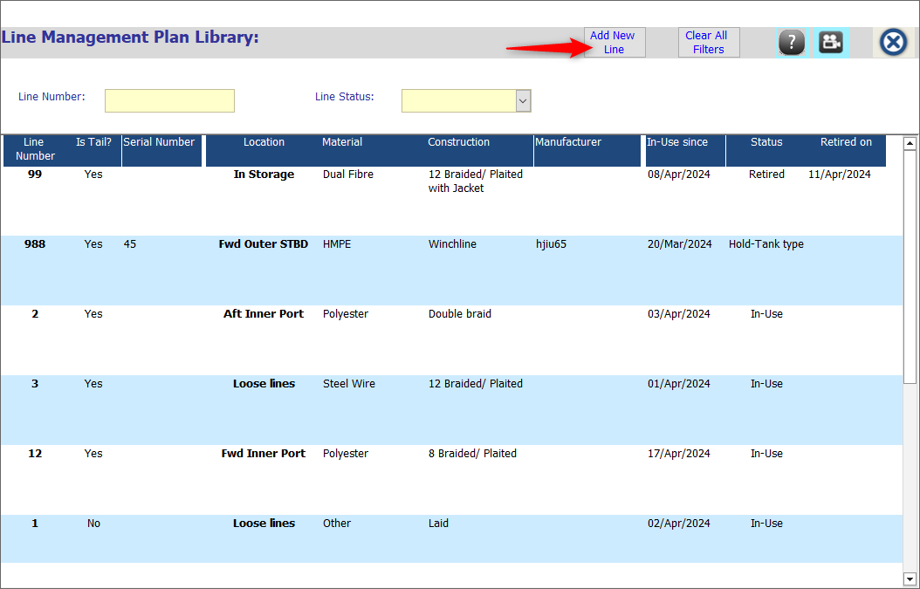
- Click on ‘Add New Line’.
- Fill up all the necessary information, specifically the fields marked as ‘*’
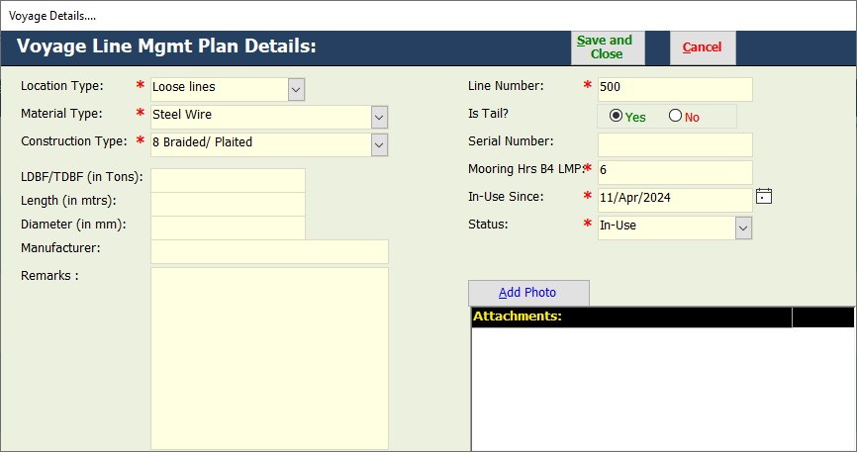
- Click on ‘Save & Close’.

How To ADD ATTACHMENTS In Line Mgmt Plan

- Open the ‘Line Management Plan’ module.
- Open the ‘Line’ record where attachment is to be added.
- Add relevant ‘Attachments’ for the same.
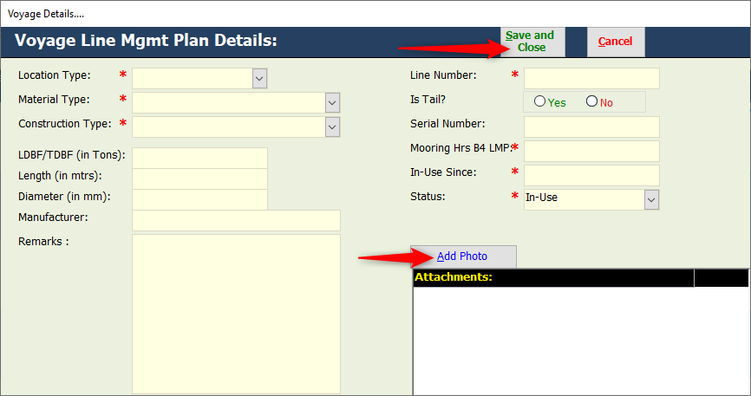
- Click on ‘Save & Close’.

How To ADD LMP Details in Departure Report

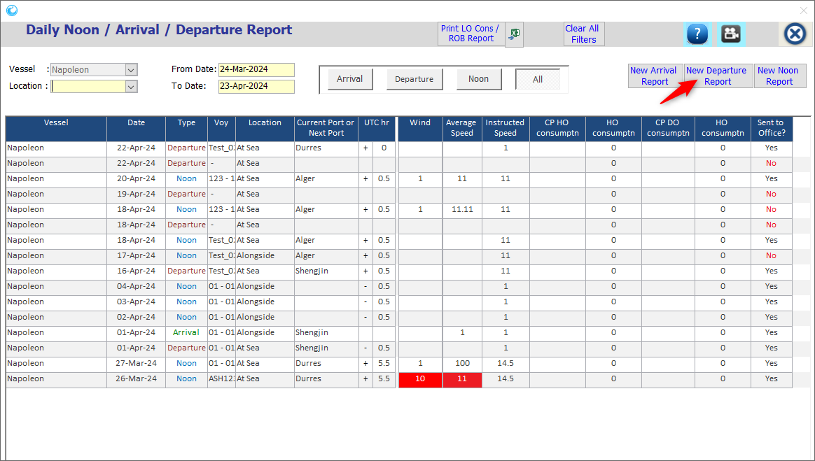
- Under ‘NAD’ module, click on ‘Add Departure Report’.

- Under the Departure report, add ‘Date’ and then click on ‘Line Management’ tab.
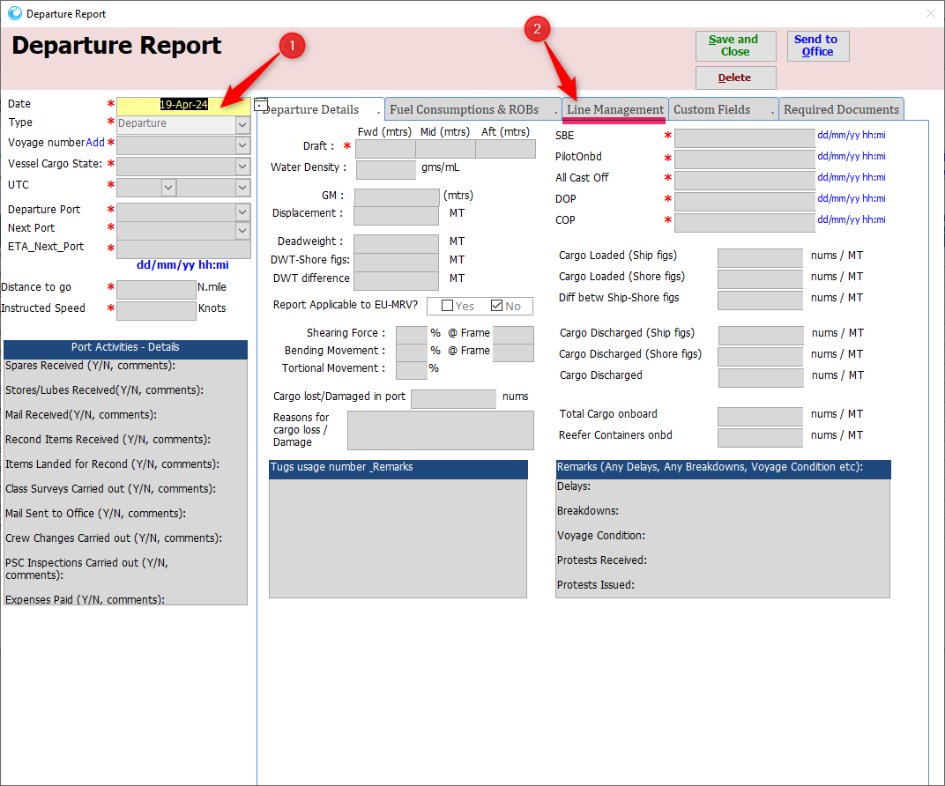

- Update the details – Line Number, From date, To date, Remarks.
- Click on ‘Save & Close’ button.
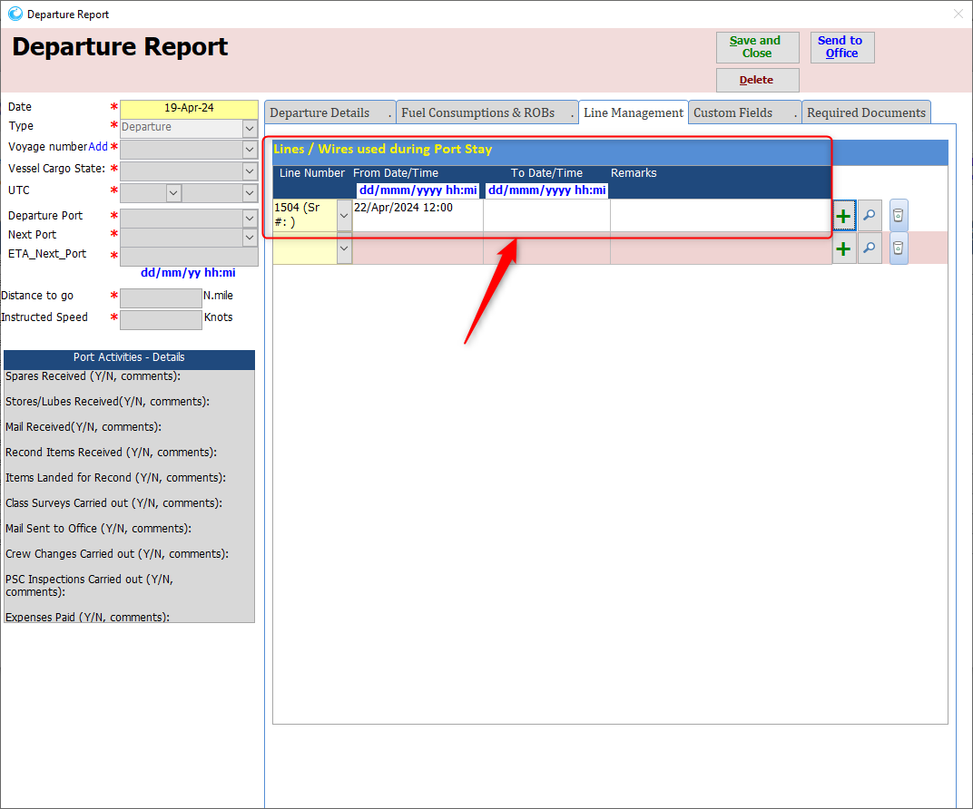

How To ADD ATTACHMENTS In Departure Report Line Mgmt

- Under ‘NAD’ module, open the ‘Departure Report’.
- Under the Departure report, click on ‘Line Management’ tab.
- Click on the ‘+’ option.
- A new window will open, to add the attachment.
- Click on ‘Add photo’ link & upload the attachment.

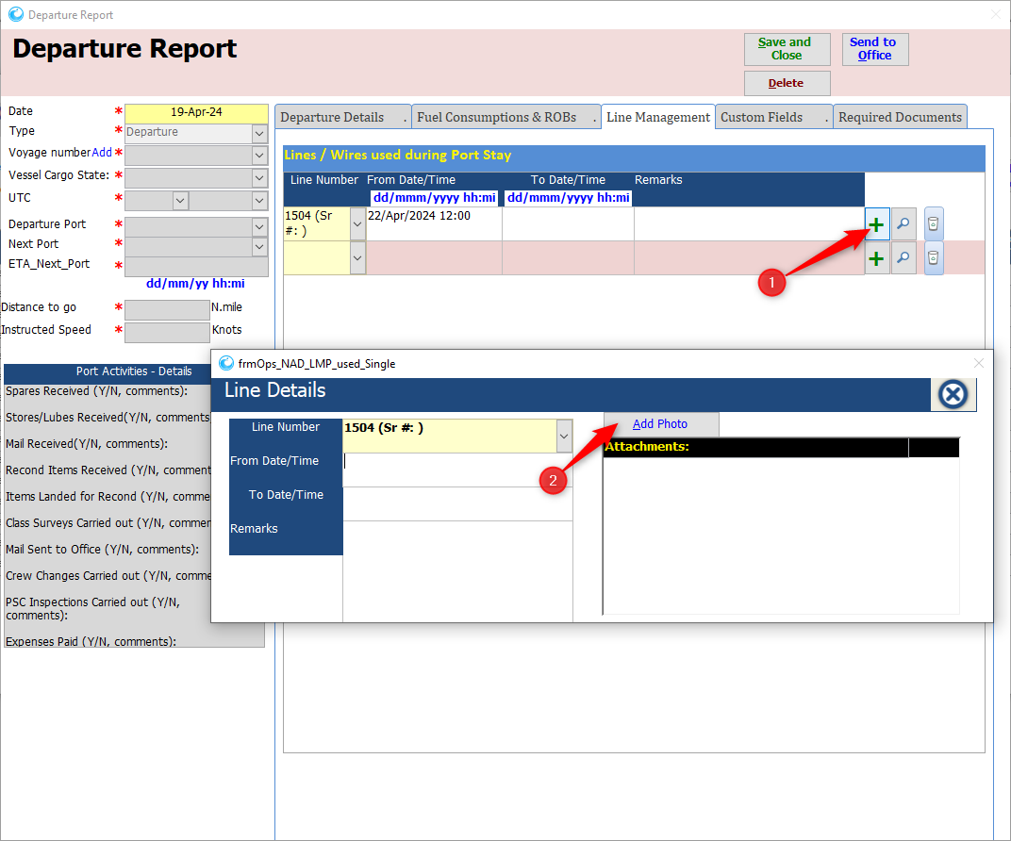

How To RETIRE the LMP Line

- When the use is over, update the Status as ‘Retired’ and ‘Retired Date’.
- Open the ‘Line Management Plan’ module.
- Open the ‘Line’ that needs to be retired.
- Update the Status as ‘Retired’ and ‘Retired Date’.
