MASTER’S SMS REVIEW

Table of Contents

Introduction 2
Purpose 2
How to ADD Master’s SMS Review 3
How to UPDATE Procedural Improvements 5
How to UPDATE Procedural Errors 6
How to UPDATE HSE Feedback 7
How to SEND the SCM record to Office 8
How to DELETE the SCM record 9
How to SEARCH for a specific SCM record 10

Introduction

Master’s SMS Review enables to annually review the SMS, ensuring that the vessel is operating accordingly, as per ISM code and that the procedures are realistic and suitable.

Purpose

- Master’s SMS Review module includes the following:
- Current position of the vessel.
- Quick overall Review of SMS & comment on Procedural Improvements & Errors.
- Master feedback on HSE.
- Master’s Open feedback.
- This report can only be SENT TO OFFICE by the Master only, though other users can add/edit the same.
- Once the Master’s SMS Review Report is sent to the office, the ship crew cannot make any changes to the same.

How to ADD Master’s SMS Review

- Login into the Onboard module using the individual credentials.
- Under ‘HSEQ’ menu, click on ‘Master’s SMS Review’.
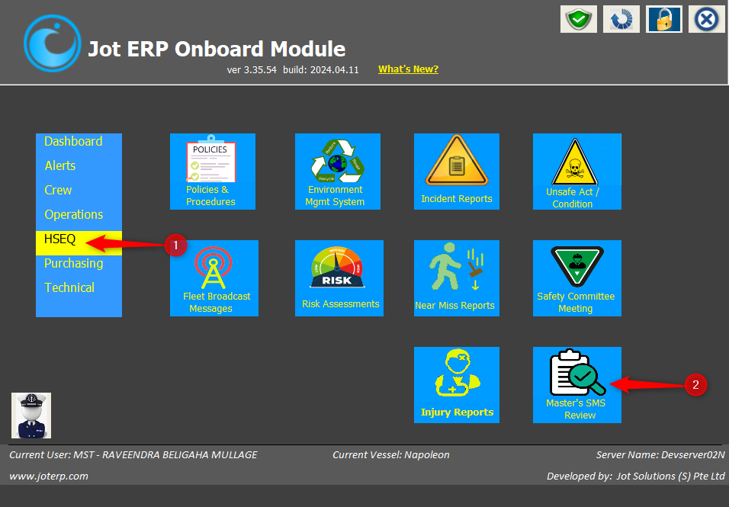

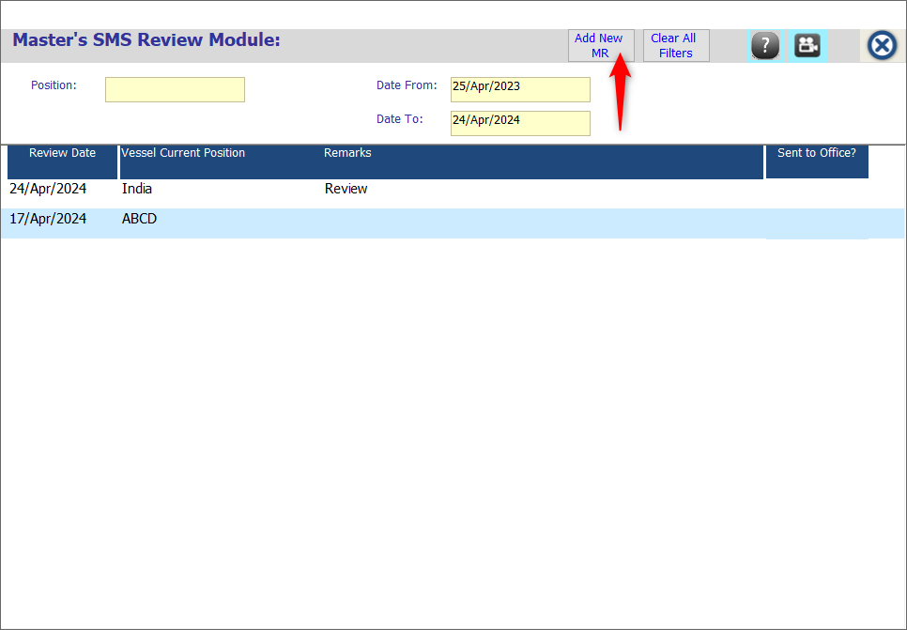
- On new window, click on ‘Add New MR’ button.
- Enter the mandatory details – Meeting Date, Current Vessel Position.
- Now update the tabs separately – Remarks, Procedural Improvements, Procedural Errors & HSE Feedback.
- Then click on ‘Save & Close’ button.
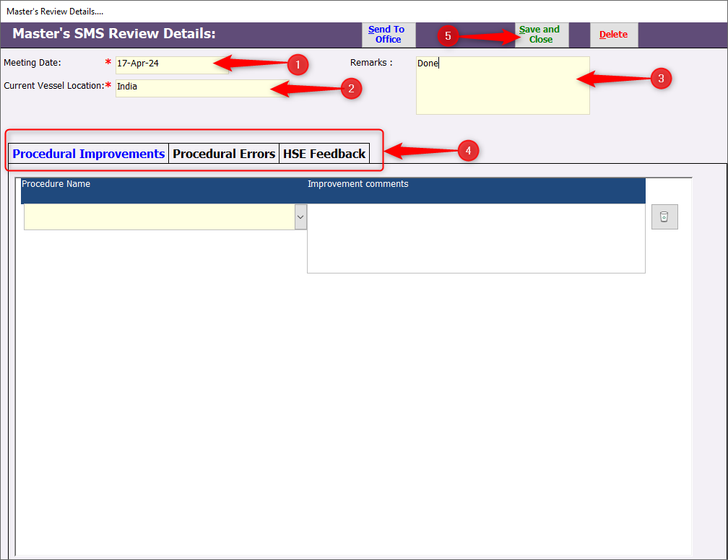

- The Master’s SMS Review will be added to the record with ‘Sent to Office’ status NO.
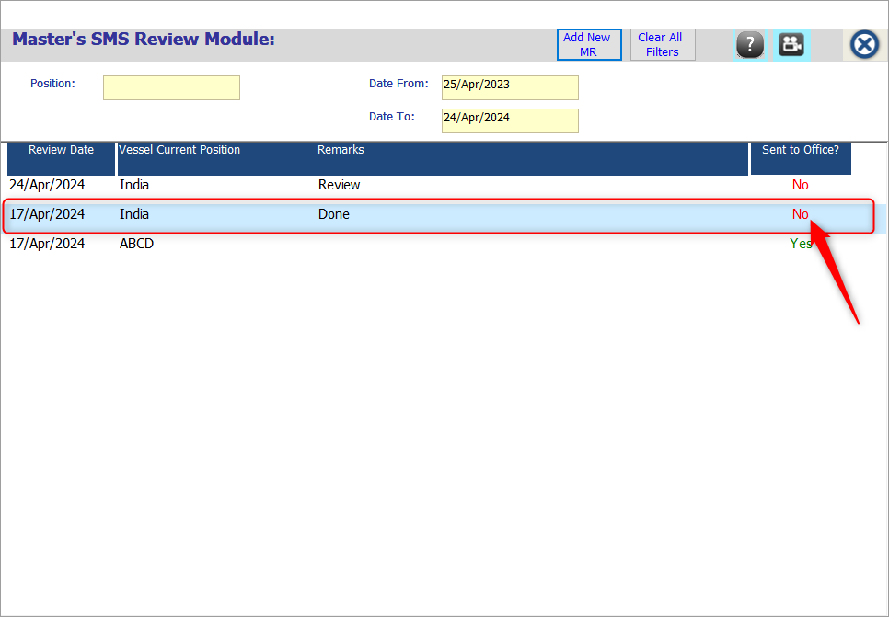

How to UPDATE Procedural Improvements
- Under ‘Procedural Improvements’ tab, select the ‘Procedure Name’ from the dropdown.
- Add ‘Improvement Comments’ and click on ‘Save & Close’.
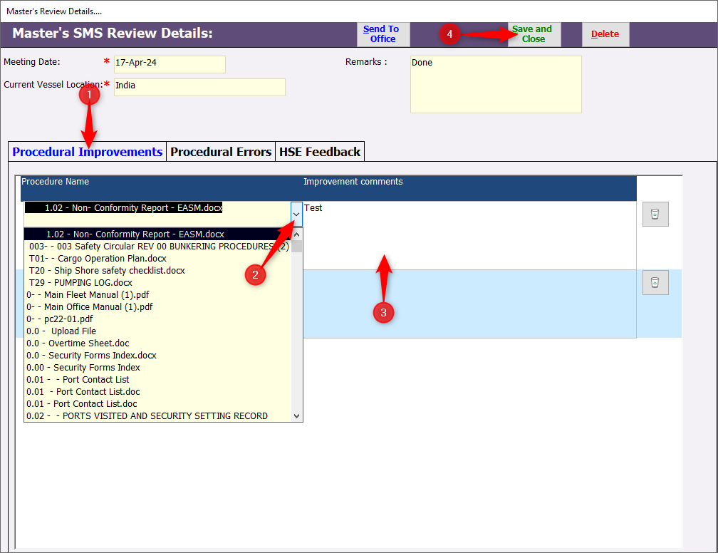

- To delete the entry, click on the ‘Delete icon’.
- Click on ‘Yes’ button, when asked for confirmation.
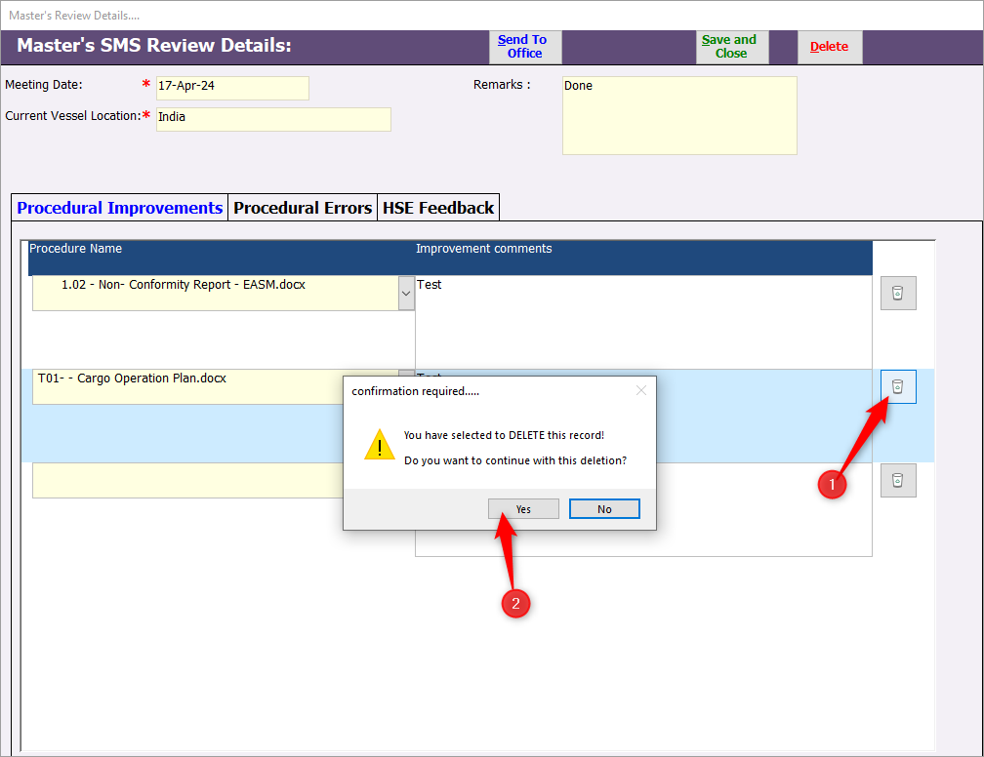

How to UPDATE Procedural Errors
- Under ‘Procedural Errors’ tab, select the ‘Procedure Name’ from the dropdown.
- Add ‘Error Details’ and click on ‘Save & Close’.
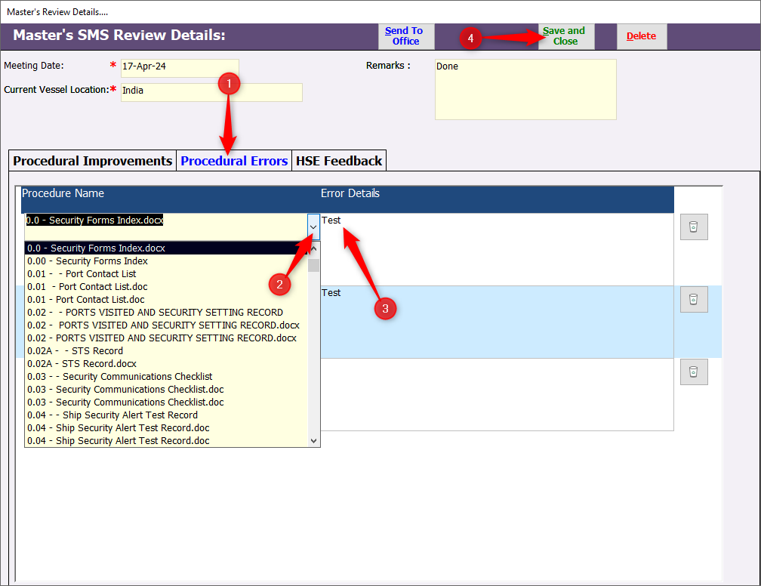

- To delete the entry, click on the ‘Delete icon’.
- Click on ‘Yes’ button, when asked for confirmation.
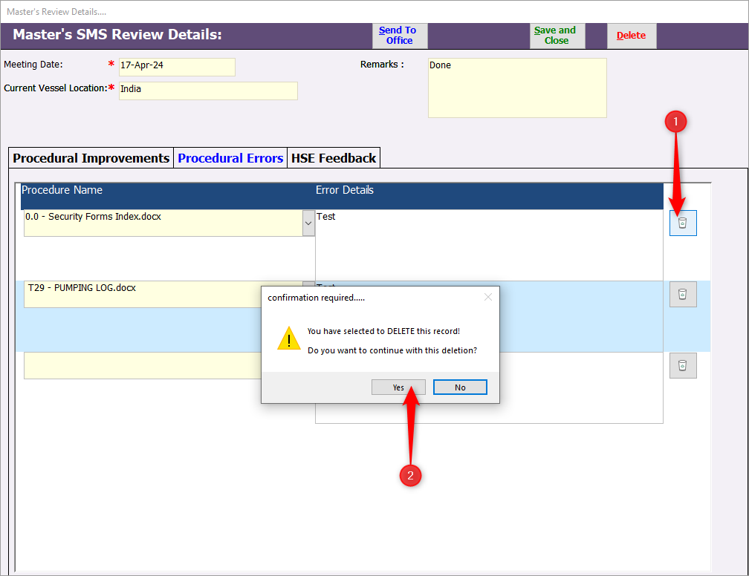

How to UPDATE HSE Feedback
- Under ‘HSE Feedback’ tab, add the feedback details.
- Click on ‘Save & Close’.
- To delete the entry, click on the ‘Delete icon’.
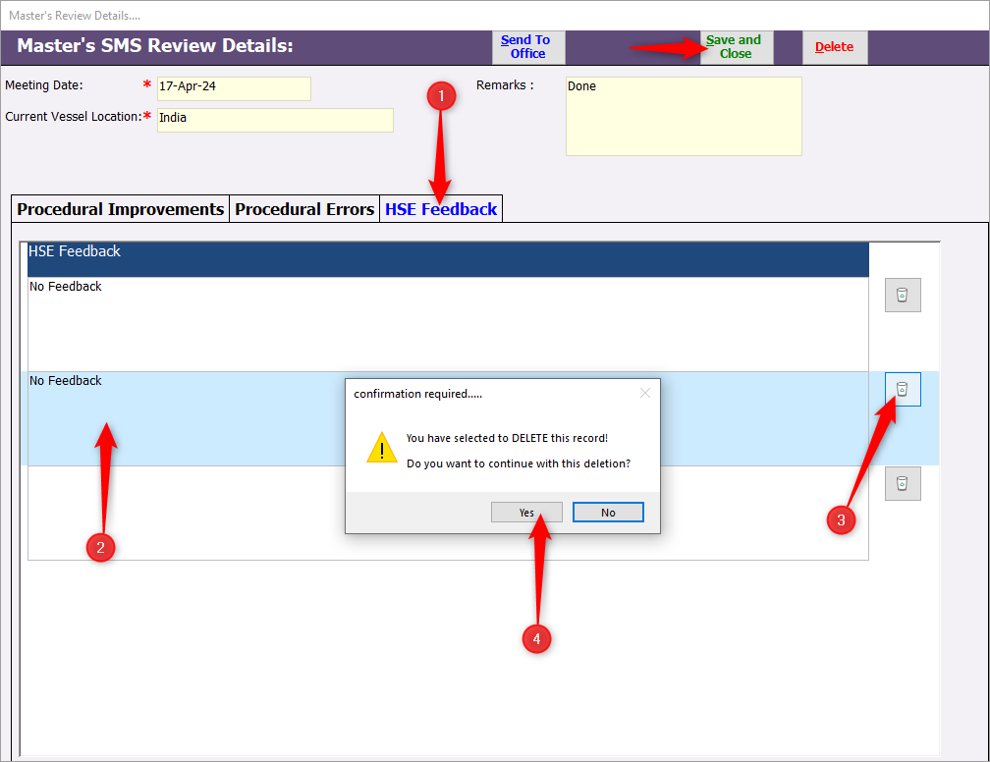
- Click on ‘Yes’ button, when asked for confirmation.

How to SEND the SCM record to Office

- Once all the tabs are updated properly, the Master will make a final review.
- Then click on ‘Send to Office’ button.
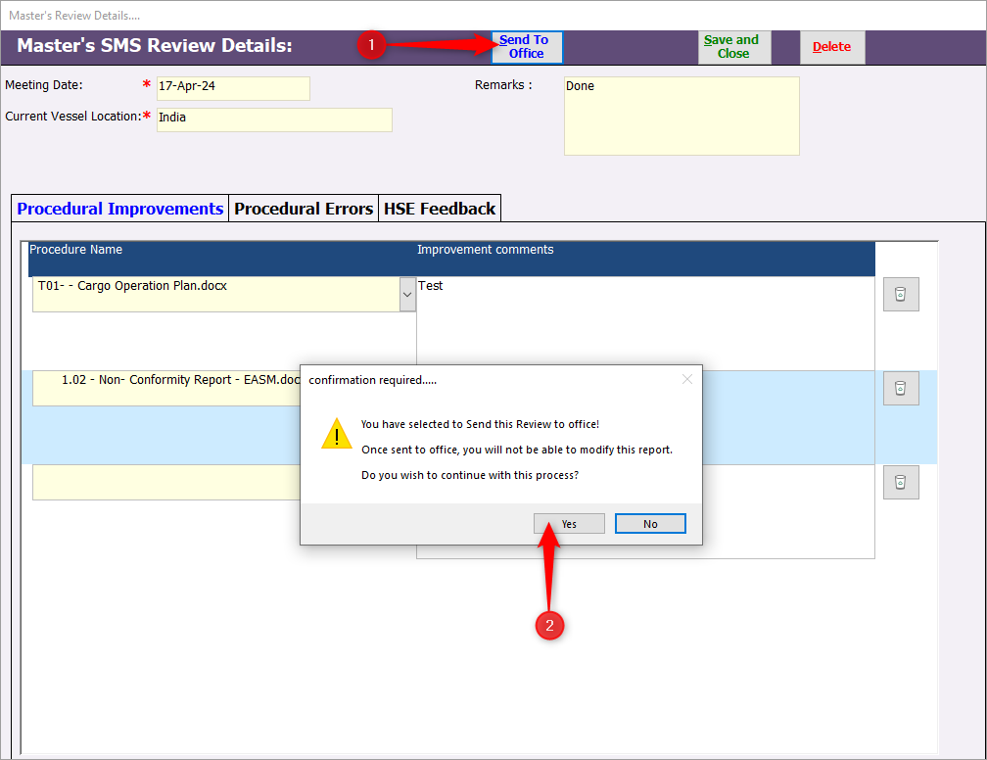
- Click on ‘Yes’ button when prompted for the confirmation.

- The status of ‘Sent to Office?’ on the Index screen changes to ‘YES’.

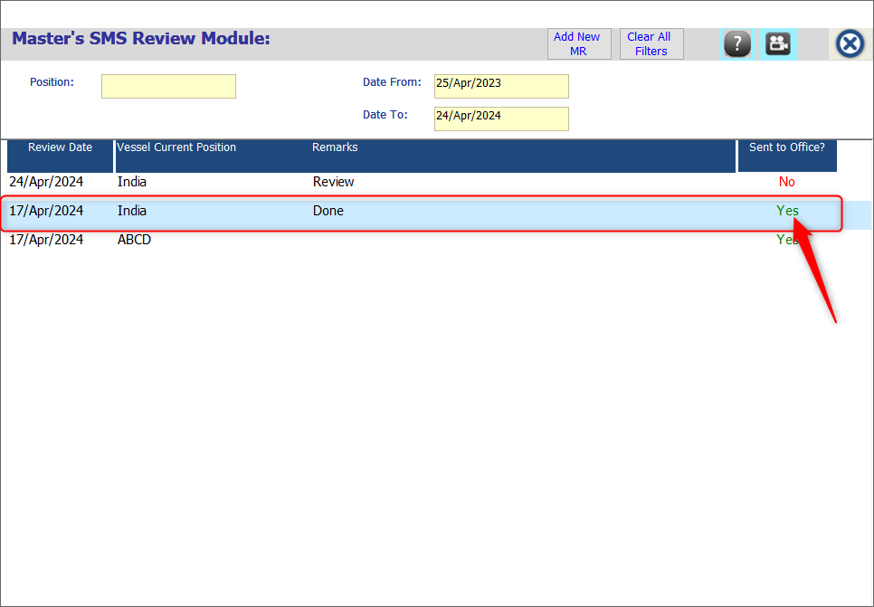

How to DELETE the SCM record
The Master’s SMS Review record can be deleted only if the ‘Sent to Office?’ status is ‘NO’.

- Click & open the Master’s SMS Review record that is NOT yet sent to the office.
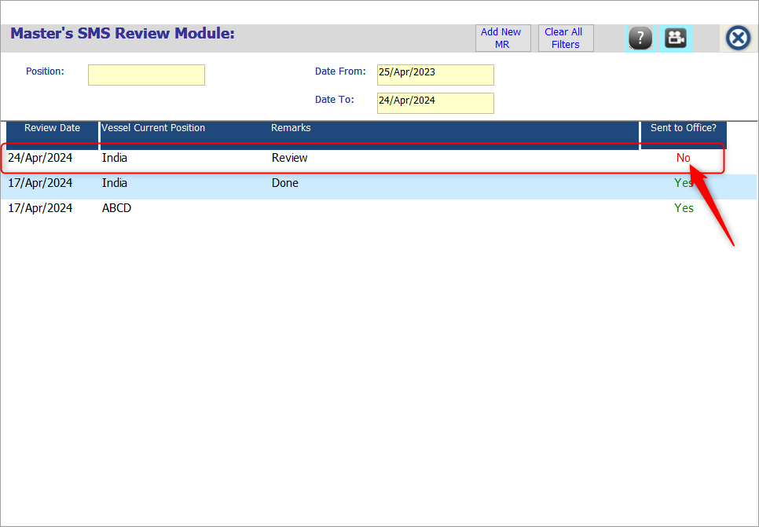

- On the window, click on the ‘Delete’ button.
- Click on ‘Yes’ button when prompted for the confirmation.

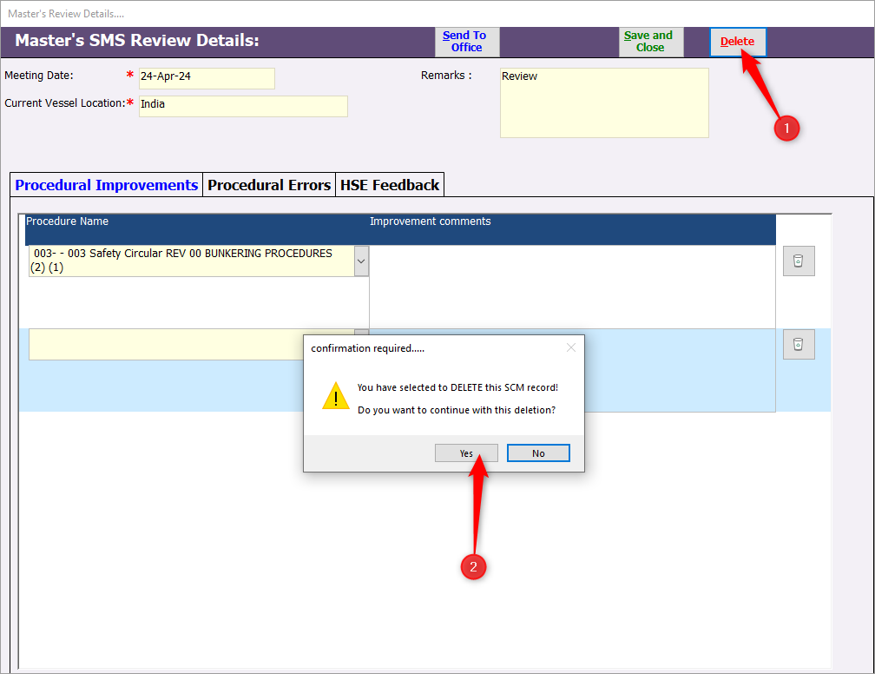

How to SEARCH for a specific SCM record
- On the Index screen of Master’s SMS Review, enter the ‘Position’ & select the ‘Date’ criteria.
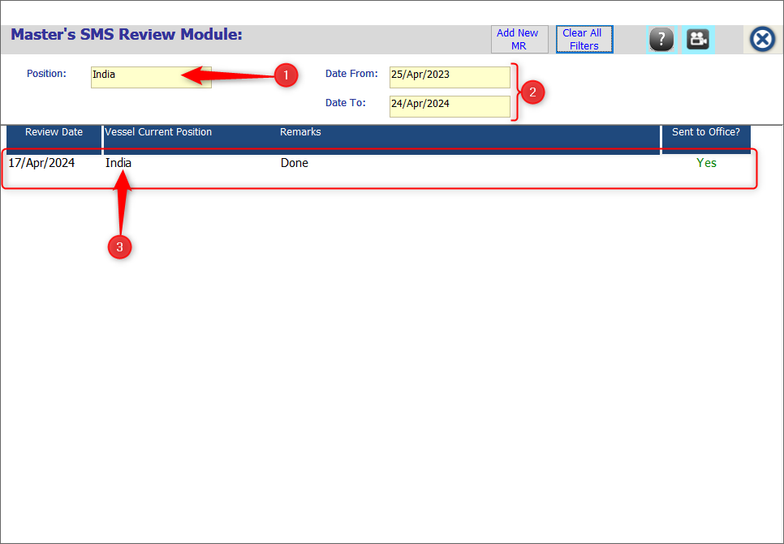
- The respective Master’s SMS Review records will be displayed under the Index screen.

