**NAD REPORTS SYSTEM**

**Table of Contents**

Purpose of the software 2

Controls and your action required. 2

Using the module 3

NAD Report 4

How to Add New Noon Reports 5

How to Add New Arrival Report 10

How to Add New Departure Report 12

NAD Follow-up 14

# Purpose of the software

1. To have a ship-specific list of Noon Reports onboard.
2. Provide vessel with means to record all valid and available information related to the noon reports.
3. Superintendent in the office will be able to view the Noon Reports, on the same day. While at
4. His remarks/instructions

# Controls and your action required.

1. Vessel will update, NAD Reports –
2. Date and time when the report is sent to the office.
3. Details of the noon that was carried out, with specifics, such as –

* Vessel location
* Average speed and distance travelled by the vessel.
* ETA, ETB and ETD
* Fuel/ Oil Consumption
* Tank Cleaning Log for Tankers.
* Line Management for Mooring wires
* BDN document in Departure report

1. Bunkering information.

# Using the module

1. Start the Jot ERP Module from the Desktop.
2. Login into the module using the individual credentials.
3. A screenshot of a computer

   Description automatically generatedAfter login, the STARTUP screen is displayed.
4. In this screen, click the **‘Noon, Arrival, Departure Report’** button, under **‘Operations’** menu.
5. The main screen of the Noon Reports module will open with 3 main functions, as shown below:

* New Noon Report
* New Arrival Report
* New Departure Report

# NAD Report

1. This contains three sections -

* view the list Noon Reports,
* their current status (Sent to office/Not)
* Allow you to add the New Report or edit the existing reports.

1. Once the Noon Report is sent to the office it is not editable.
2. The top middle part of the screen shows filters, for showing information by – Arrival, Departure, Noon Report title From Date and To Date.
3. 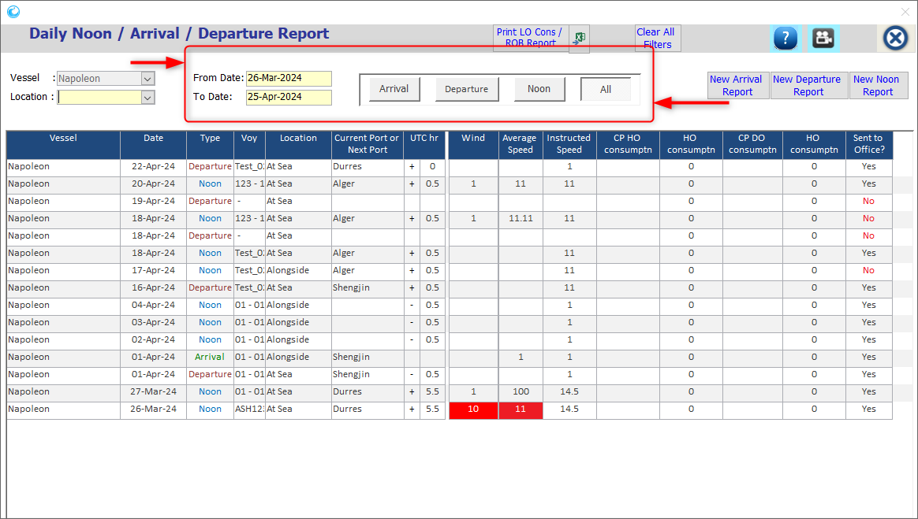In the rest of the screen, each NAD report is represented by a row.

## How to Add New Noon Reports

When a noon report is created out physically by the vessel staff, you need to update details of the noon reports in the Jot ERP using the following steps:

1. A screenshot of a computer

   Description automatically generatedIn the Noon Reports window, click on the “New Noon Report” button on extreme-Top the Window.
2. A new window will open as shown below.

1. In this window, feed all **mandatory** fields of the tabs below –
2. 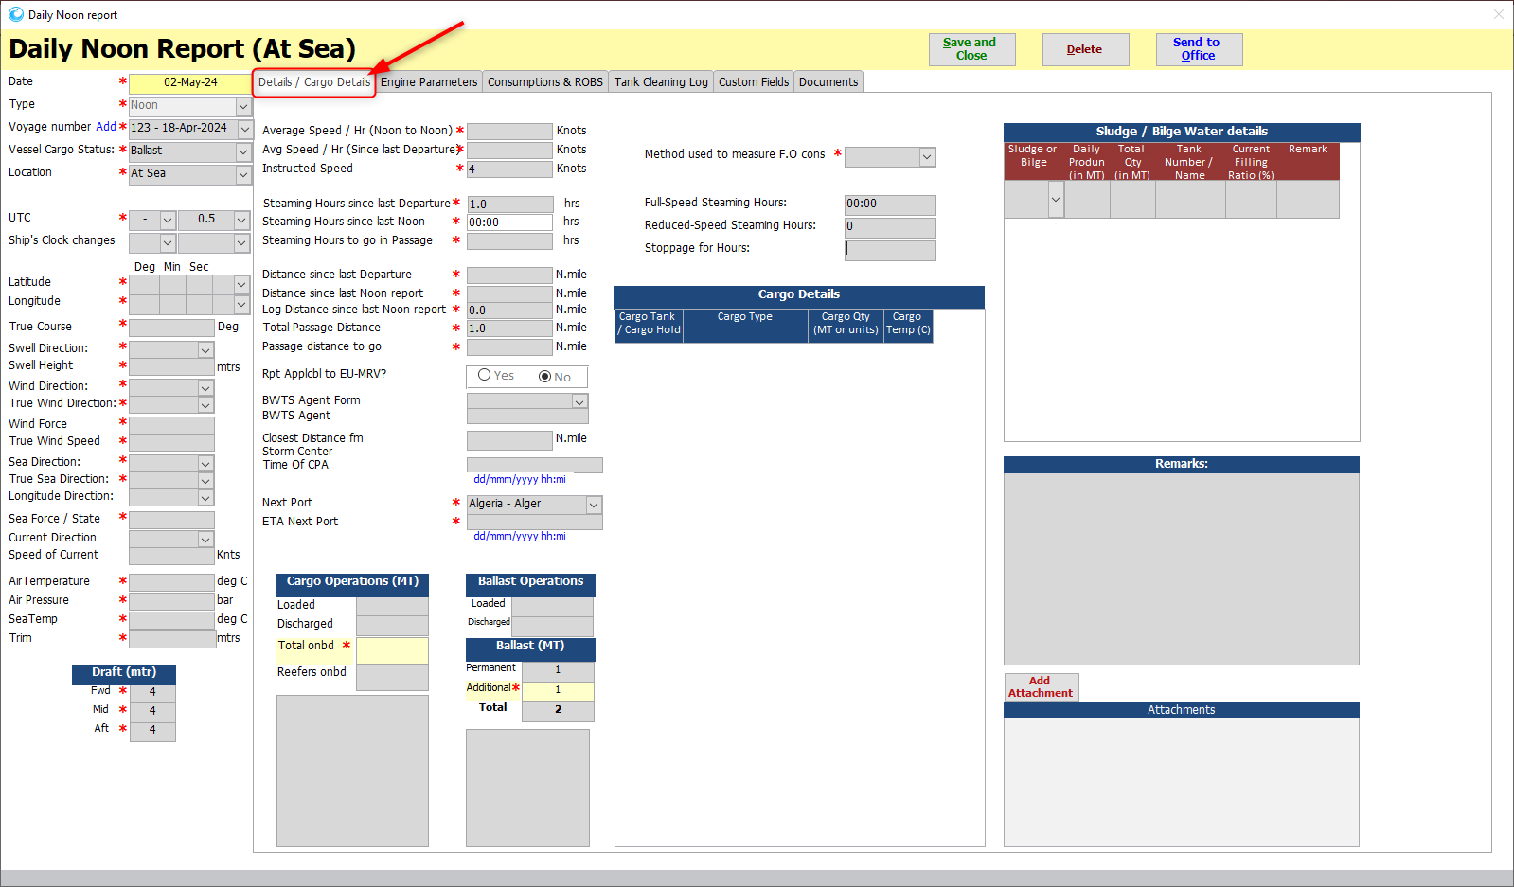**Details/ Cargo Details** – This tab displays the various fields to be filled with their respective values.
3. **Engine Parameters** – This displays the details like: **R/hrs, Thermal Oil Heaters** etc.

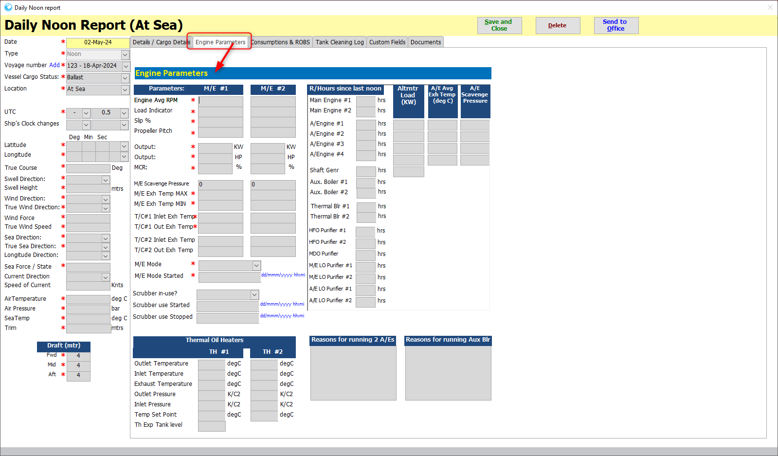

1. **Fuel Consumptions & ROBs** – This gives the details of the Consumptions of the fuel & their remaining onboard.

* Click on the drop-down menu to select the **CONSUMPTION TYPE**.
* Then select the **FUEL TYPE & MACHINERY TYPE** from the drop-down menu.
* Then enter the **CURRENT VALUE** of the same & **REMARKS**, if any.
* 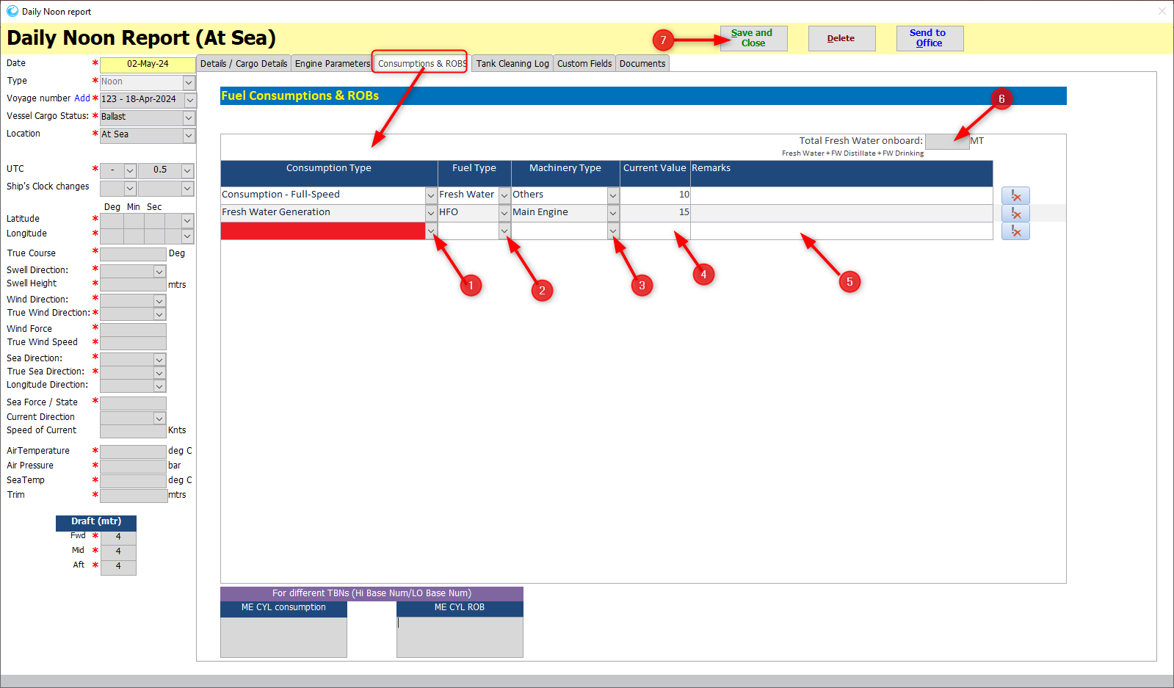Also, enter the **TOTAL** **FRESH** **WATER** **ONBOARD** value.
* While adding the **ROB**, **ALWAYS** select **OTHERS** as **FUEL TYPE**.
* A screenshot of a computer

  Description automatically generatedTo DELETE the record, click on the DELETE icon.

1. **Tank Cleaning Log** –

* From the drop-down menu, select the **Cargo tank/ hold**, the date/ time.
* A screenshot of a computer

  Description automatically generatedTo DELETE the record, click on the DELETE icon.

1. **Customer Fields** – This displays the **TRAIT** details added in the library, to add the **TRAIT VALUE**.
2. **Documents** – In this tab, list of **Documents** to added while sending the report is mentioned.

These documents can be marked as **MANDATORY** as well.

1. After updating all details regarding Noon report then press button SAVE AND CLOSE.

1. This will update Noon Report in the index screen.
2. When the Master or Captain opens this window again, they can see a button “Send To Office” in this screen.
3. They need click this button to send this report to the office.
4. A screenshot of a computer

   Description automatically generatedIf under a case, these details are incorrect, any ship staff can choose to delete this report by using the button DELETE.

## How to Add New Arrival Report

When a new arrival report is created out physically by the vessel staff, you need to update details of the arrival reports in the Jot ERP using the following steps:

1. In the Noon Reports window, click on the “New Arrival Report” button on extreme-Top middle the Window.

1. A screenshot of a computer

   Description automatically generatedA new window will open as shown below.
2. In this window, feed all the mandatory fields.
3. Then press button SAVE AND CLOSE.
4. This will update Arrival Report in the index screen.
5. When the Master or Captain opens this window again, they can see a button “Send To Office” in this screen. They need to click this button to send this report to the office.

1. A screenshot of a computer

   Description automatically generatedIf under a case, these details are incorrect, any ship staff can choose to delete this report by using the button DELETE.

## How to Add New Departure Report

When a new department report is created out physically by the vessel staff, you need to update details of the departure reports in the Jot ERP using the following steps:

1. A screenshot of a computer

   Description automatically generatedIn the Noon Reports window, click on the “New Departure Report” button on extreme-Top left the Window.
2. In new window, feed all the mandatory fields & ‘Save & Close’ button.

1. This will update Noon Report in the index screen.
2. A screenshot of a computer

   Description automatically generatedWhen the Master or Captain opens this window again, they can see a button “Send To Office”. They need click this button to send this report to the office.
3. A screenshot of a computer

   Description automatically generatedIf under a case, these details are incorrect, any ship staff can choose to delete this report by using the button DELETE.

# NAD Follow-up

All the follow up comments added by office or ship are visible in a new screen called NAD FOLLOWUP INDEX.

Follow-ups are added only after the NAD reports are sent to the office, using the following steps:

1. Open any NAD report whose SENT TO OFFICE status is YES.
2. On the top-right side of the screen, we have a button FOLLOWUP.
3. Click on the FOLLOWUP button.
4. The FOLLOWUP DATE & FOLLOWUP BY details will be automatically displayed.
5. Enter the FOLLOWUP remarks.
6. A screenshot of a computer

   Description automatically generatedClick on SAVE button.
7. A screenshot of a computer

   Description automatically generatedThe FOLLOWUP will display on the below Index.
8. A screenshot of a computer

   Description automatically generatedAlso, it will separately display in the NOON REPORTS FOLLOWUP module, as below.