Planned Maintenance System

A) Purpose of the software 2

B) Controls and your action required 2

C) Using the module 3

* PMS STATUS 4
* HISTORY OF JOBS DONE 8

D) RUNNING HOURS 9

* Current Status 9
* Running-Hours’ History 10
* Weekly Update 11

E) DEFERRING PMS JOBS 12

* Process Flowchart 12
* How to Defer a PMS Job 13
* How to VERIFY a Defer Request 14
* How to view Superintendent response to Vessel Defer Request 16

# Purpose of the software

1. To have a ship-specific list of Planned Maintenance jobs Onboard.

2. Provide vessel with means to record all valid and available information related to the job

3. At the end of each month, report to the Office, list of Overdue jobs with –

* Reasons why it is overdue, including any associated and pending requisition numbers.
* Planned completion date

4. Superintendent in the office will be able to view the progress on jobs done, on the same day. While at month-end, he will respond to the ship’s Overdue PMS jobs with –

* His remarks/instructions
* Approved completion date

5. Allow Vessel to raise DEFERMENT REQUEST for one or multiple PMS Jobs

6. Allow vessel to raise change requests (coming soon in the Jot ERP) for jobs that are –

* Not applicable to your vessel
* Missing in the list
* Changing defined frequency of jobs
* Assigning it to different department / rank

# Controls and your action required

1. Vessel will update, for each job –

* 1. Date when job carried out
  2. Running Hours of the machinery, when the job was carried out
  3. Details of the work that was carried out, with specifics, such as –
     1. Conditions of the internal parts when the machinery was dismantled,
     2. Spare parts replaced, including their types/models, such as Bearing numbers when bearings have been renewed.
     3. Various clearances and measurements taken during overhauling
     4. Parameters checked during testing, after boxing back the equipment.
     5. Photographs to be attached
     6. Forms, such as decarb report to be attached

2. Jobs updated will still require VERIFICATION by Master, Chief Engineer or Chief Officer.

3. Every week, update running hours for the machinery in Jot ERP.

4. Vessel can request for Deferment for a PMS Job and seek Superintendent’s approval for same.

5. List of Overdue PMS jobs at each month-end to be sent to the office.

6. Make the PMS listing ship-specific, by asking for relevant change requests.

# Using the module

1. Start the Jot ERP Module from the Desktop.
2. After login, the STARTUP screen is displayed.
3. In this screen, click on Technical tab present on the dashboard as shown below.
4. 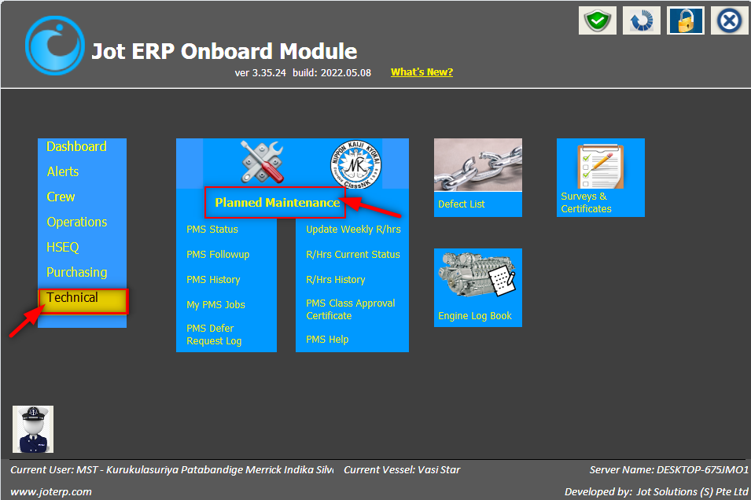And you can see the Planned Maintenance Module, under this sub modules are present

PMS STATUS - Allows you to view the complete list of PMS jobs

1. The screen is divided into two sections; in the above section we have search criteria as Machinery, Sub-catalogue, and Job title, Department, Criticality, CMS and Due Dates.
2. In the below section, we can view the list of jobs under Job Title with their respective Job Codes.
3. The frequency of jobs is mentioned in terms of Months, Hours, and Days.
4. 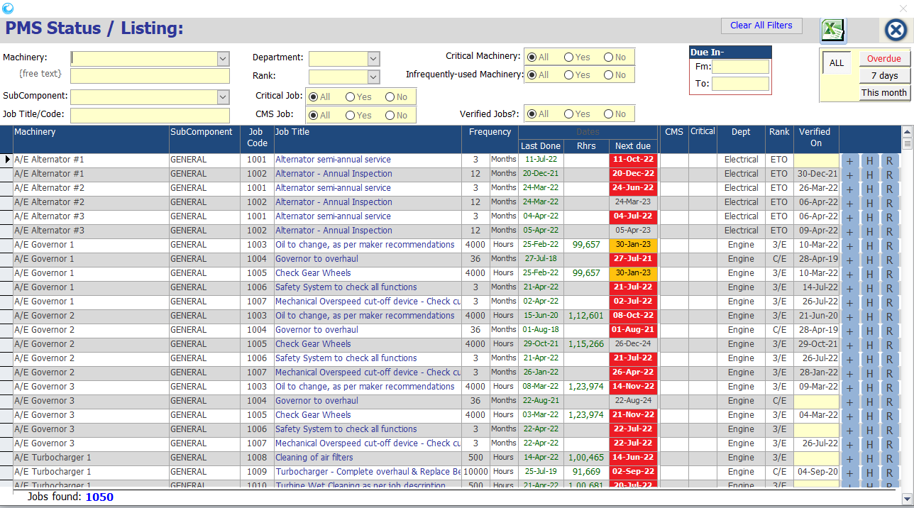The amount of work already done, the last updated date and Next due date are also mentioned.
5. PMS jobs need to be verified by Master, Chief Officer, and Chief engineer. After the verification only we can add a new history record for that PMS Job.
6. You can update the DATE/RHOURS done and history comments.
7. The jobs for which Next due date has passed and are still pending, the Next due dates are highlighted in RED.
8. The jobs for which due dates are near i.e. in next 30 days it will highlight yellow
9. To view –
   1. Details of a job and its status click on the job row.
   2. On clicking the “H” button on extreme-right of each job, a new window will open to show history of that job.
   3. On clicking the “R” button on the extreme-right of each job, a new window will open to show the history of running hours of that machinery.
   4. We can add new record for a verified job using the “+” sign present on the extreme-right of each job.

k) When a job is carried out physically by the vessel staff, you need to update details of the work done in the Jot ERP using the following steps:

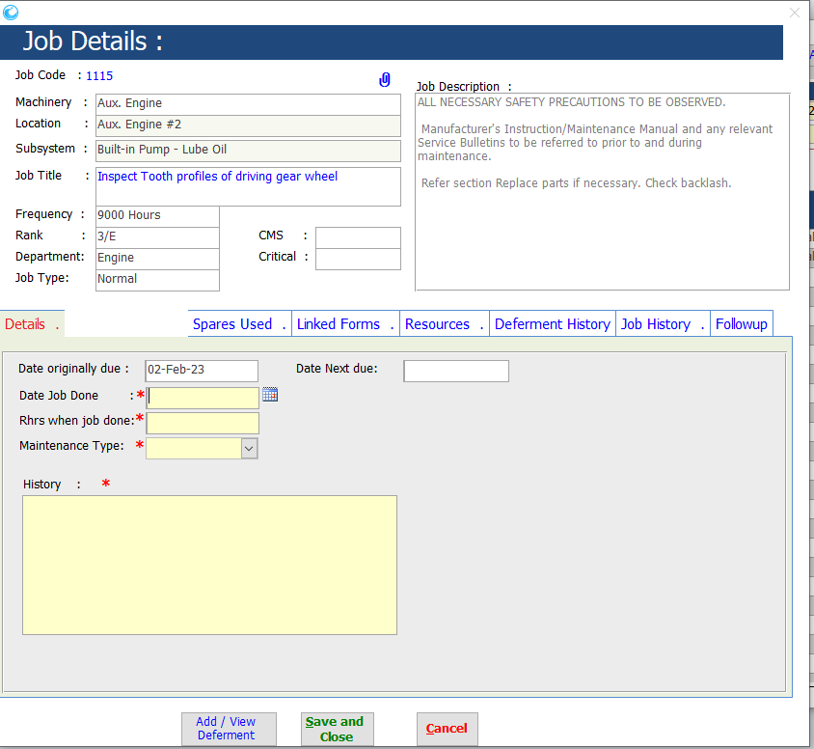 a. In the PMS STATUS / LISTING window, click on the “+” button on extreme-right of that job.

b. A new window will open as shown below:

c. In this window, feed the yellow-coloured fields:

* + 1. DATE JOB DONE
    2. RUNNING HOURS WHEN JOB DONE – only for jobs whose frequency is based on Running hours.
    3. HISTORY –
* Conditions of the internal parts when the machinery was dismantled.
* Spare parts replaced, including their types/models, such as bearing numbers when bearings have been renewed.
* Various clearances and measurements taken during overhauling.
* Parameters checked during testing, after boxing back the equipment.
  1. Then press button SAVE AND CLOSE.
  2. This will update status of that job in the STATUS screen.
  3. When the Chief Engineer, or Chief Officer or the Master open this window again, they can see a button VERIFY JOB in this screen, as shown below:

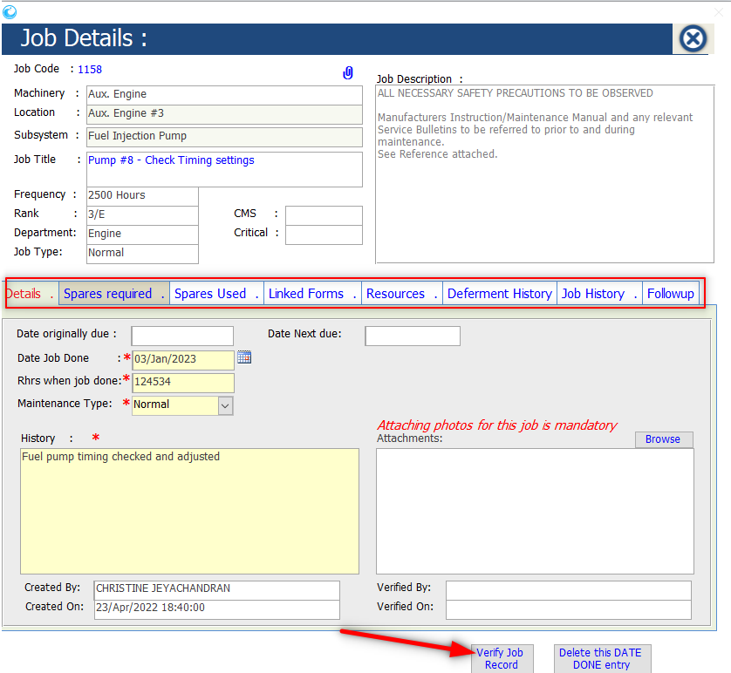

* 1. They need click this button to verify this job, only then this job will be updated and go to the office.
  2. If under a case, these details are incorrect, only the Master/Chief Engineer/Chief Office can choose to delete this job by using the button DELETE THIS DATE DONE ENTRY.
  3. In this window you can also view the Spares required, Spares used, Linked forms (If the PMS job has forms attached), Resources and Job History.

**SPARES REQUIRED**- It will display the spare materials required for the PMS job.

**SPARES USED**- It will display the spare parts used in completing the PMS job.

**LINKED FORMS**- We can view the assigned forms to a PMS job using this tab.

**RESOURCES**- In this tab, you can find the references related to the PMS job.

**JOB HISTORY**- In this tab, you can find the job history related to a PMS job.

**DEFERMENT HISTORY:** If any deferment history or request is there, it will be visible here

**NOTE:** Incase an incorrect PMS Job has been verified on the vessel side. The authorized user from office side can still unverify from the office side ERP. Also, they need to mention the valid reason for the changes done in the Job done blank, the same will be reflected on the vessel side after synching from the office side using the Jot synchronizer.

For example: You can refer the below image in which the comments have been updated by the office user and the same are being reflected on the vessel side after doing synchronization.

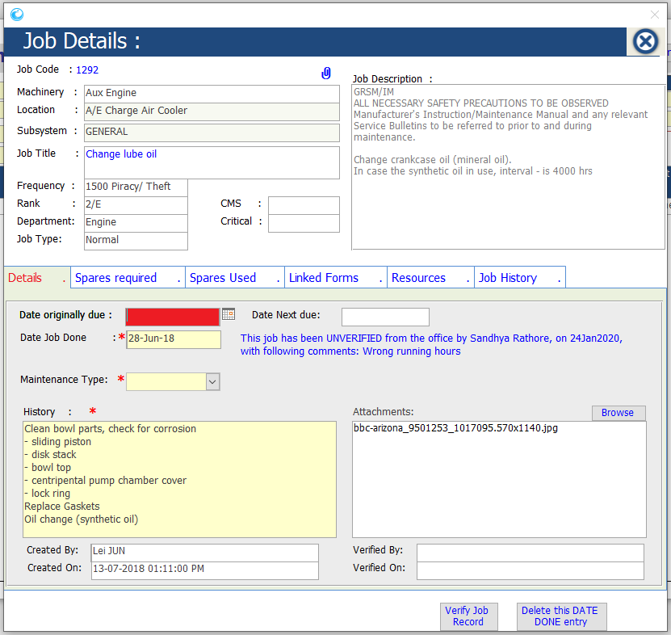

HISTORY OF JOBS DONE

1. This section allows you to view the past records of the PMS jobs for all/one machinery, one sub-catalogue, and Job title, Department, Criticality, CMS and Due Dates.

2. On the PMS main screen, click on the button HISTORY OF JOBS DONE

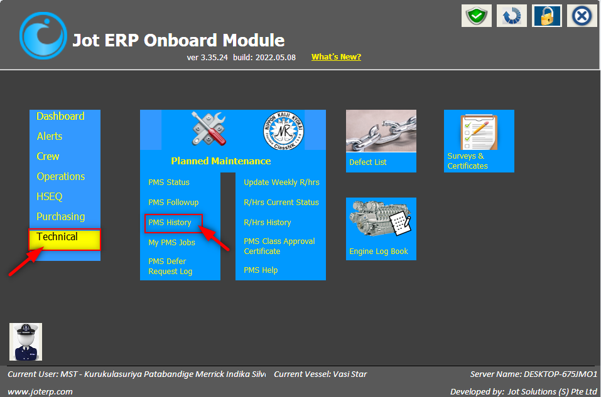

3. This will open the PMS history screen, as shown below:

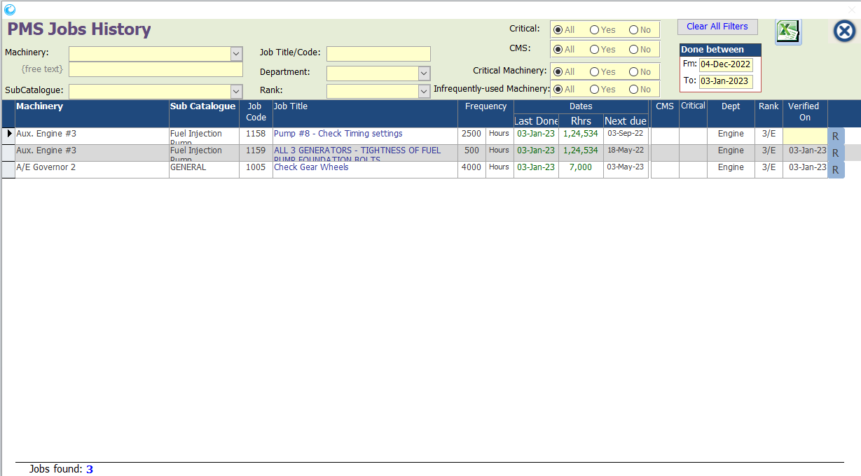

4. It displays the history of jobs already done. This is only in READ-ONLY mode.

5. We can also see the current running hours for machinery using the button “R” present on extreme right side.

## D) RUNNING HOURS

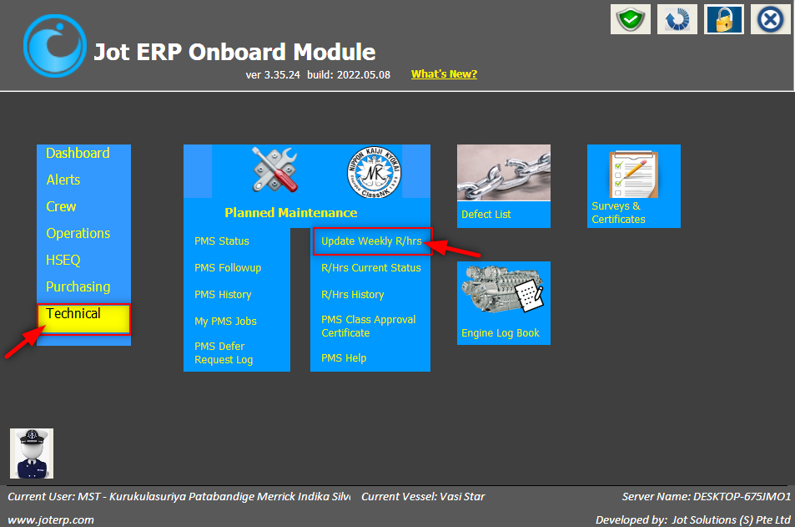

***Note: In the Jot ERP PMS module, ALWAYS feed the TOTAL running hours in all screens where the running hours have to be updated. NEVER feed running hours for machinery since its last overhaul.***

This contains three sections –

1. Current Status
2. History
3. Weekly Update

### **Current Status**

1. This will open the latest set of running hours saved in the Jot ERP module for all machinery, as shown in the screenshot below:

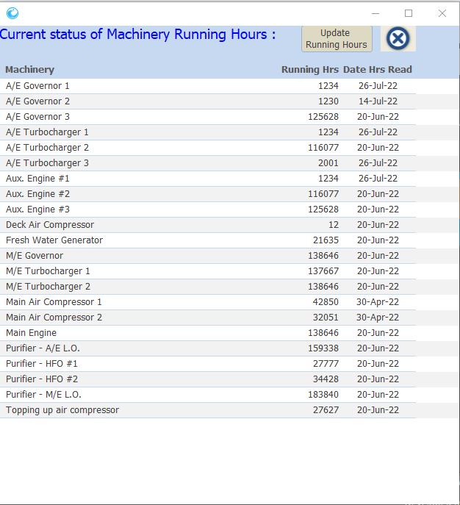

### **Running-Hours’ History**

1. This button will open the running hours as saved for each machinery in a sequential manner (Starting from the recent date), as shown below.

2. Purpose of this screen is primarily linked to the jobs under this machinery.

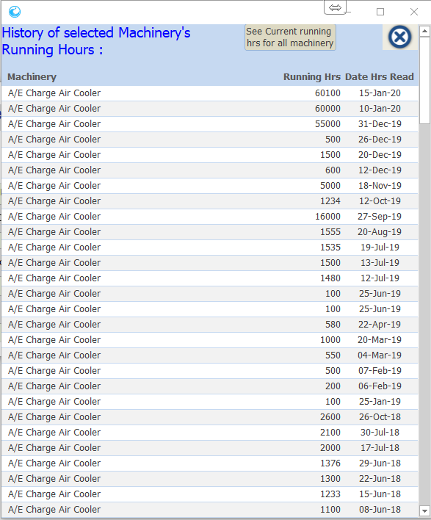

### **Weekly Update**

1. This option is to be used at the end of the week to update the latest running hours of the selected machinery.

2. When you select this option, the below window will open displaying the last running hours updated for each machinery.

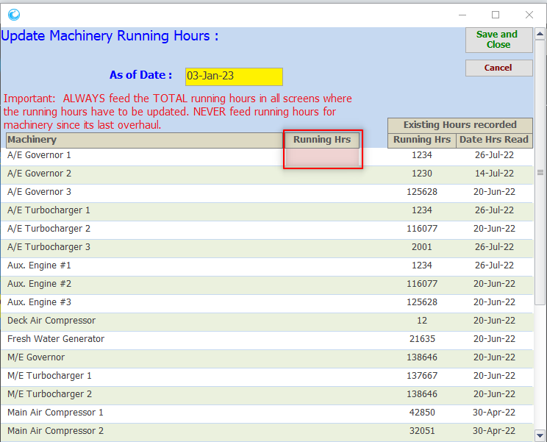

1. In this screen, update the DATE when you took the readings of the running hours for machinery.
2. Then go to “RUNNING HOURS” column for each machinery and update its running hours, as recorded on the YELLOW-COLORED-DATE.
3. If you do not want to update running hours for any machinery, simply leave the column RUNNING HOURS empty for that machinery.
4. Once this is done for one/more/all machinery, then click the button SAVE AND CLOSE.
5. This will recalculate the DATE DUE for each job for that machinery, based on the latest running hours that you have updated.

## DEFERRING PMS JOBS

## 

Based on your company’s policies, you may NOT be able to defer a CRITICAL PMS Job

All users of the Jot ERP Onboard module can raise a new Defer Job Request, with REQUEST TO DEFER DATE and REASONS

Superintendent’s response will then be visible in the ship-side menu PMS DEFER JOB LOG.

***If request has been approved, it will modify the NEXT DUE DATE accordingly***, and will also display in the PMS JOB tab “Deferment History”.

This Approval / Rejection will then sync to the ship, in the next Jot Data Packet

The Superintendent in the office, will then be able to APPROVE this request with the same DEFER REQUEST DATE or modify same,  
  
**OR**, he may choose to REJECT the request, with reason.

Only Master or Chief Engineer can VERIFY this request.

This request, upon verification by Master or C/Engineer, will be forwarded by system to the office side, in the next Jot Data-Packet

### How to Defer a PMS Job

1. In the STARTUP form, click on PMS STATUS
2. The PMS STATUS screen will open.
3. Search the job that you wish to defer, using various filters provided in this screen, like MACHINERY NAME and/or JOB TITLE
4. Once the required job is identified, click on the JOB TITLE.
5. The JOB DETAILS window will open, as shown below.

6. Click on the button ADD / VIEW DEFERMENT. The following window will open.

7. In this window:

* 1. Update the DEFER TO DATE – date to which you want to defer this PMS job to
  2. REASONS FOR DEFER REQUEST – provide detailed explanation as to why it should be deferred.
  3. Click on green-coloured SAVE REQUEST button

8. If you want to add attachments to your request, in the PMS JOB screen, click again on button ADD / VIEW DEFERMENT, and in DEFERMENT REQUEST window, click on button BROWSE (top-right side), to select one or multiple files.

9. Once saved, this request will then be visible in the PMS DEFER REQUEST LOG

How to VERIFY a Defer Request

1. Only the Master or Chief Engineer can verify a Defer Job Request.
2. Go to PMS DEFER REQUEST LOG screen.
3. Click on filter REQUEST VERIFIED? to NO
4. Graphical user interface, text, application

   Description automatically generatedThe list of PMS Defer requests made, but not yet VERIFIED by Master/Ch.Engineer will be displayed.
5. Click on the PMS Job, that you wish to verify.
6. The JOB DETAILS screen will open.
7. Click on button ADD/VIEW DEFERMENT
8. The PMS DEFERMENT REQUEST window will open.
9. In this window, you can modify the DEFER TO DATE, put your VERIFICATION REMARKS
10. Click on VERIFY REQUEST button, to complete the verification process.

### How to view Superintendent Response to Vessel Defer Request

There are two ways to view Superintendent’s response to the vessel’s PMS DEFERMENT REQUESTS

**Option-1:**

1. In the STARTUP screen, click button PMS DEFER REQUEST LOG
2. 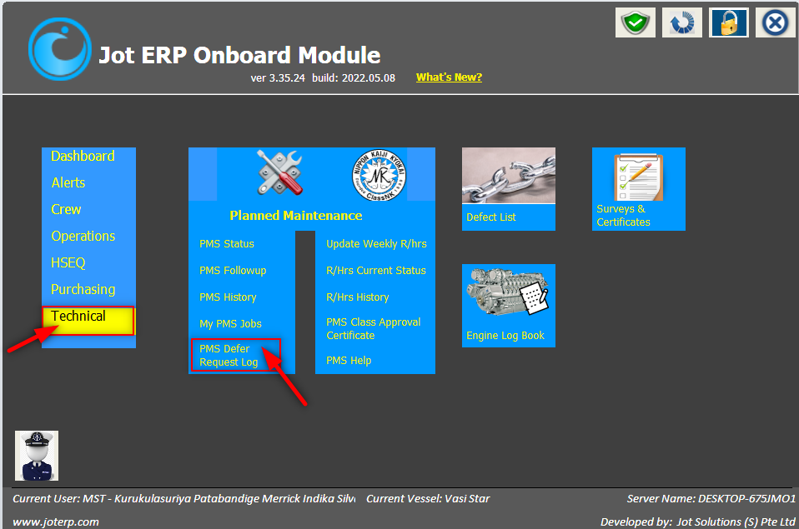This will open the PMS DEFERMENT LOG screen.
3. In this INDEX screen, click on filter REQUEST ACTIONED to YES
4. The screen will then display all your requests which have been actioned by the vessel Superintendent in the office.
5. The extreme-right cell **APPROVED?** for each request, will display the result of your request.
6. However, to read his comments for this APPROVAL / REJECTION:
   1. Click on the PMS JOB to open the job details window.
   2. In this window, click on tab DEFERMENT HISTORY
   3. That will display the approved defer date and name of the Superintendent and his remarks.

**Option-2:**

1. In the PMS STATUS screen, click on the PMS job to open the JOB DETAILS screen.

2. In this JOB DETAILS screen, click on DEFERMENT HISTORY to view the superintendent’s response to your request.

