PORT ACTIVITIES

Table of Contents

Introduction 2
Purpose 2
Controls & Actions Required 2
Using the module 3
To Add Follow-up: 5

Introduction
During a vessel's port call, various activities take place to ensure efficient cargo handling, crew management, and vessel maintenance. These activities include loading and unloading of cargo, bunkering (refueling), provisioning (supplying with food, water, and other essentials), waste disposal, and crew changes.

Purpose
- To provide details of activities to be carried out at a particular port. This information is provided by the office.
- To view and maintain a log of the activities carried out by the vessel at port.

Controls & Actions Required
- All the Crew members can update the details in Port Activities.
- Vessel can only add follow ups for Planned, Confirmed, Deferred and Cancelled stages.
- Vessel cannot add New Port Activity.

Using the module

- To open the module, click on Port Activities, under Operations menu on the DASBOARD page.
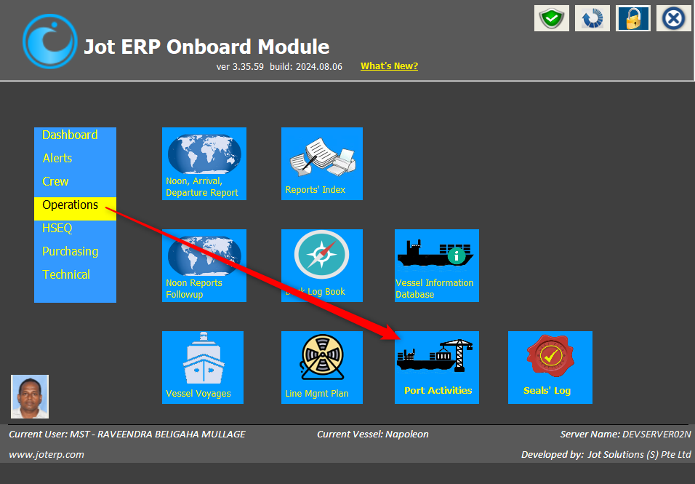

- A new window will open displaying the Port Activities in various stages
- Planned
- Confirmed
- Completed
- Deferred
- Cancelled

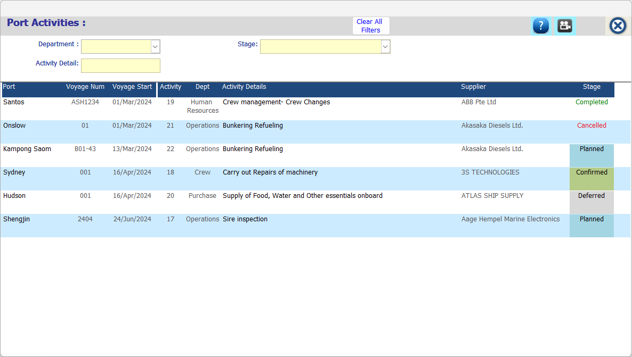
- Click on the activity under PLANNED OR CONFIRMED stage to open and view the details. Port Activity Details window will open.
- You can view the activity details.
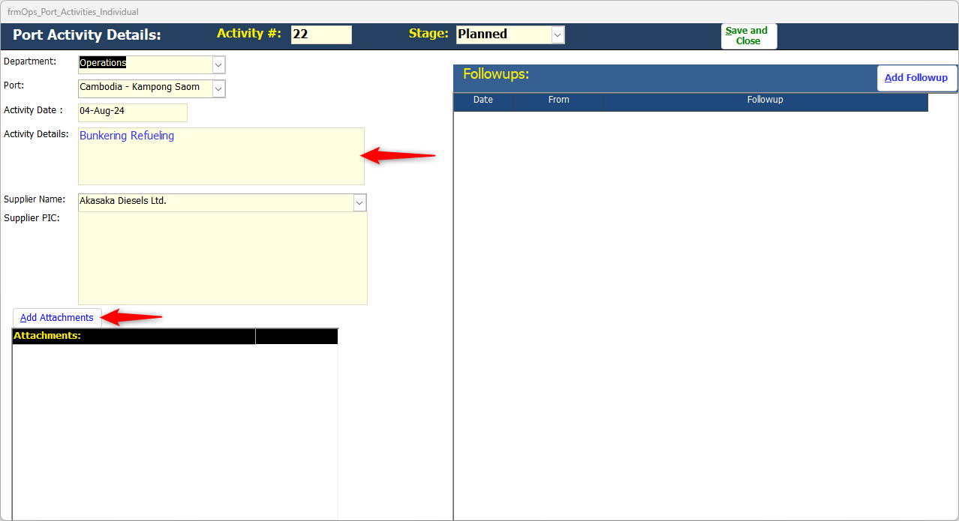
- Add Attachments if any.

To Add Follow-up:
- Click on the ADD FOLLOW UP button to add the follow up details.
- New Follow Up window will open. Add the follow up and attachments if any.
- And click on the SAVE & CLOSE button.
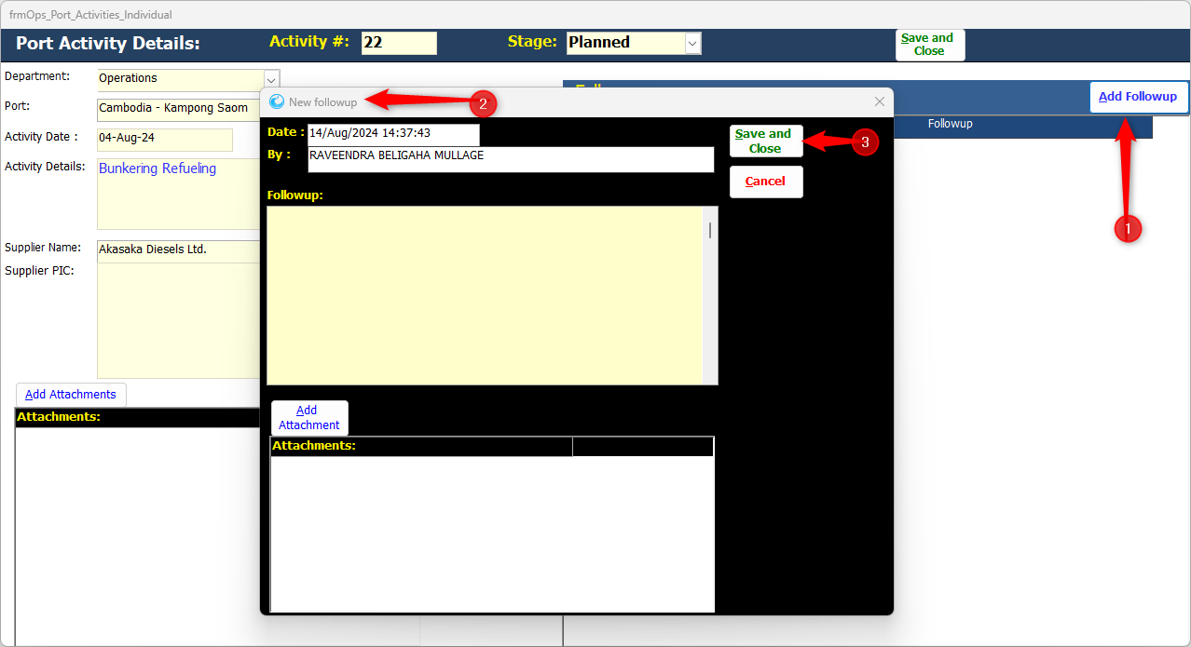
- The said follow-up will be added.

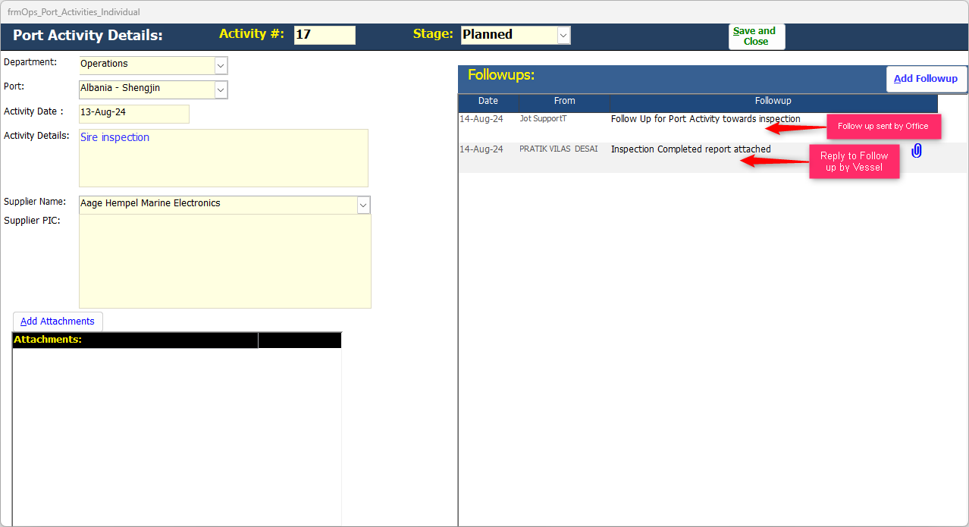
5. Follow-up details can be viewed on the left.

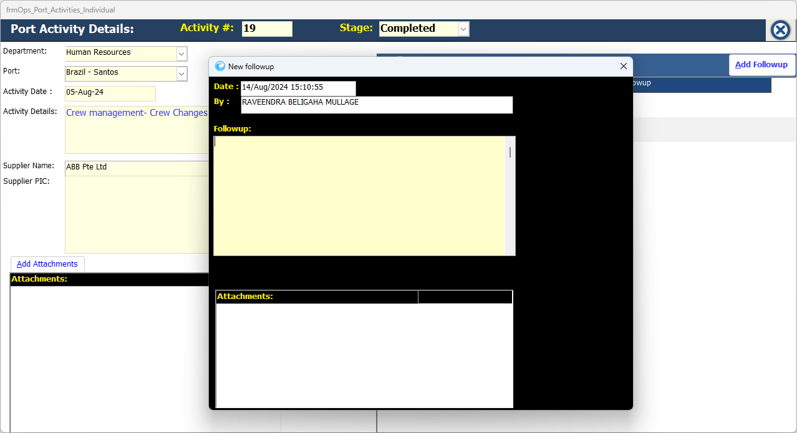
Note: Follow -Up cannot be added for activities in Completed Stage. Save and Close/ Cancel Tab is not available.
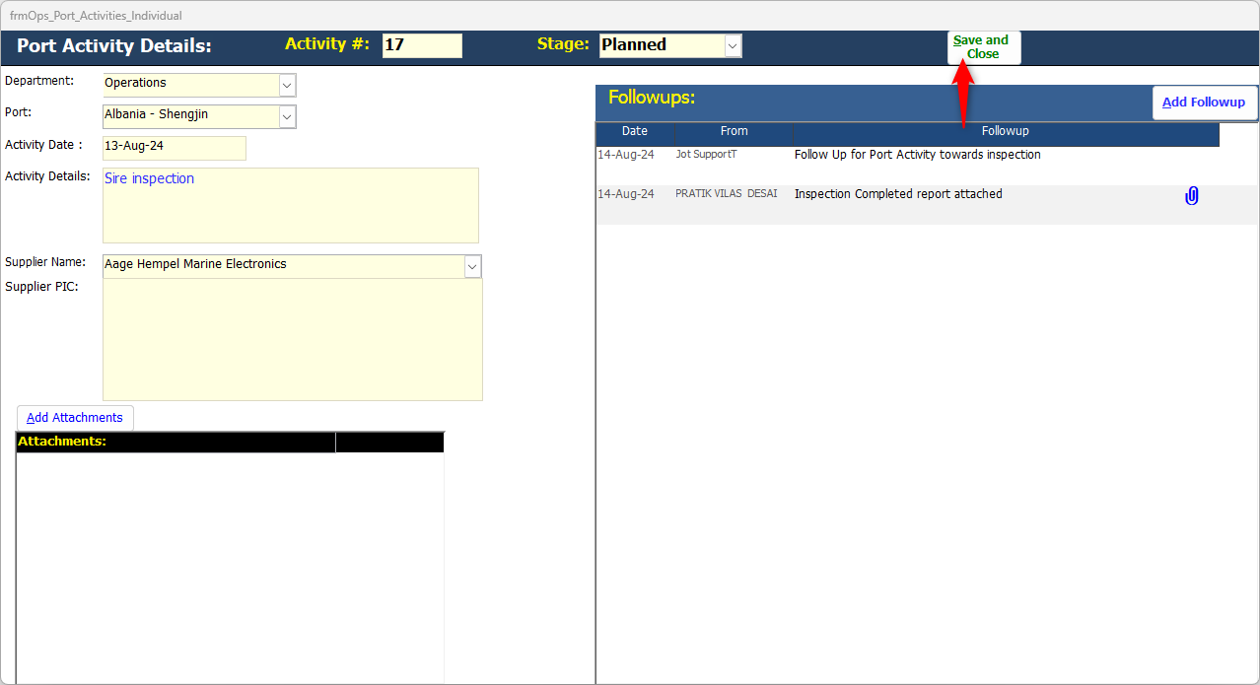
- Click on Save and Close button.

- Stages- Completed, Deferred and Cancel are for viewing purposes.

- Follow-up can be added for Deferred and Cancel Stages.

