POLICIES AND PROCEDURES

Table of Contents

Purpose 2
Controls 2
Using the module 3
To View Report 7

Purpose

- The procedures are uploaded by the office.
- The purpose is to Search and View the Procedures from the designated folders.
- This has all the vessel docs, manual, checklists, policies, procedures, audit reports, inspection reports etc.

Controls
- These are read-only files and changes cannot be made in these documents.

Using the module

- Start the Jot ERP Onboard Module from the Desktop.
- After login, the STARTUP screen is displayed.
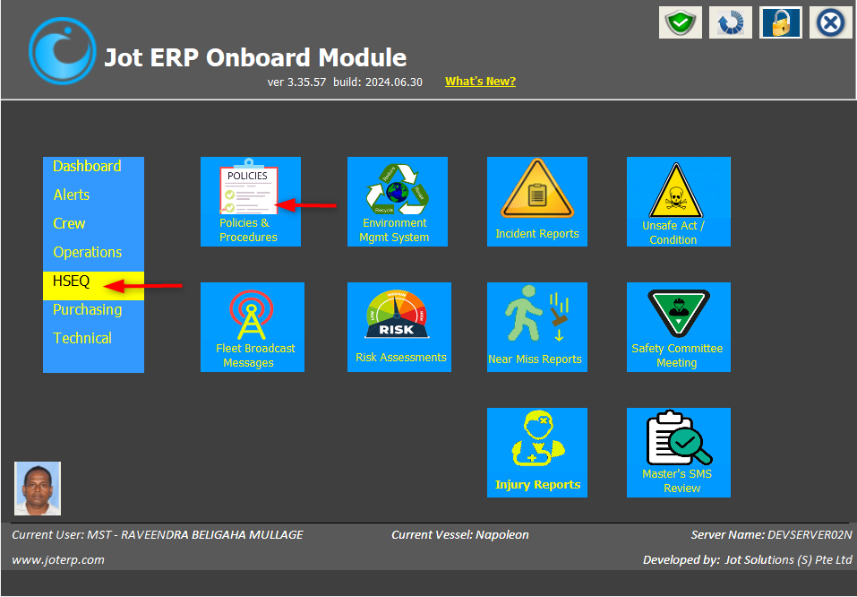
- In this screen, click on Policies and Procedures under HSEQ menu.

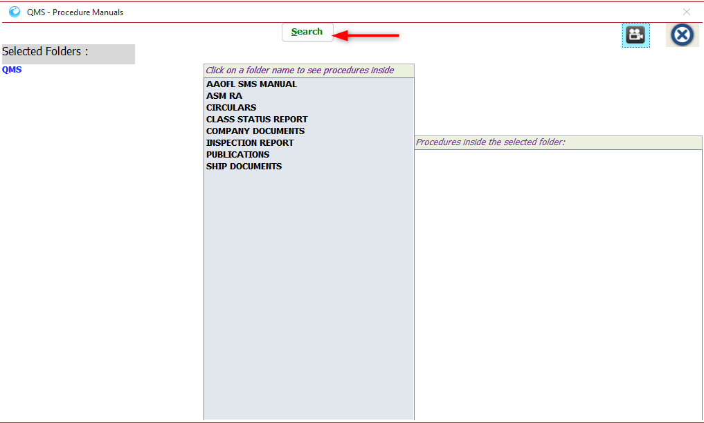
- The main screen of the Policies and Procedure module will open, as shown below

- In this main screen –
- To search procedures, Click on SEARCH and the search window will open.
- You will see the columns Parent, File name, Date Modified on, Status as Read/ Not Read.
- Type the name of the Procedure. Eg Ship and click on SEARCH. The search result will display. Status Read and Not Read displayed on the right.
- After reading the policy, click on “Not Read :Click here to mark as read” and the status will turn to Read and in colour Green.
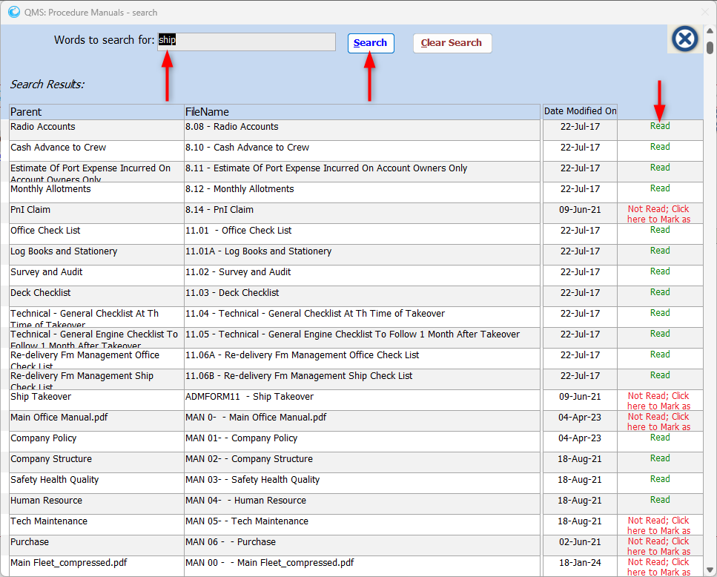

- Click on CLEAR SEARCH and the filter will be removed and refresh the window.
- Close the window.
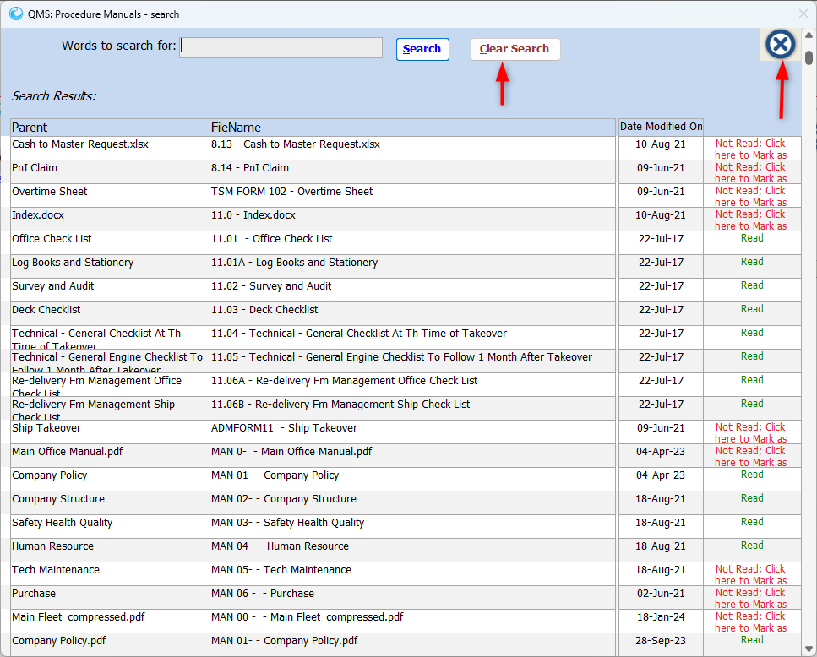

To View Report

- Click on Procedure Folder in the centre Eg Security.
- Click on Selected Folder Eg Forms
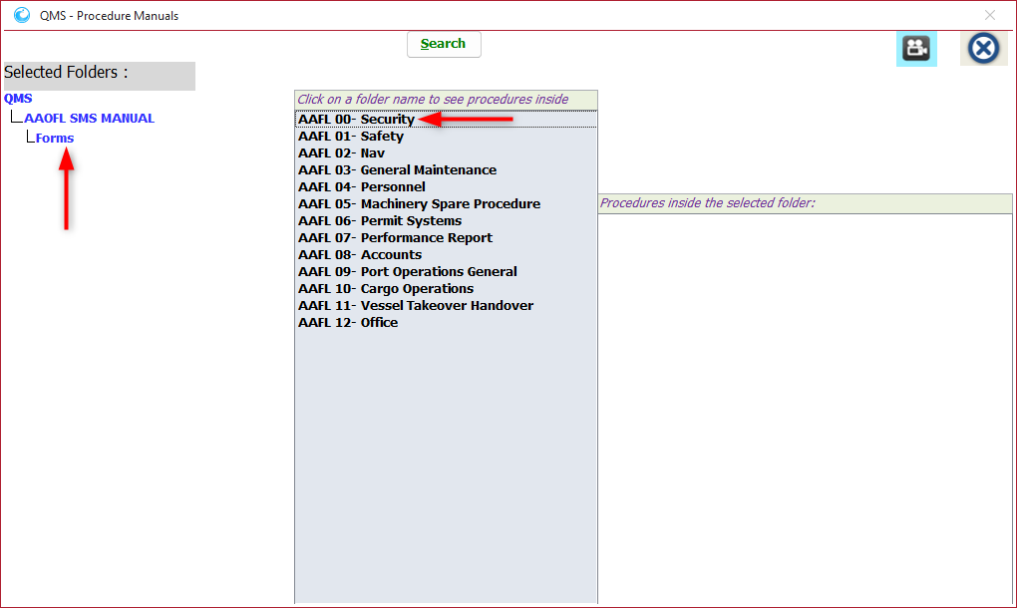

- Procedure document will display on the right. Click on the same, the document will open. Read the same.
- Click on Mark as Read after reading the procedure.
