**VESSEL REPORT FORM INDEX**

Table of Contents

**Purpose 2**

**Using the module 3**

**How to ADD new forms 5**

**How to View the Overdue Report/ Forms 7**

# Purpose

To allow ship staff to be able to file/submit their standard ISM forms, in the Jot ERP module –

* As per the planned schedule for each form.
* Ad-hoc (as-and-when) use of an ISM/Company form
* System has Attachment based forms only.
* **Deleted forms in the forms library by office, for whom the Reports were uploaded in past, will also be visible in the Report Index.**

**Please discuss with your office to check if they still need you to send a paper form, after you have already submitted a form in Jot ERP Onboard Module.**

# Using the module

1. Start the JotERP Onboard Module from the Desktop.
2. After login, the STARTUP screen is displayed.
3. 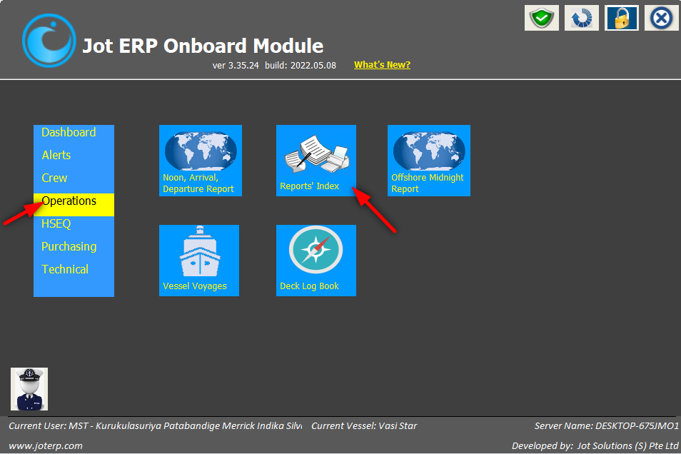In this screen, click on the Operations menu, then select Report Index as shown below.
4. This will open the REPORTS INDEX screen, as shown below:
5. This screen by-default displays all those reports or forms that have SENT TO OFFICE ‘YES’.
6. A screenshot of a social media post

   Description automatically generatedThe left section displays the standard list of forms as per your ISM manuals. You can also use the SEARCH field to search for a specific form.

# How to ADD new forms

1. On the Reports/ Form Index main screen, select the form from the left section (list of forms).
2. A screenshot of a social media post

   Description automatically generatedClick button ADD NEW button, as shown below.
3. A new pop-up will open for you to ADD REPORT / FORM.
4. In this screen, update -

* Add the REPORT DATE – the date on the relevant form.
* Click on BROWSE button to select the form that has been filled on the computer.
* Click on SAVE AND SEND TO OFFICE to submit the form.
* **One can also tag the Crew onboard for specific documents such as – Evaluation or Inventory Reports etc.**

1. A confirmation prompt will appear. Click on YES to save the report/form.

1. A screenshot of a social media post

   Description automatically generatedThe saved form will now appear on the INDEX screen, under SENT TO OFFICE? As ‘Yes’, as shown below:

# How to View the Overdue Report/ Forms

* In this section, you can view the Vessel Report/ Forms that are Overdue, respective to their assigned frequencies.
* **As well, the Report/ forms that have never been uploaded by the ship previously.**
* To view the Overdue Report/ Forms –

1. On the main Report/ Forms Index screen, click on the VIEW OVERDUE REPORTS/ FORMS button.
2. A new window will open with the respective report/ form names.
3. A screenshot of a computer

   Description automatically generatedOne can Print the report by clicking on the PRINT button.