SAFETY COMMITTEE MEETING

Table of Contents

Introduction 2
Purpose 2
How to ADD the Safety Committee Meeting 3
How to mark the ABSENTEES 5
How to ADD the Minutes of Meeting 6
How to ADD the NCRs Not disposed 7
How to ADD the Drills carried out 8
How to ADD remarks for Drills not done 9
How to ADD the Trainings 10
How to SEND the SCM record to Office 13
How to DELETE the SCM record 14
How to SEARCH for a specific SCM record 15

Introduction

Safety Committee Meeting helps to record & review the Minutes of Meetings, NCR’s, Drills, Trainings, attendance of the crew etc. to ensure the safety & health of the ship crew onboard.

Purpose
- This report can only be SENT TO OFFICE by the Master only, though other users can add/edit the same.
- Once the SCM Report is sent to the office, the ship crew cannot make any changes to the same.

How to ADD the Safety Committee Meeting
- Login into the Onboard module using the individual credentials.
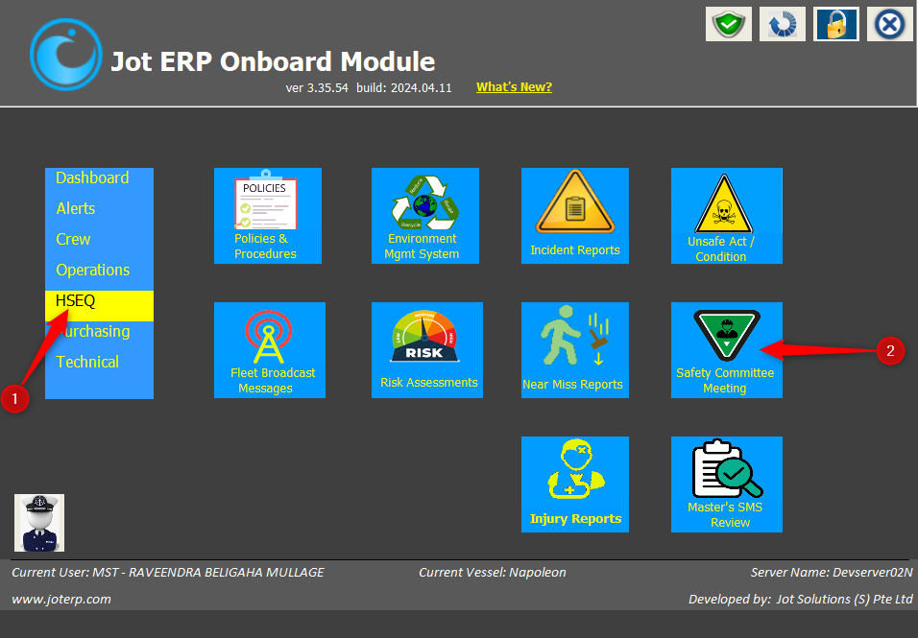
- Under ‘HSEQ’ menu, click on ‘Safety Committee Meeting’ module.

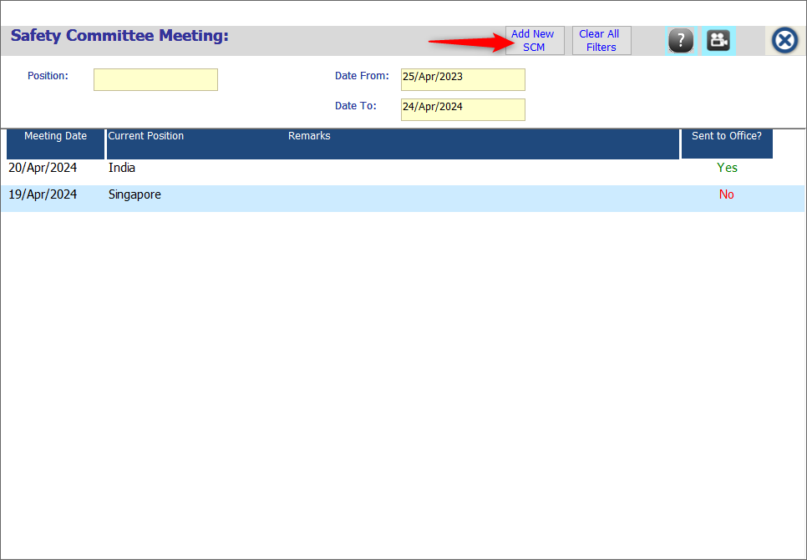
- On the new window, click on ‘Add New SCM’.
- Update the mandatory fields marked in ‘*’ – Meeting Date, Current Vessel Location.
- Now update the tabs separately – Absentees, Meeting Minutes, NCR not disposed, Drill carried out, Drills not done, Trainings.
- Then click on ‘Save & Close’ button.
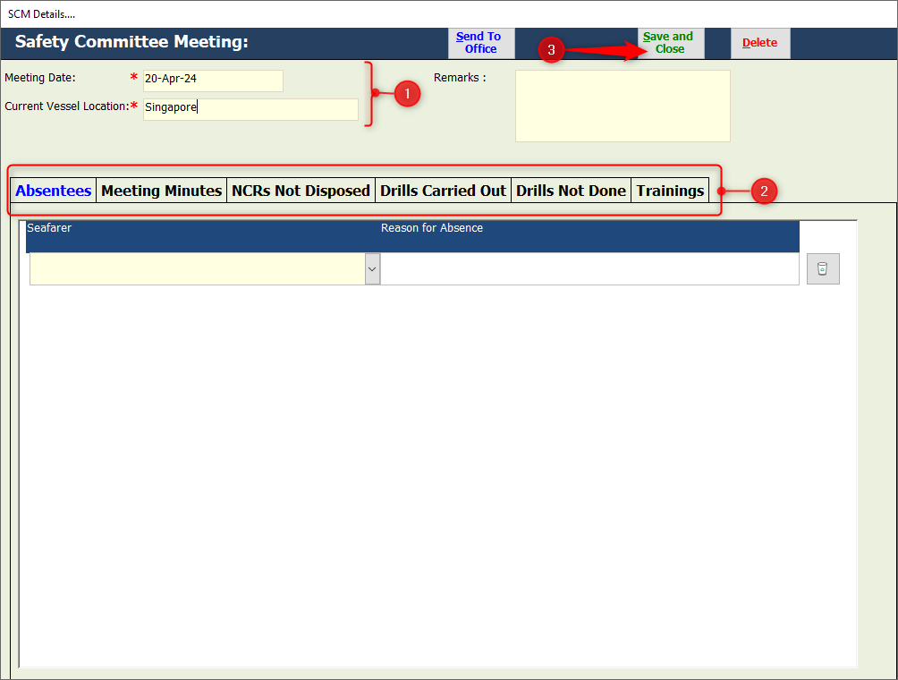

- The SCM will be added to the record with ‘Sent to Office’ status NO.
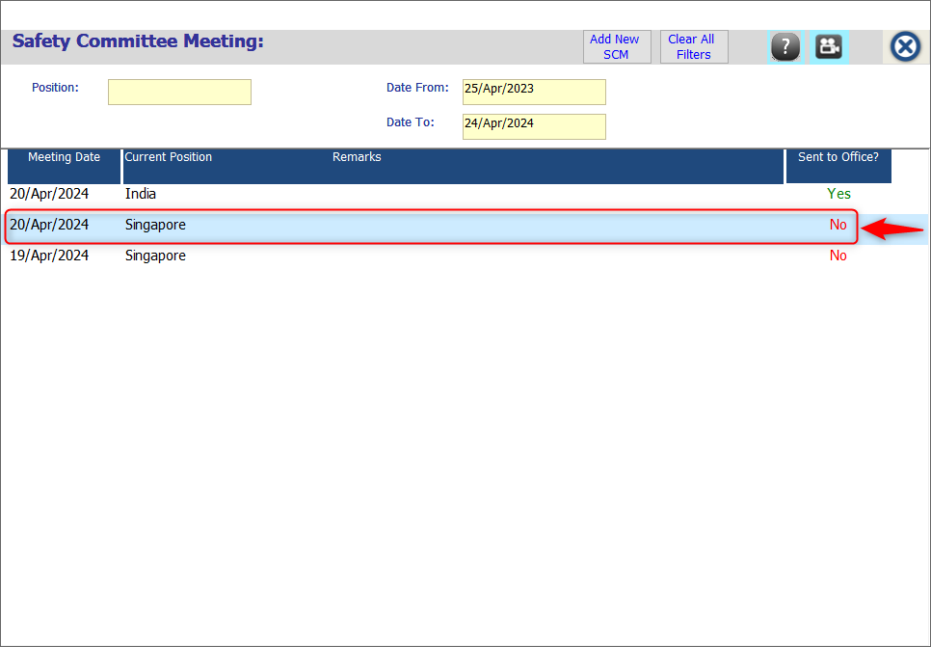

How to mark the ABSENTEES
- In the ‘Absentees’ tab, select the seafarer’s name from the dropdown.
- Mention the ‘Reason for Absence’ in the said column.
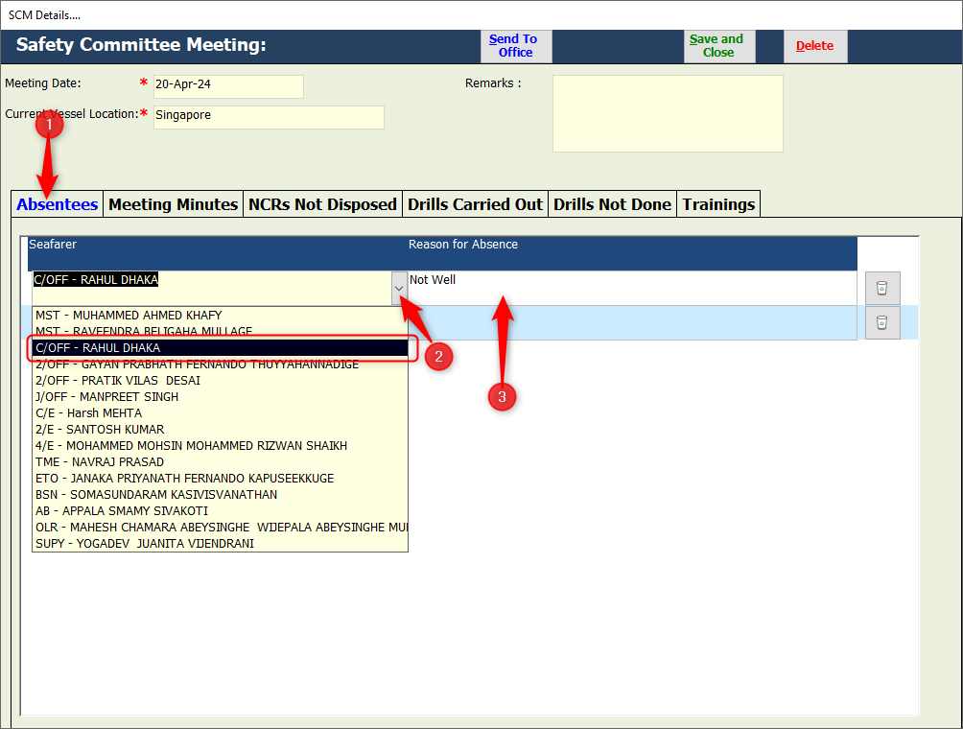

- To delete the name of the absent seafarer, click on the ‘Delete icon’.
- Click on ‘Yes’ button, when asked for confirmation.
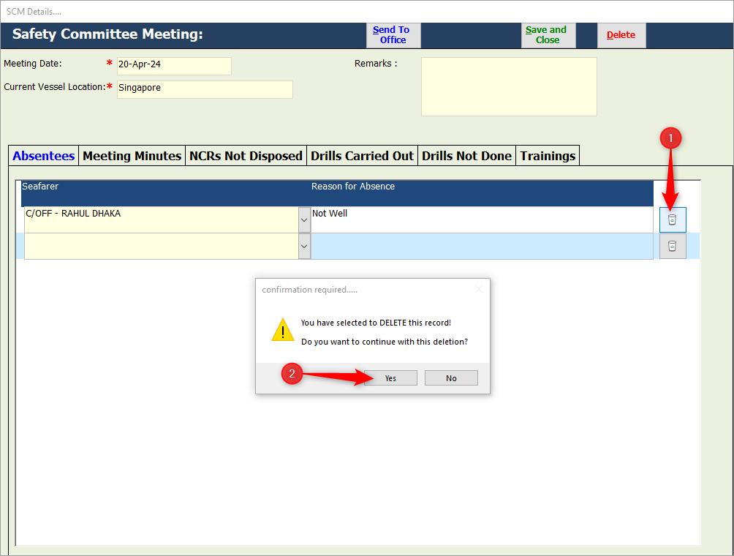

How to ADD the Minutes of Meeting

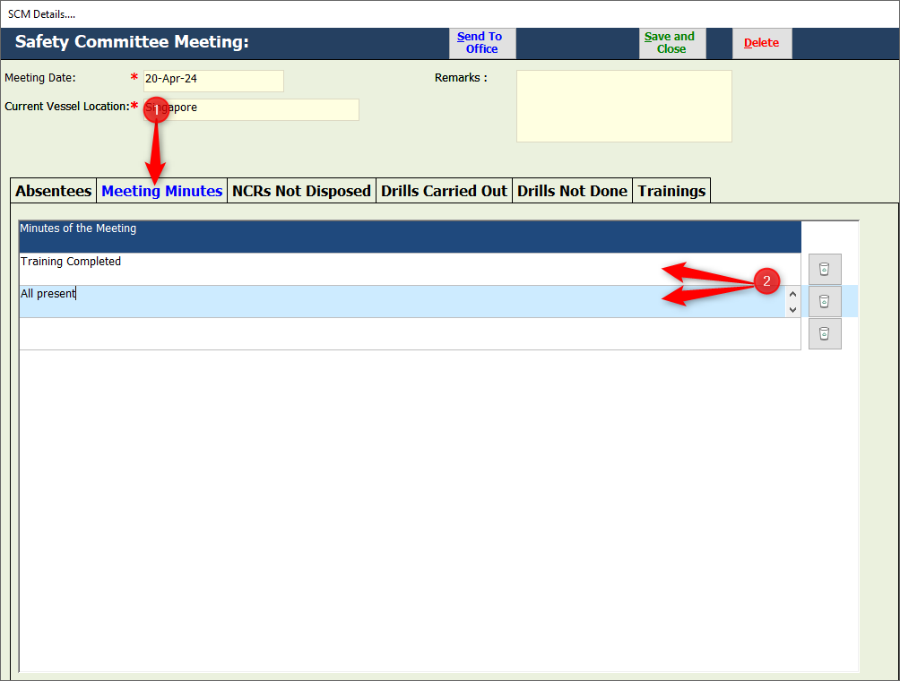
- Under the ‘Meeting Minutes’ tab, enter the points in separate rows.

- To delete the entry of minutes, click on the ‘Delete icon’.
- Click on ‘Yes’ button, when asked for confirmation.
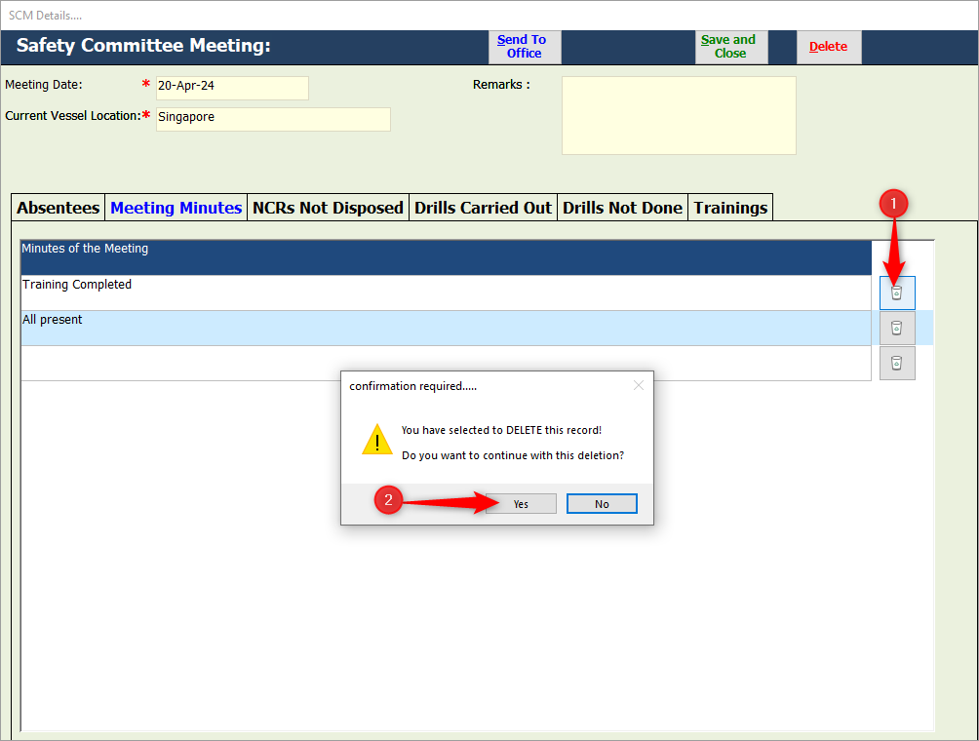

How to ADD the NCRs Not disposed

- Under the ‘NCRs Not disposed’ tab, there will be a list of NCRs that are not disposed.
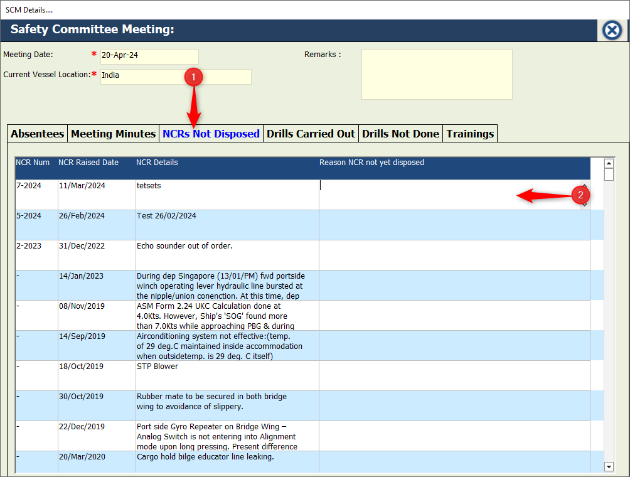
- Enter the ‘Reason’ for the same.

How to ADD the Drills carried out

- Under the ‘Drills carried out’ tab, a list of drill types will be mentioned.
- Update the ‘Drill Date’, ‘Drill Next Due’ & ‘Remarks’ for each type.
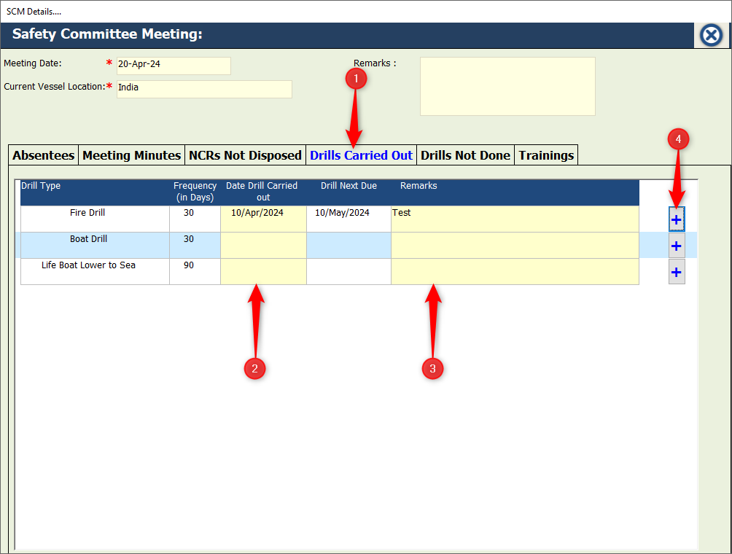
- To add the images of the drill, click on ‘+’ button.

How to ADD remarks for Drills not done

Note:
- ‘Drills Not Done’ tab will have the list of the drills that were NOT carried out or the drills that are Overdue.
- The list of the drills NOT done or Overdue drills will appear when the Master clicks on ‘Send to office’ button.

- Under the ‘Drills not done’ tab, the list of overdue & abandoned drills will be present.
- Mention the ‘Reasons’ for the respective drills & click on ‘Save & Close’ button.
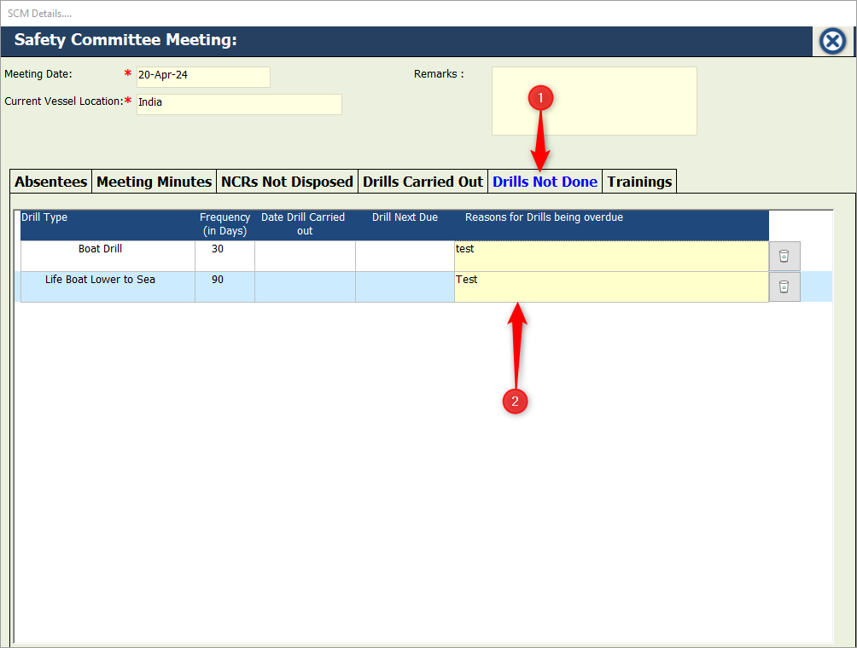
- Then the Master can send the SCM record to the office.

How to ADD the Trainings

- Under the ‘Trainings’ tab, click on ‘Add Training’ button.
- A new window will open to add – Training Date, Training Type from dropdown, Trainer from dropdown & Training details.
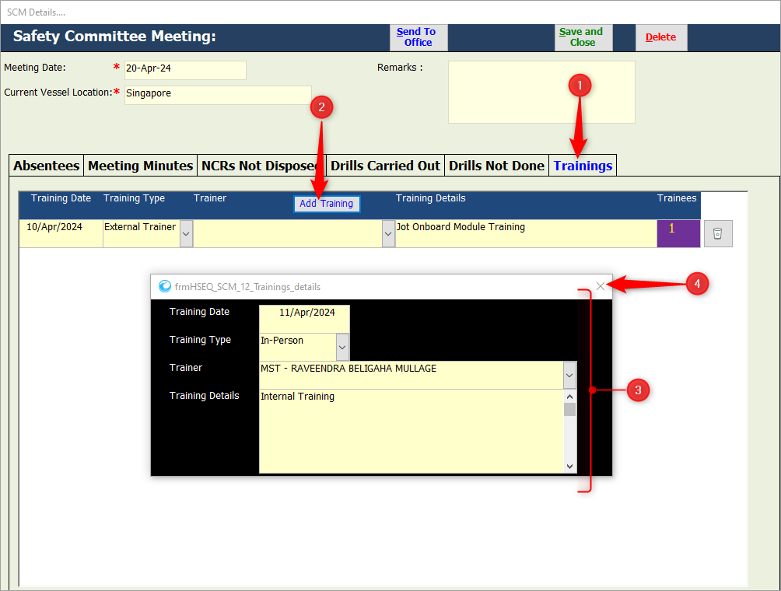

- Once done, close the window to view the details under ‘Training’ tab.
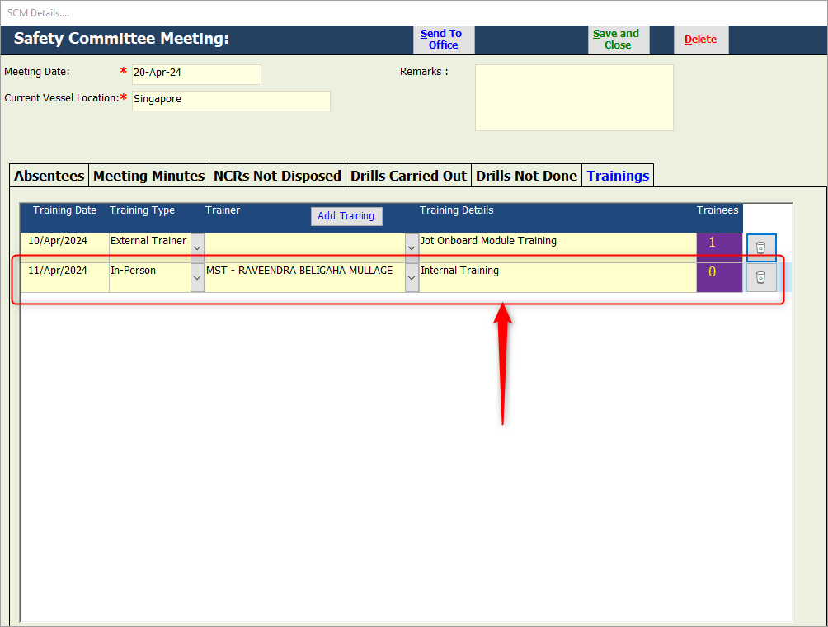

- To add the ‘Trainee Names’, click on the ‘Count’ in the ‘Trainees’ column.
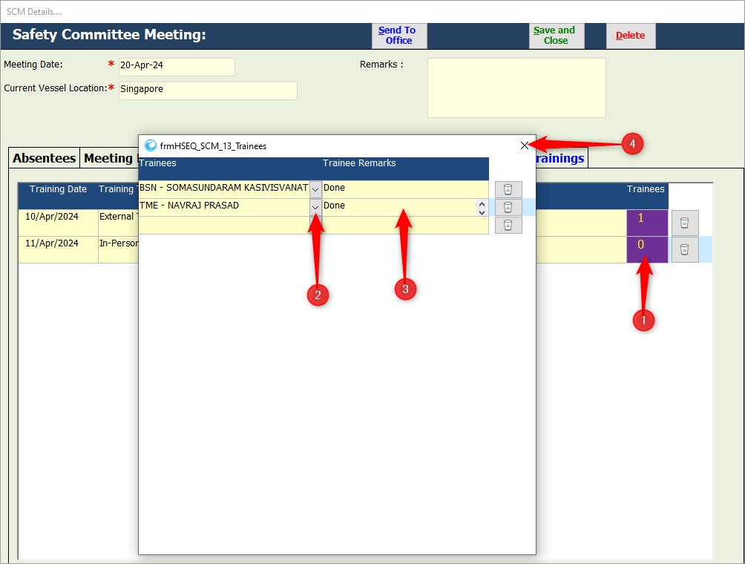
- From the dropdown, select the Trainees & add the ‘Remarks’.

- Close the window. The count will be displayed.

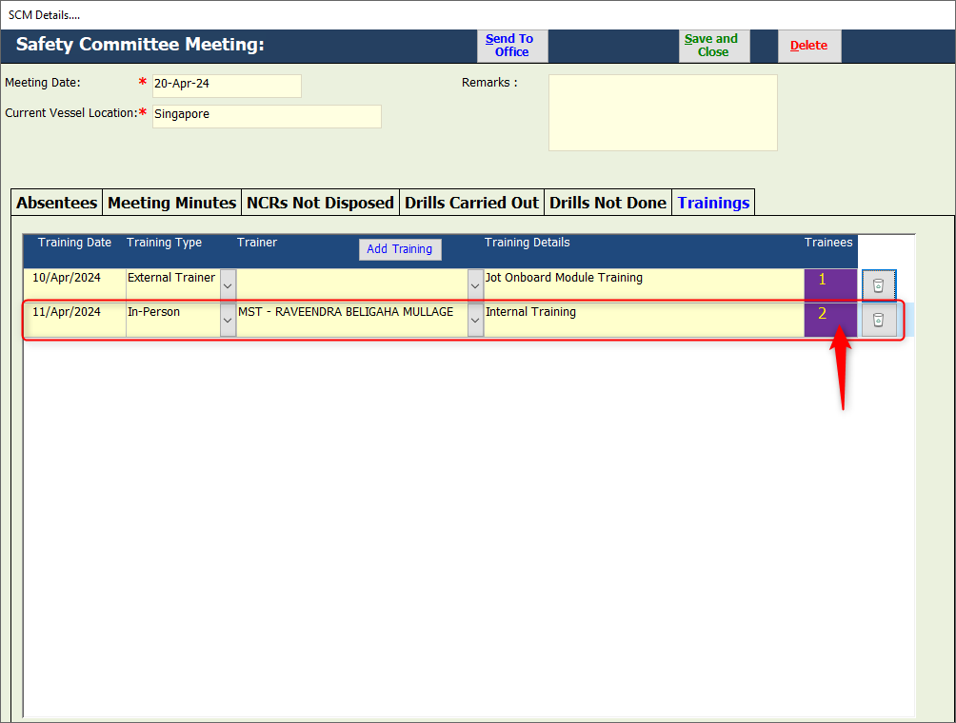
- To delete the entry of Training, click on the ‘Delete icon’.
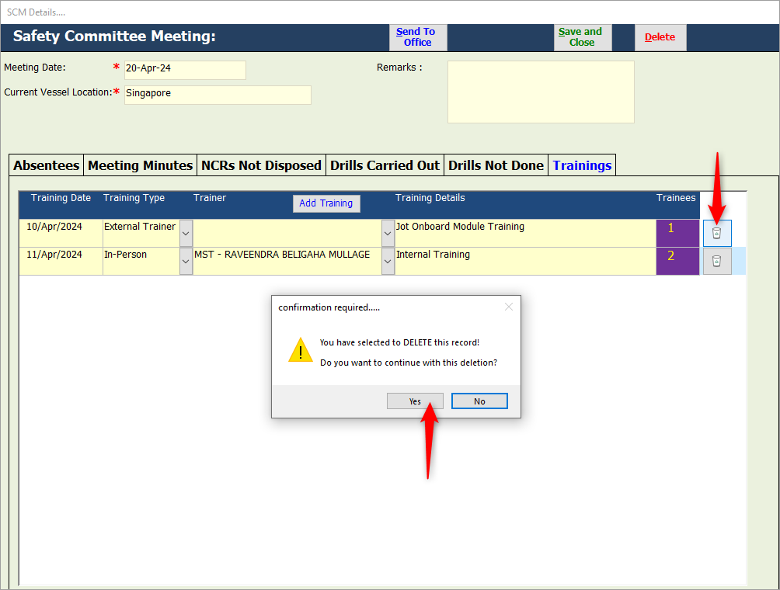
- Click on ‘Yes’ button, when asked for confirmation.

How to SEND the SCM record to Office

- Once all the tabs are updated properly, the Master will make a final review.
- Then click on ‘Send to Office’ button.
- The system will prompt for the confirmation.
- Click on ‘Yes’ button.
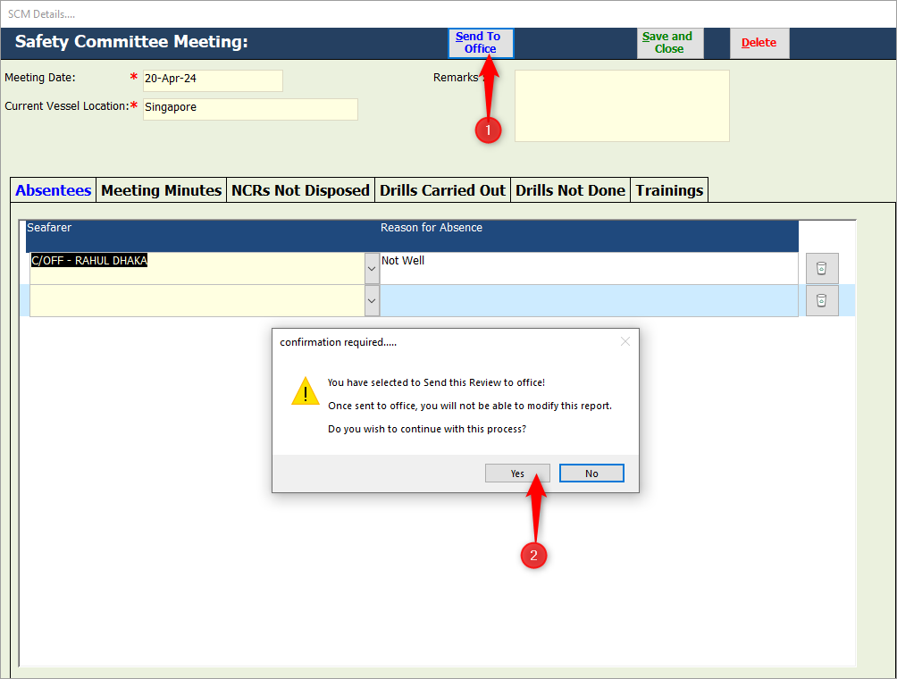

- The status of ‘Sent to Office?’ on the Index screen changes to ‘YES’.

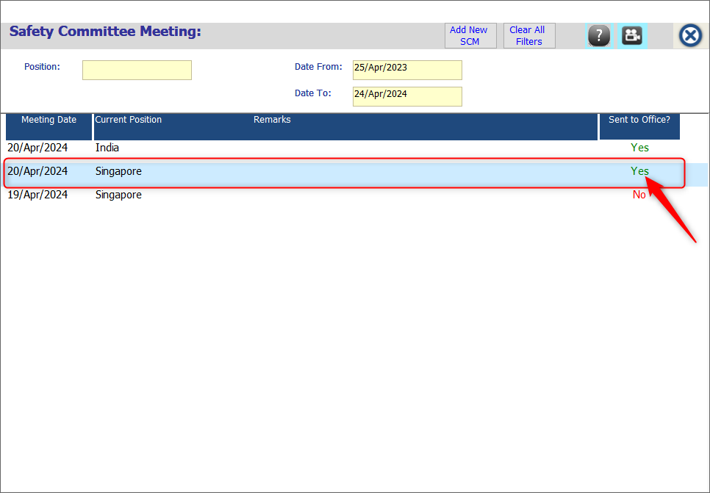

How to DELETE the SCM record

The SCM record can be deleted only if the ‘Sent to Office?’ status is ‘NO’.

- Click & open the SCM record that is NOT yet sent to the office.
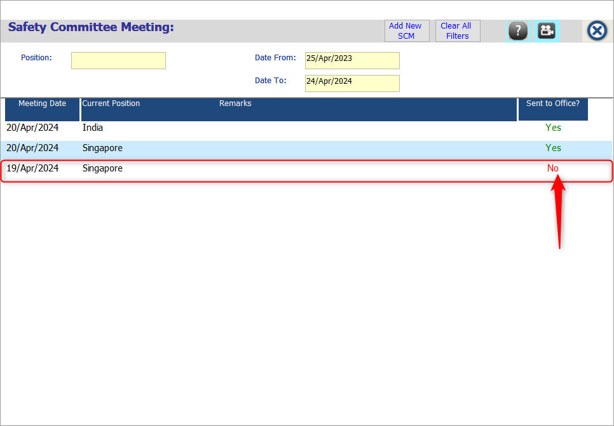

- On the window, click on the ‘Delete’ button.
- The system will prompt for the confirmation.
- Click on ‘Yes’ button to delete the SCM record.

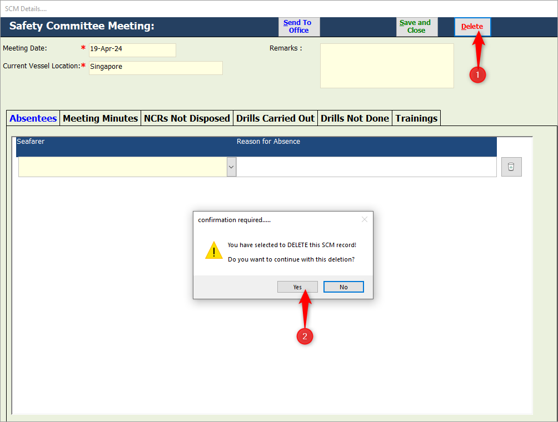

How to SEARCH for a specific SCM record

- On the Index screen of SCM, enter the ‘Position’ & select the ‘Date’ criteria.
- The respective SCM records will be displayed under the Index screen.

