Surveys & Certificates

Contents

Purpose of the software 2
Controls and your action required 2
Using the module 2
Add New Record 4
Add the Attachments & Endorsements 6
To View the Survey/ Certificate records 8

Surveys & Certificates

Purpose of the software
- To have a ship-specific list of Survey Certificates, and records of their date done and next due.
- Provide vessel with means to view records and the uploaded attachments for each instance of a survey or certificate

Controls and your action required
- Both Office & Ship can update records in this module.
- Vessel is however able to extract the status list in MS Excel format.

Using the module
- Start the Jot ERP Module from the Desktop.
- After login, the STARTUP screen is displayed.
- In this screen, click on ‘TECHNICAL’ module from Left hand side list.
- Then click on SURVEYS & CERTIFICATES.
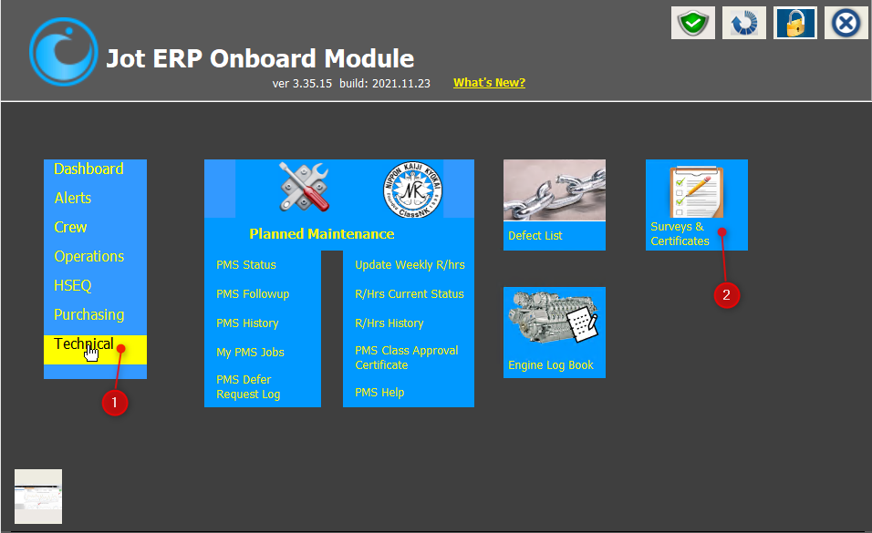
- The main screen of the Surveys & Certificates module will open, as shown below.
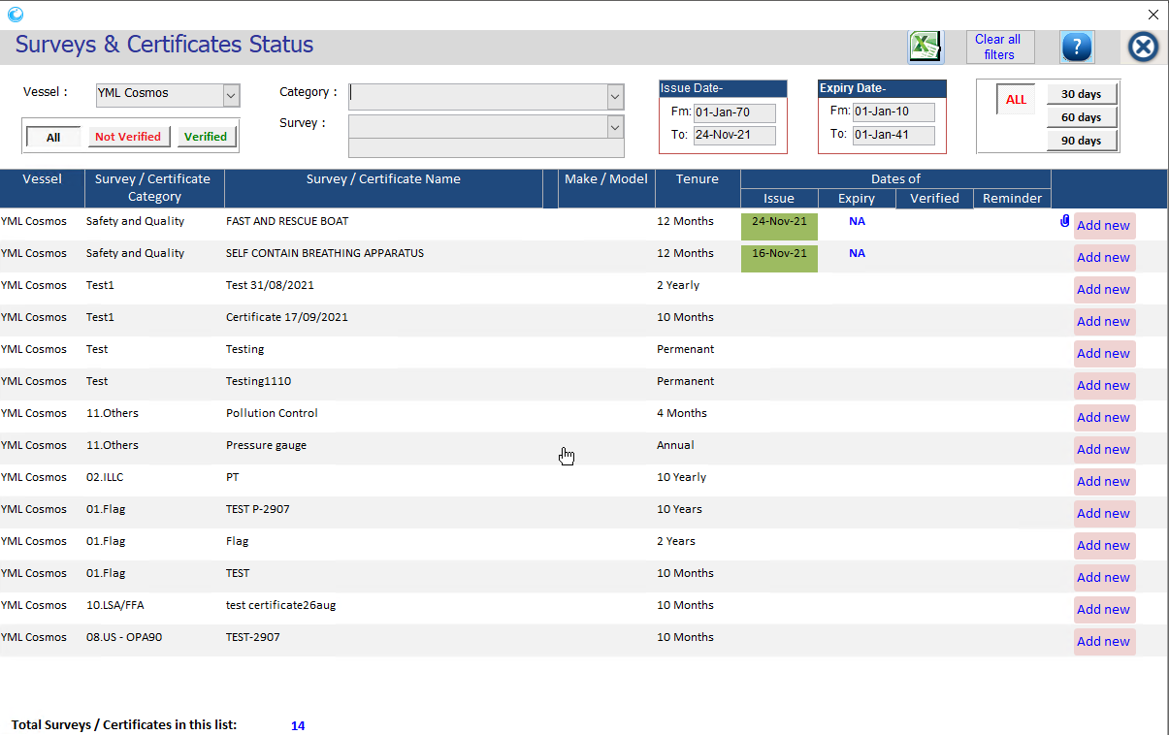
- This will display list of Surveys & Certificates for your vessel, with their current set of Dates of Issue and Expiry. If a record has an attachment, it will also be displayed on the extreme-right of this screen.
- It will also have a “Add New” button, to add new records of the said list of Survey & Certificates.
- You can use the filters in the top section of this screen to filter the information available. The filters you can use are:
  - Category
  - Survey/Certificate name
  - Issue Date – From and To
  - Expiry Date – From and To
  - Due in number of days – 30, 60, 90 days

Add New Record:

Based on your office's preferences, the ship may be permitted to upload the Surveys/Certificates in the Jot ERP, or your office may choose to upload themselves from shore side.
This ADD option is only available onboard basis these criteria.
Note: The records can be saved without Certificate No. and if there is no ‘Date of Expiry’ then tick mark against the box of ‘No Expiry Date’.

- To add new record to the Survey/ Certificates, click on “Add New” button on the extreme right-hand side.
- It will open a new window – “Survey Details- Add new record”.
- Feed in the required details, such as Certificate No., Date of Issue, Date of Expiry & Remarks.
- Click on “Save & Close” button.

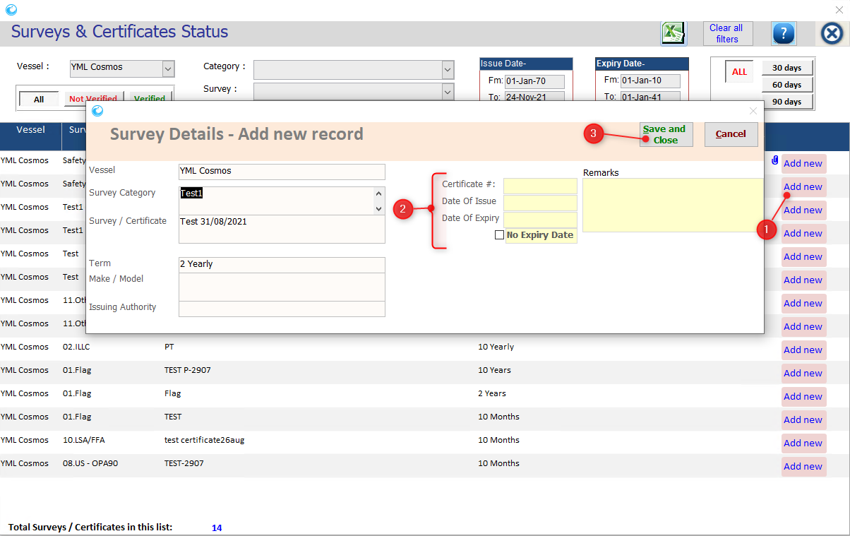

- The new record will be added, as below.
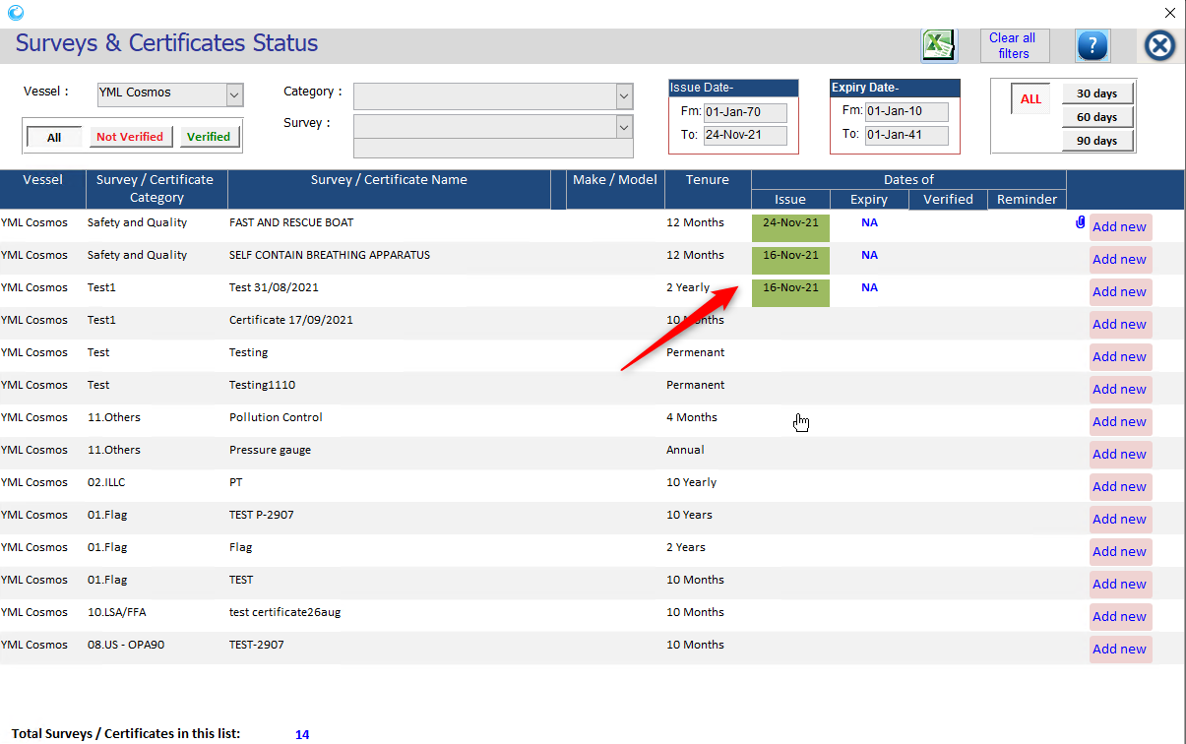

Add the Attachments & Endorsements:

- Select the Survey/ Certificate name.
- A new window will open. Click on ‘New Endorsement’.
- Another window will open to feed in the details, such as – Planned date, Issue date, Remarks & Attachment.
- Then click on ‘Save & Close’ button.
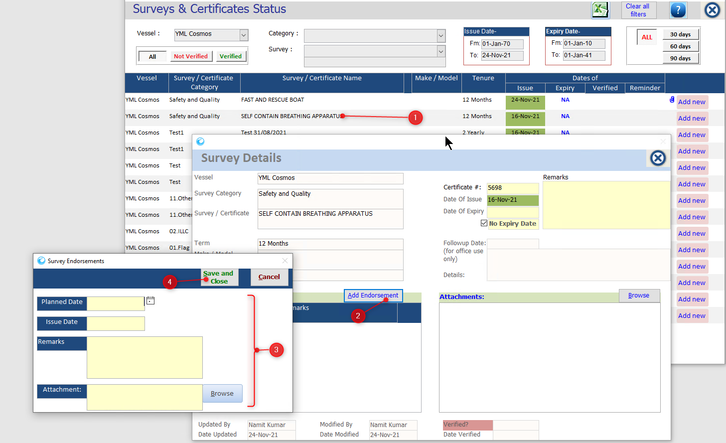
- And the Endorsement will be added.

- To add the Attachment, click on browse button.
- Select the image & click on Open.
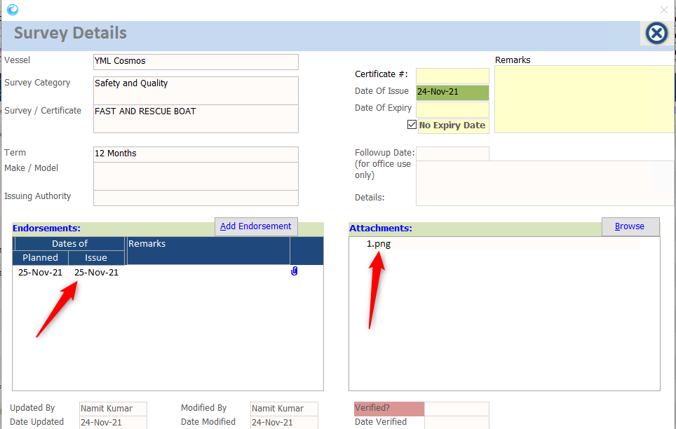
- The attachment will be added.

To View the Survey/ Certificate records:

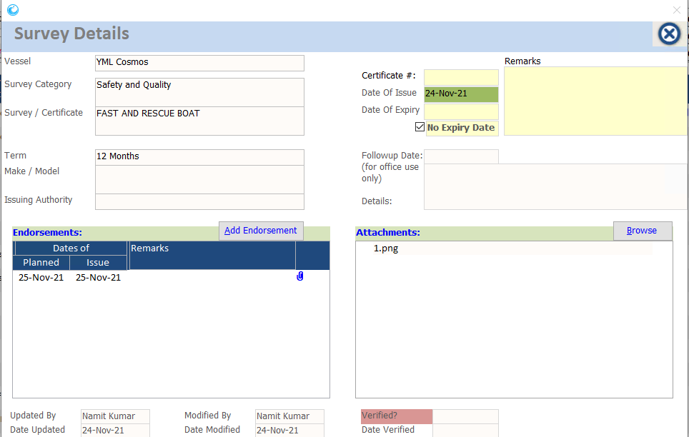
- On clicking on a record in the lower section of the screen, the individual screen will open, displaying the full-style details of the Survey/Certificate record saved in the Jot ERP, as shown below:

- In this screen, you will also get access to the multiple attachments uploaded by the office for that survey/certificate record. On clicking on any of the attachment names, you can view that attachment.
- Apart from the various details, there is another option of having a REMINDER DATE for this survey/certificate type. This date and its Remarks are updated only from the shore offices.

