**UNSAFE ACT AND UNSAFE CONDITION**

**Table of Contents**

**Purpose** 2

**Controls & Actions** 2

**Using the module** 3

**To ADD new Unsafe Act/ Condition Report** 6

# **Purpose**

* **UNSAFE ACT** is any activity or task that is conducted in a manner which will increase the probabilities of an accident.
* **UNSAFE CONDITION** is a condition in the workplace that is likely to cause damage or injury.
* The system will allow the ship staff to take immediate corrective actions whenever possible, to overcome observations of unsafe acts, condition or both and report those unsafe acts or condition observed and action that had been taken.

# **Controls & Actions**

* Unsafe act & Condition is added from the ship end but marked as **COMPLETED** from the office end.
* Once the Unsafe Act/ Condition report is **SAVED**, it cannot be edited.

# **Using the module**

1. A screenshot of a computer

   Description automatically generatedTo open the module, from the Start-up window, click on the **UNSAFE ACT/ CONDITION** module, under **HSEQ** menu.
2. A new window will open –
3. The **UPPER SECTION** is the **SEARCH FILTER** to find a particular report, using filter options such as –

* Location
* Details
* A computer screen with a red border

  Description automatically generatedType

1. 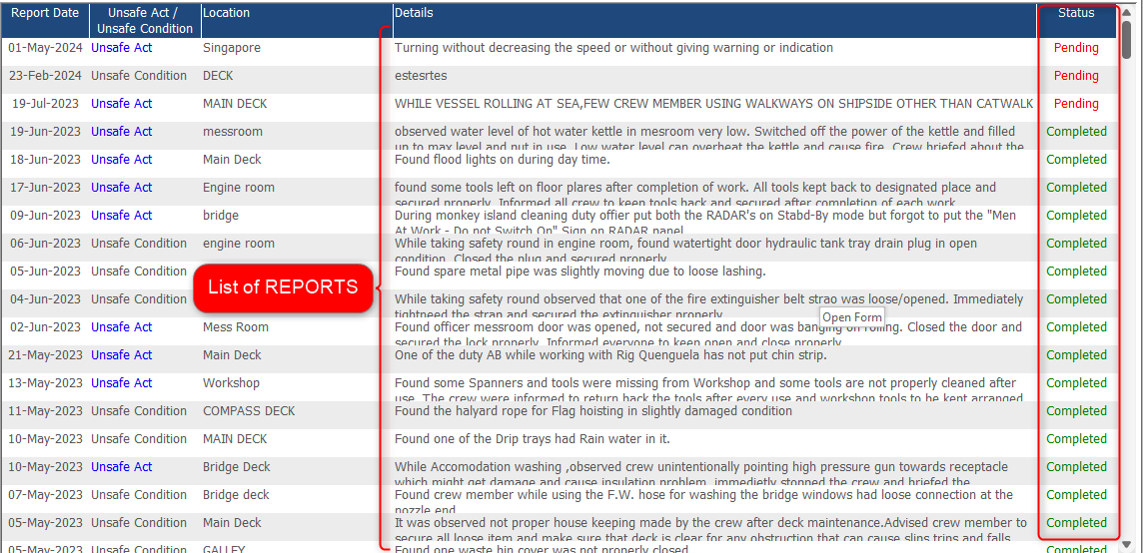The **LOWER SECTION** consists of the **list of the Unsafe Act/ Conditions** reported by the ship staff, with their current status – **Pending/ Completed** highlighted in Red and Green respectively.
2. To view the report details –

* A screenshot of a computer

  Description automatically generatedClick on the desired record.
* A screenshot of a computer

  Description automatically generatedA new window will open with all the relevant details of the report created.

1. Ship Staff can view the Unsafe Act/ Condition report but cannot make any changesonce the report has been **saved and close.**

## **To ADD new Unsafe Act/ Condition Report**

1. A screenshot of a computer

   Description automatically generatedClick on the **ADD NEW** button, from the main index screen of Unsafe Act/ Condition module.
2. A new window will open to enter the following mandatory details –

* Report Date
* Location
* Type – Unsafe Act/ Unsafe Condition
* Act/ Condition Details
* Questionnaires and Remarks

1. Once all the details have been added, click on the **SAVE & CLOSE** button.

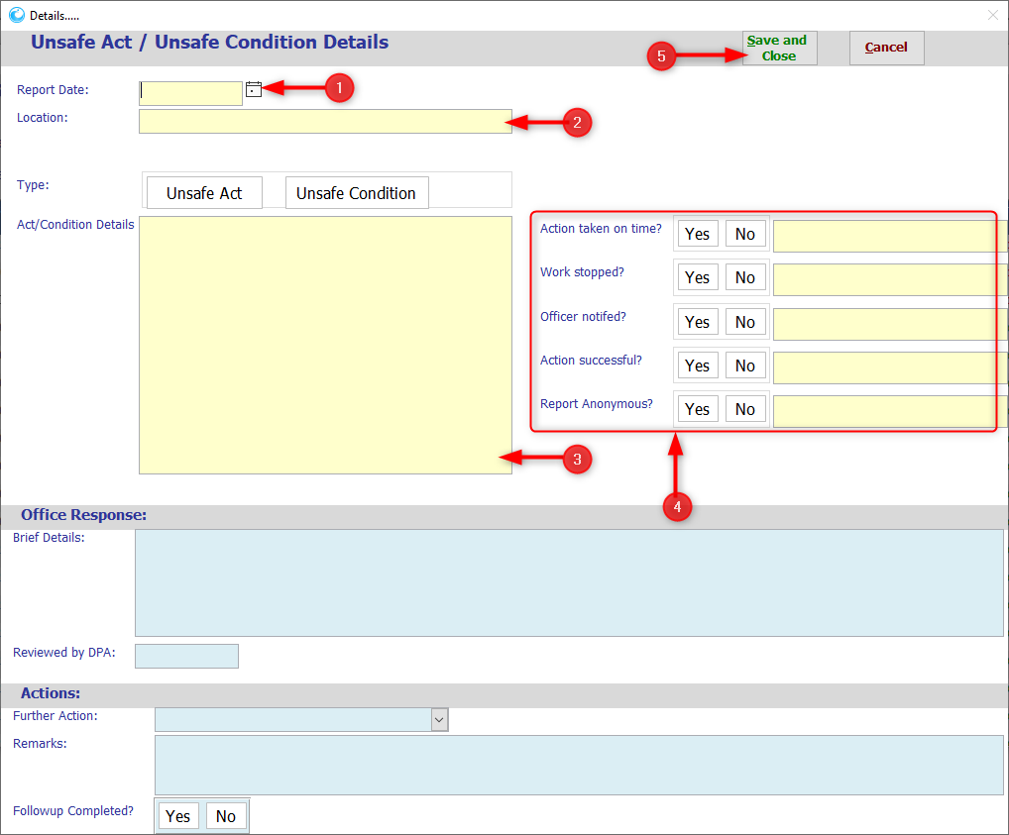

1. 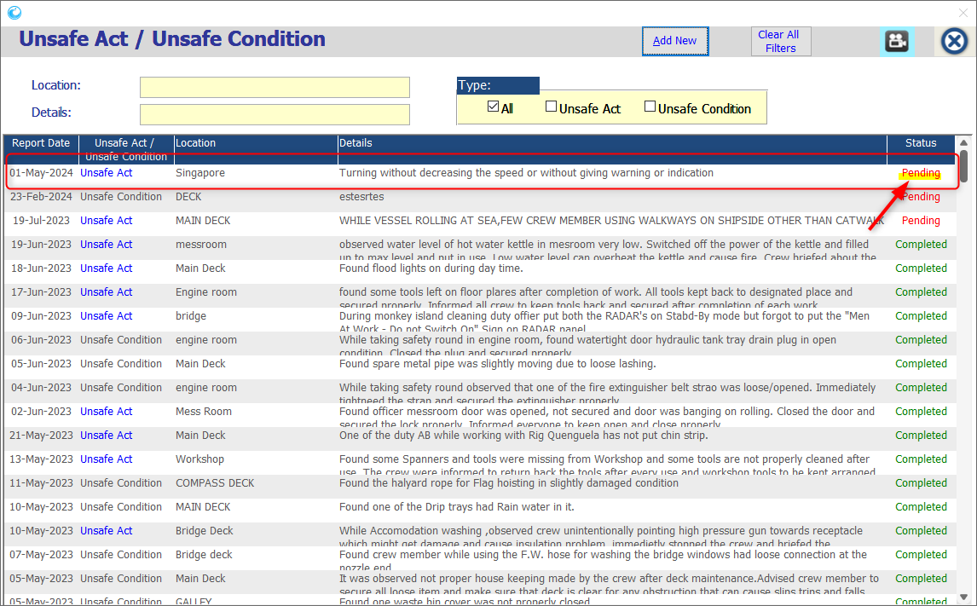The report will be added to the existing list with Status as **PENDING**.
2. The further process to **REVIEW** & marking as **COMPLETED** will be done by the office end.