**VESSEL INFORMATION DATABASE**

**Table of Contents**

**Introduction** 2

**Purpose** 3

**Using the module** 4

# **Introduction**

The module covers the **vessel characteristics**, such as – Capacity, Dimensions, Management & Ownership Structure & details, Classification, Engine Equipment, Yard & build information, through VID types, such as – **HVPQ, Q88, BATLIC 99**.

# **Purpose**

If the **“Inactive Form”** date is updated for any of the VID type, then that record is unable to be edited.

The questions are answered by the vessel staff, but it is **VERIFIED** by the office staff.

The questions in the VID are added from the office end **ONLY**.

# **Using the module**

1. A screenshot of a computer

   Description automatically generatedTo open, click on the **VESSEL INFORMATION** module, under **OPERATIONS** menu.
2. It will display the list of **VID** **TYPES** with the **TOTAL QUESTIONS COUNT**.
3. A screenshot of a computer

   Description automatically generatedClick on any one of the **VID TYPE**.
4. 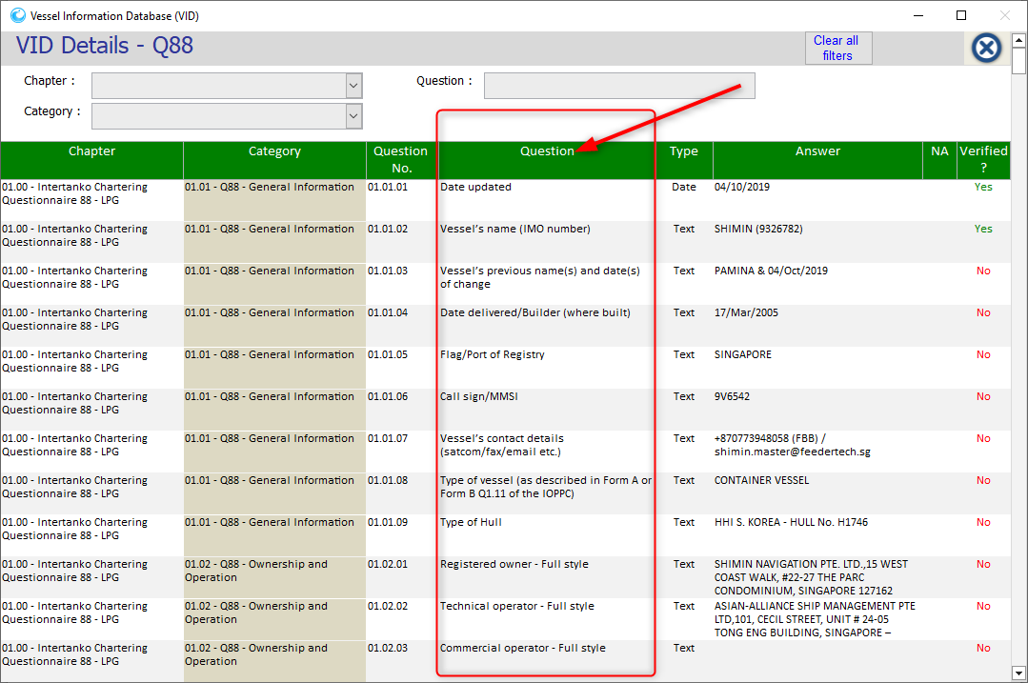A list of **QUESTIONS** will appear in the new window.
5. A screenshot of a computer

   Description automatically generatedClick on the any **QUESTION**, whose **VERIFIED** status id **NO**.
6. It will open a new window, with **QUESTION** details.
7. In the **TYPE** field, the nature of **ANSWER** is mentioned.
8. In the **ANSWER** field, enter the **ANSWER** to the question.
9. In the **NA** field, select the **APPLICABLE** option.
10. A screenshot of a computer

    Description automatically generatedAnd click on **SAVE & CLOSE** button.
11. A screenshot of a computer

    Description automatically generatedIf the question is **NOT** relevant to your ship, then select the **NOT** **APPLICABLE** option from the **NA** field.
12. Once the task is completed, **CLOSE** the window.
13. The updated data will be synched on the office end for the **VERIFICATION** purpose.