**VESSEL VOYAGES**

Table of Contents

**Purpose 2**

**Using the module 3**

**How to ADD New Voyage 5**

**How to mark the Voyage as COMPLETED 8**

# **Purpose**

* In the **VESSEL VOYAGE** submodule, user can create vessel voyages.
* These vessel voyages are linked with the **NAD module**, where the ship staff has to select the **VESSEL VOYAGE** while creating the Noon, Arrival & departure report.
* New **VESSEL VOYAGE** can be added, **ONLY** when the previous voyage is **CLOSED**.

# **Using the module**

1. Start the Jot ERP onboard module from desktop.
2. 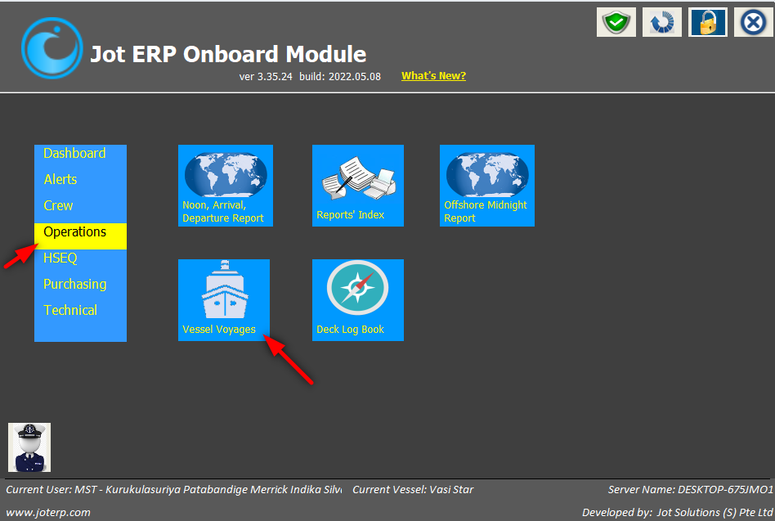Click on the VESSEL VOYAGE, under OPERATIONS menu.
3. A new window will open with a list of Voyages, along with other details such as – Voyage Number, Start date, Actual End Date, Charter Type, Charterer & Voyage Status.

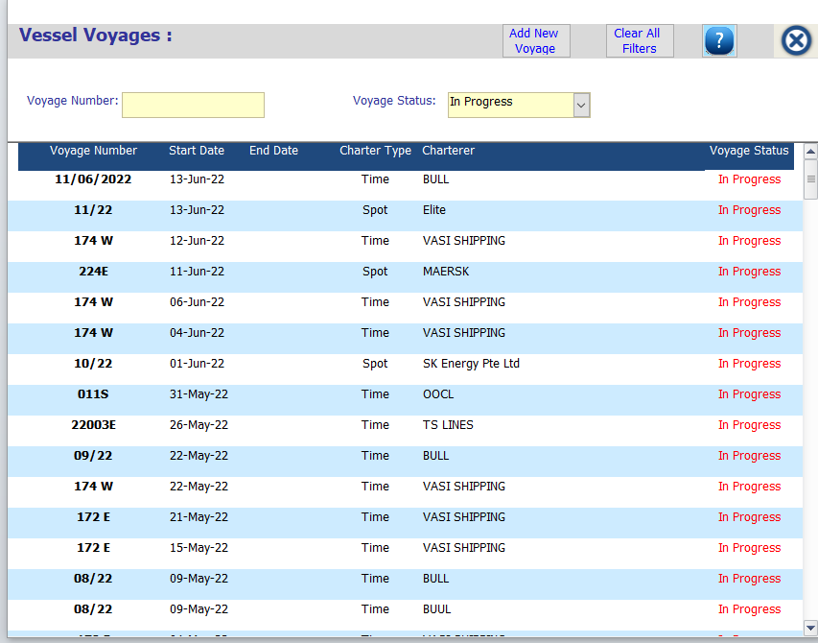

1. This window is divided in to two parts:
2. Search Criteria - If user wants to search any item, then he can search by field:

* Voyage Number
* Voyage Status – In Progress or Completed

1. List of Voyages - The system will show you the list of all voyages.

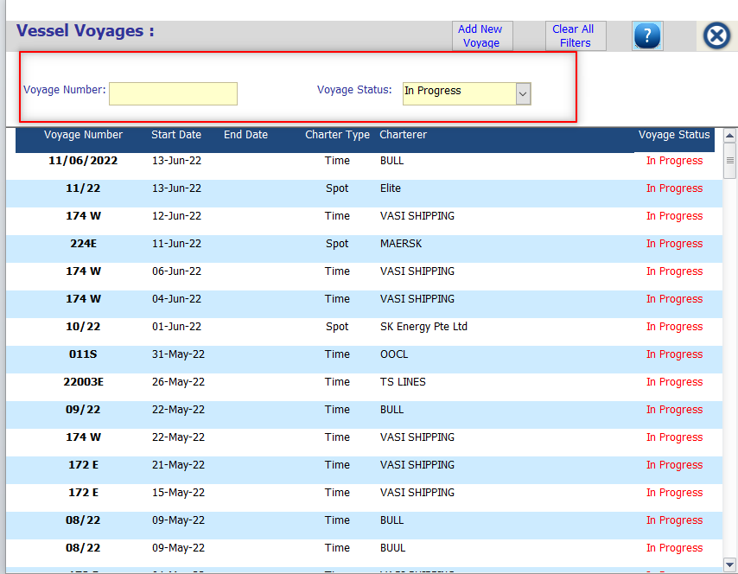

1. 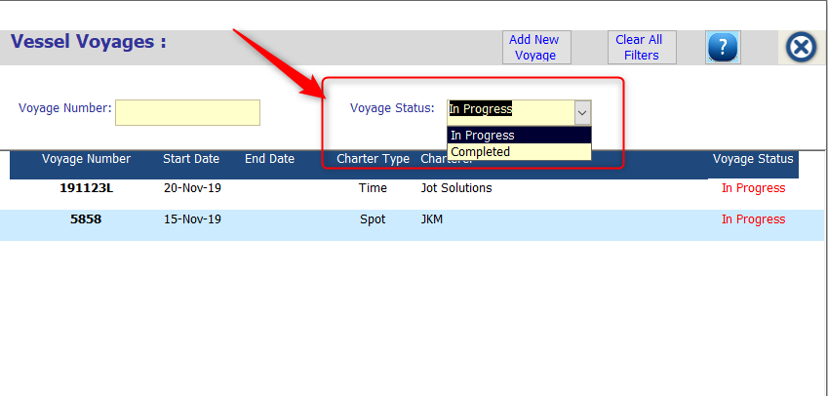In the voyage status column, system will show the status of voyages which can be in-progress i.e. not completed or completed stage.

## How to ADD New Voyage

1. 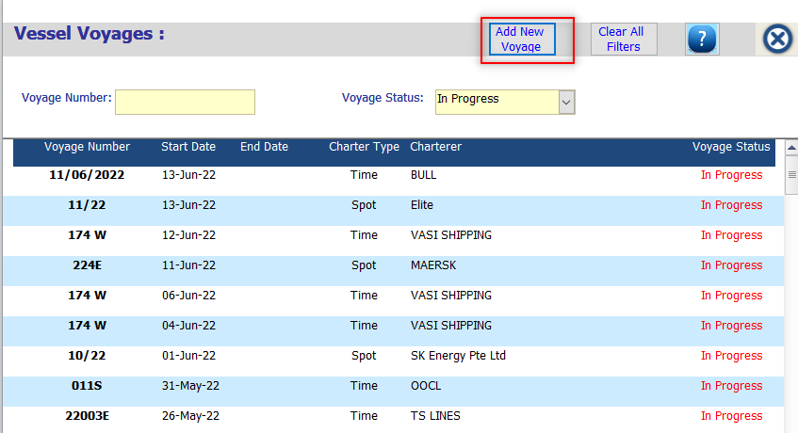To add new voyage, click on the ‘Add New Voyage’ button.
2. A new window will open, to enter below details –

* **Voyage Number** - Here user need enter voyage number.
* **Voyage Start Date** – In this field user need to enter date when the respective voyage is started.
* **Voyage End Date** – Once voyage has completed user need to enter voyage end date, if it is in process, you can keep blank as it is.
* **Charter Type** – Here user can select charter name from the charter name dropdown. If the charter name is not present in the dropdown, then you can add manually charter name also.
* **Voyage Remarks** – Here user can put the voyage remark also.

1. After entering, all data user needs to click on the **‘SAVE AND CLOSE’** button as shown in below screenshot.

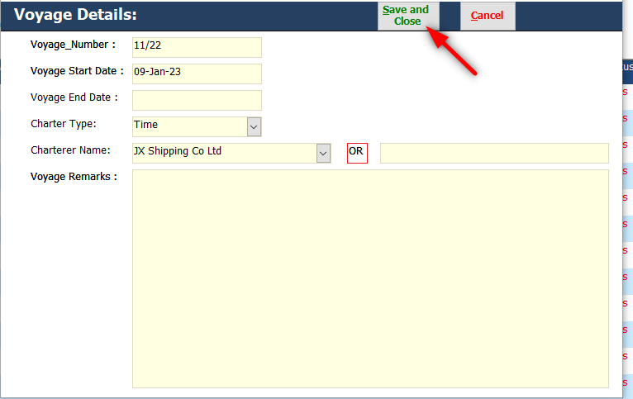

1. 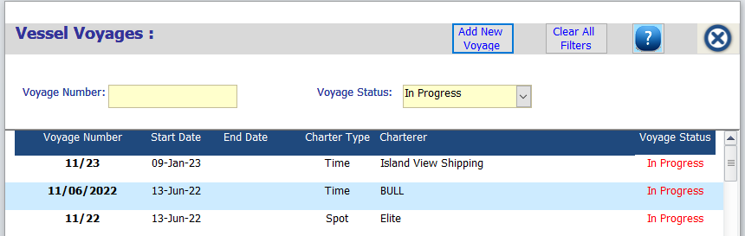This will reflect in a voyage index screen as a voyage status IN PROGRESS.

## How to mark the Voyage as COMPLETED

1. To mark this voyage as Completed, click on the respective Voyage.
2. Update the VOYAGE END DATE.
3. 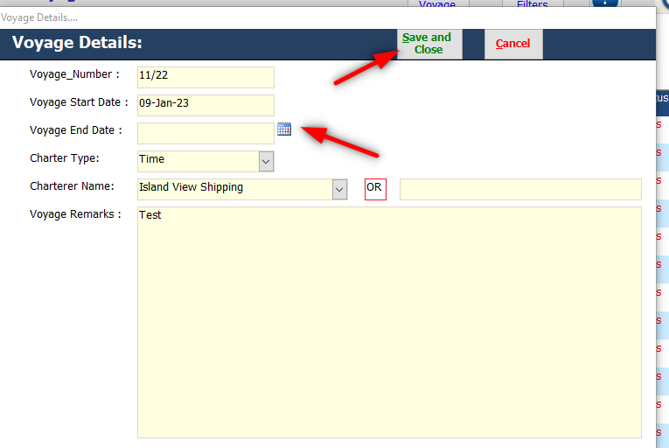And click on SAVE AND CLOSE button.
4. 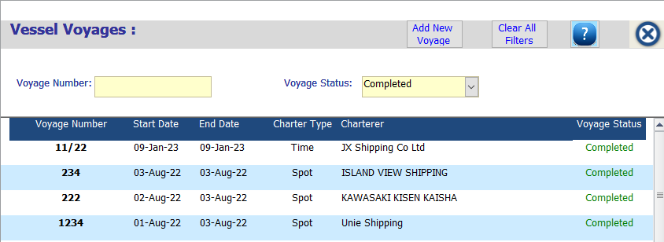After adding voyage end date, voyage will display under voyage status ‘Completed’.