Crew Evaluation

Purpose
To evaluate/appraise ship-staff, as per the planned schedule for that rank

Validations
- Master can assess all Deck Officers and ratings
- Chief Engineer can assess all Engine/Electrical Officers and ratings
- Master & Chief Engineer’s appraisal will be carried out from the office end.

Using the module
- Start the JotERP Onboard Module from the Desktop.
- After login, the STARTUP screen is displayed.
- In this screen, click the button CREW EVALUATIONS under Crew & Accounts
- The main screen of the Crew Evaluation module will open and it will display all the crew whose evaluation is IN PROGRESS.
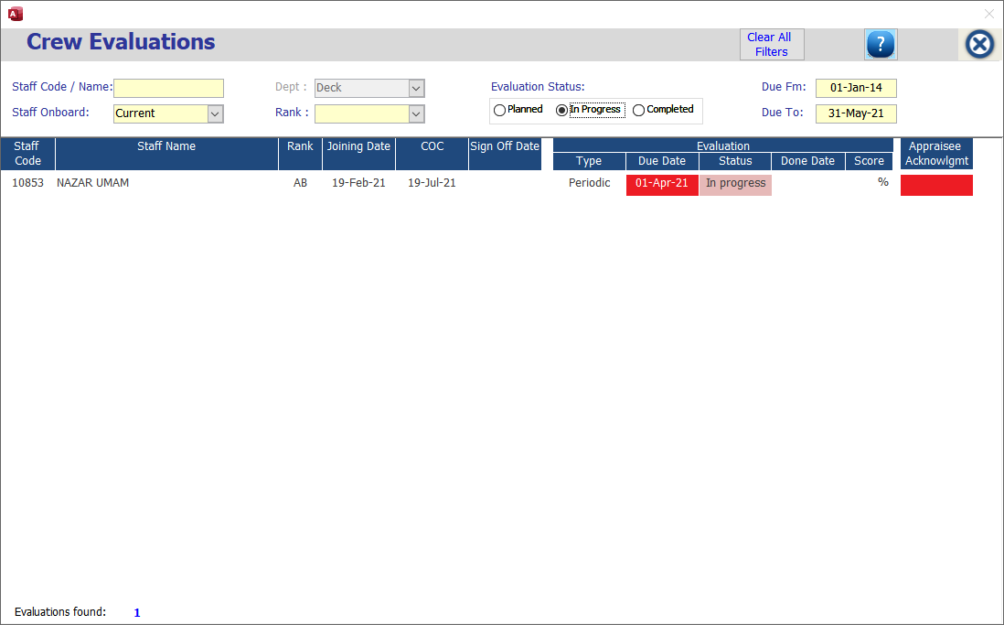
The evaluations that are currently ‘overdue’, will have their DUE DATES in re color, as shown below:

- In this main screen –
  - Top part of the window contains various filters to filter relevant Crew Evaluations:
- Staff Code / Name
- Staff Onboard / Signed-off
- Department
- Rank
- Evaluation Status – Planned / In Progress / Completed
- Due From Date
- Due To Date
- Clear Filter

  - Lower part of the window by default displays the entire crew list whose evaluation is pending with their due dates along with following information’s: Staff Code, Staff Name, Rank, Joining Date, COC, Sign off Date, Evaluation Type, Evaluation Due Date, Evaluation Status, Evaluation Done Date and Score in percentage

Help continues in the next page.

- To evaluate any crew in Crew Evaluations, click on the row of the desired crew.

- Another window will open, showing details as given below:
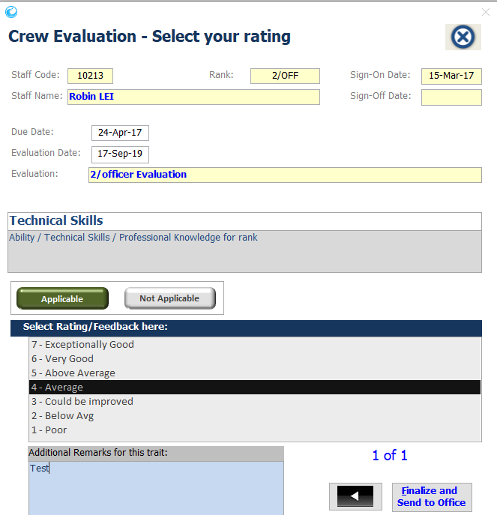

- At the top of this window you will see the crew details as staff code, rank, Sign on Date, Staff Name, Sign off date, Evaluation due date, Evaluation date and evaluation rank.
- Consider these criteria and select appropriate rating – Will show you different criteria to evaluate/rate the crew under ‘Select Rating here’ options.
- If ratings under ‘Select Rating here’ option goes ’Below Average’ an additional remark will automatically alert for remarks. Min 20 characters required to move on next criteria.
- Also, if you try to move on next criteria without rating it will prompt you an alert message “Select a rating for this criteria first!” and not allow user to move on next or previous criteria’s.

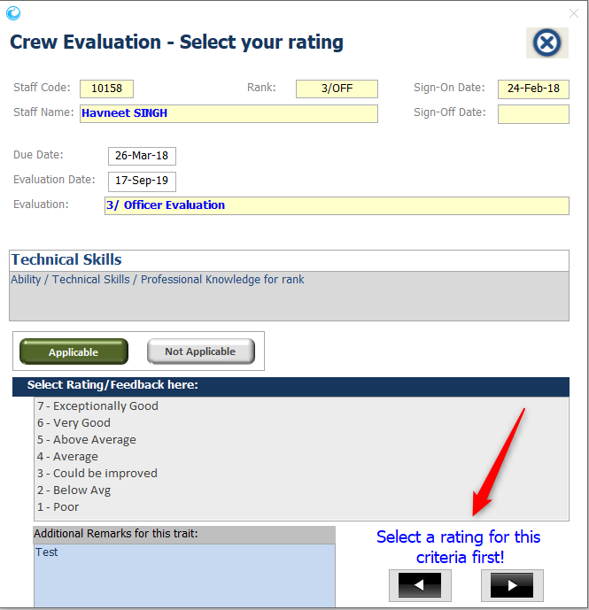

- If the marks given are below the average scores, then putting your Reasons/Remarks for that criteria are mandatory, as shown below:
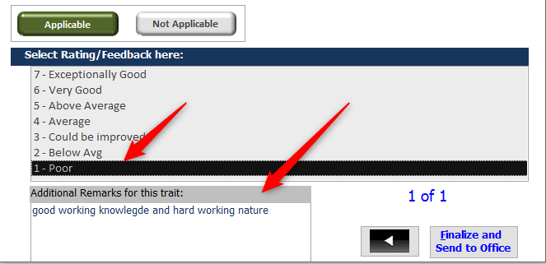

- If the criteria or question is not applicable, you can select option NOT APPLICABLE

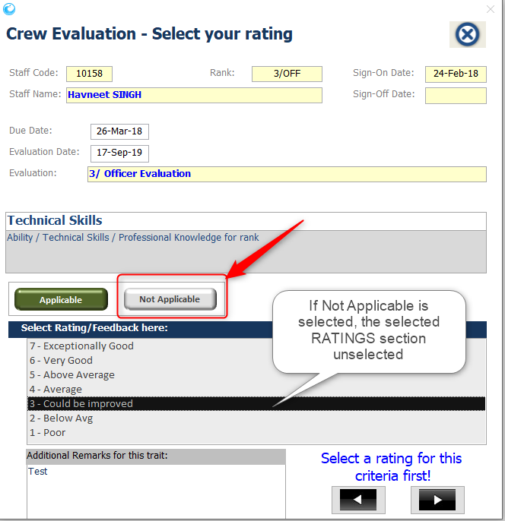

- When you finish rating as per various criteria’s, the next button will automatically change in to ‘Finalize and Send to Office’ button.
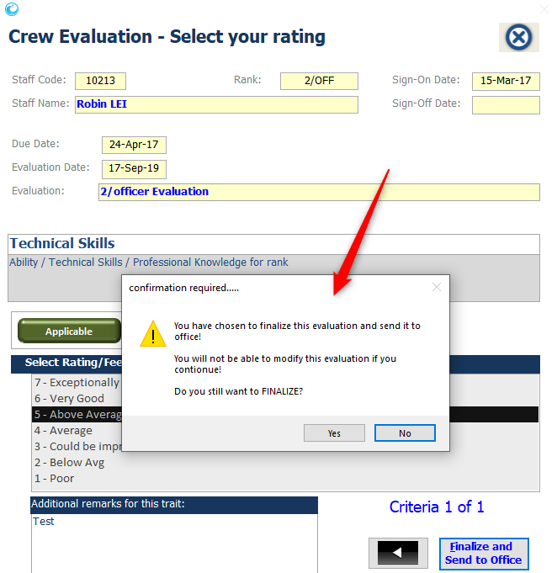

- To finalize it will ask to confirmation for same as below. Click YES to complete the evaluation exercise for the selected staff.

- Once you will finalize the crew Evaluation that crew name will automatically go to the completed evaluation list and can be viewed only using by ‘Evaluation Status‘ filters.
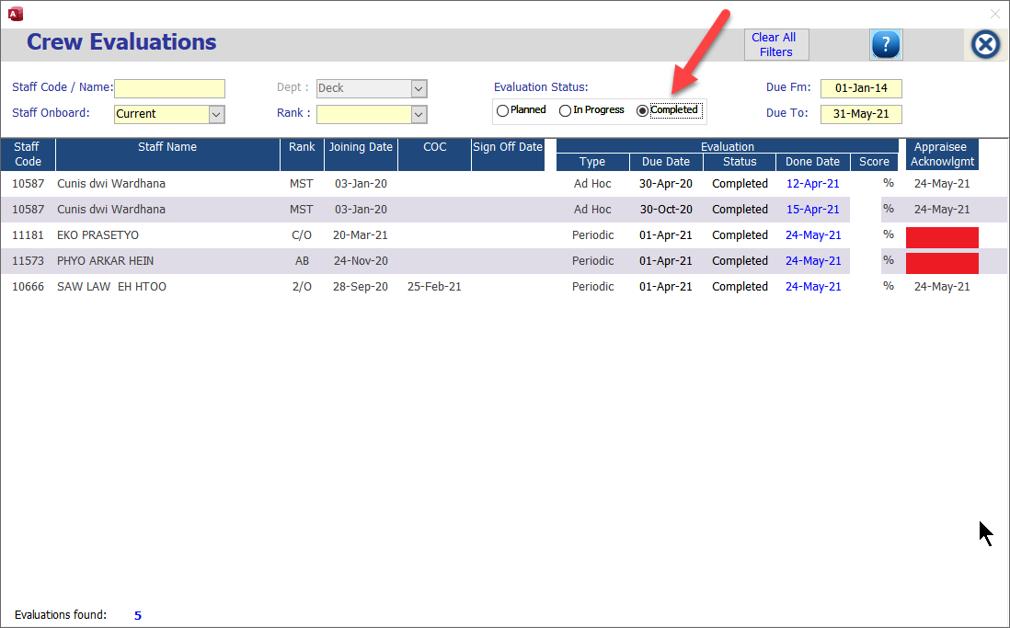

Help continues in the next page.

- Each seafarer, whose Appraisal / Evaluation has been marked completed by the department head, will be able to login to the Jot ERP Onboard module, and be able to view his own appraisal.

He will also be able to give his feedback about each of the grading that is given in his appraisal under column APPRAISEE COMMENTS

Once he has completed his response, he has to click on button

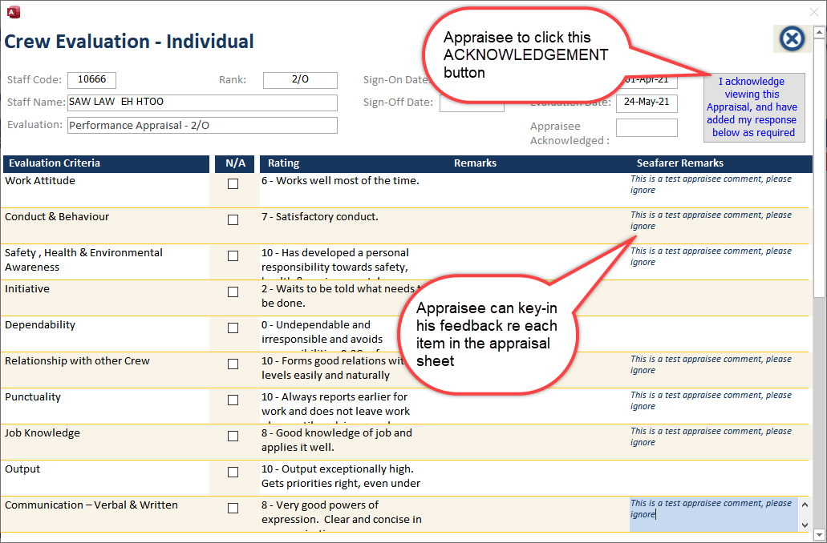

Appendix – A: Seafarer Appraisal Business Process:

Planned Evaluations / Appraisals are automatically created
in the Jot ERP Office side, based on the schedule provided by the Crewing Department
Planned Evaluations are then visible onboard ships
Upon the DUE DATE, the Master & Chief Engineer onboard can update the evaluations for Deck and Engine respectively departments
Evaluations can be updated and saved.
REMARKS are mandatory by the Appraiser if poor rating is given to a question.
Once an evaluation is completed, the Master/Chief Engineer can FINALIZED that evaluation.
The Appraisee can then login to the Jot ERP onboard, and he can view only his own appraisal.
He can view it and place his response for each grade. Once completed, he has to Acknowledge that he has sighted and responded to the appraisal.
The Evaluation is then automatically synchronized with the office side, where the Crew Team and the Superintendent can view it and mark it as VERIFIED.

